INTM559420: Hybrids: Imported mismatches (Chapter 11): Examples: Hybrid loan funded by several relevant payments

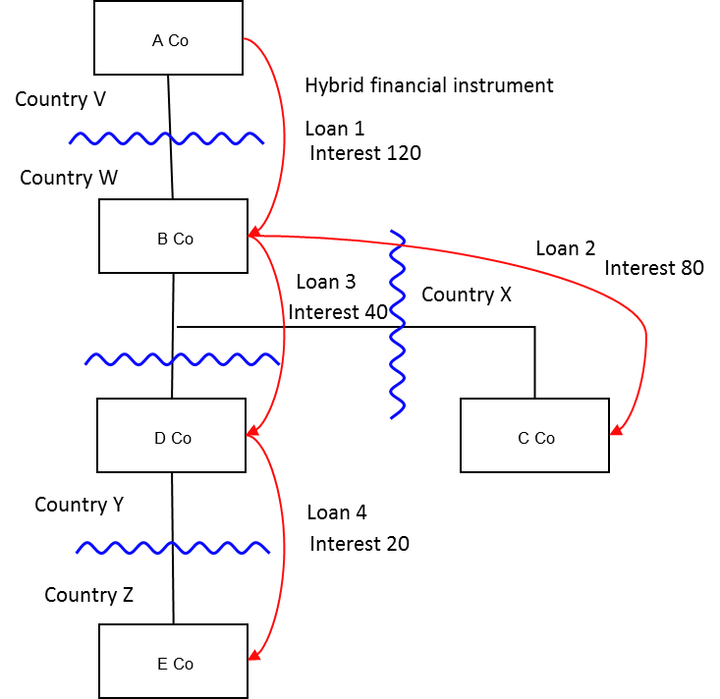

Background
- A Co is resident in Country V, and owns all the shares in B Co (resident in Country W)
- B Co owns all the shares in C Co (resident in Country X) and D Co (resident in Country Y)
- D Co owns all the shares in E Co (resident in Country Z)
- A Co makes a loan (interest payable 120) to B Co (Loan 1) under which the payments of interest are treated as deductible in calculating B Co.’s ordinary income but which are treated as non-taxable equity receipts in calculating A Co.’s ordinary income.
- The terms of Loan 1 satisfy the conditions in Chapter 3 at s259CA.
- Neither Country V nor Country W have rules based on the OECD’s Final Report on Neutralising the Effects of Hybrid Mismatch Arrangements published on 5 October 2015 or any replacement or supplementary publication
- B Co on-lends two thirds of the funds provided under Loan 1 (resulting in interest payable of 80) to C Co (Loan 2) and the balance (with interest payable of 40) to D Co (Loan 3).
- D Co on-lends half of the funds provided under Loan 3 (that is, a sum on which interest of 20 is payable) to E Co (Loan 4)
- B Co, C Co, D Co and E Co under the laws of Country W, Country X, Country Y and Country Z respectively treat the relevant loans as debt instruments and treat the payments of interest as deductible or as taxable as ordinary income in the relevant jurisdictions accordingly.

Analysis - Applying the tests in s259KA
Are the relevant conditions satisfied to bring this example within the scope of the imported mismatches rules in Chapter 11?

Condition A: Are there payments or quasi-payments made under, or in connection with, an arrangement?
Loan 2, Loan 3 and Loan 4 each constitute an imported mismatch arrangement (where the UK is Country X, Country Y or Country Z respectively) and the relevant interest payments are each transfers of money made under them.
Condition A is met.

Condition B: Is the payer in relation to that imported mismatch arrangement within the charge to corporation tax for a relevant payment period?
As the UK has adopted the Part 6A rules, the assumption is that the UK is not either Country V or Country W.
Where the UK is Country X, C Co is a payer in relation to the Loan 2 arrangement and is within the charge to corporation tax.
Where the UK is Country Y, D Co is a payer in relation to the Loan 3 arrangement and is within the charge to corporation tax.
Where the UK is Country Z, E Co is a payer in relation to the Loan 4 arrangement and is within the charge to corporation tax.
Condition B is met as long as one of the above is satisfied.

Condition C: Is this arrangement one of a number of arrangements which are each entered into in pursuance of, or in relation to, an over-arching arrangement (a series of arrangements)?
As identified in Condition A, Loan 2, Loan 3 and Loan 4 each constitute a relevant arrangement, and together with loan 1 form a series of arrangements.
Loan 4 was made pursuant to Loan 3, which was made pursuant to Loan 1. This is part of the over-arching arrangement as defined in s259KA(5) where the UK is in the position of either Country Y or Country Z.
Loan 2 was also made pursuant to Loan 1. This is therefore part of the over-arching arrangement as defined in s259KA(5) where the UK is in the position of Country X.
Condition C is satisfied for Loan 2, Loan 3 and Loan 4 in relation to Loan 1.

Condition D: Under an arrangement within this series (other than the imported mismatch arrangement), is there a payment or quasi-payment in relation to which it is reasonable to suppose that there would be a relevant mismatch (as targeted by Part 6A rules)?
The terms of Loan 1 are such that they would satisfy the conditions to fall within Chapter 3.
The relevant arrangement in the series is therefore Loan 1 and the relevant mismatch would be a hybrid or otherwise impermissible deduction/non-inclusion mismatch within Chapter 3.
Condition D is met in respect of Loan 1.
The relevant mismatch here is the extent of the mismatch as computed under Chapter 3, which is the entire 120 deduction arising to B Co.

Condition E: After amendment in Finance Act 2021, Condition E is whether it is it reasonable to suppose that the relevant mismatch is not capable of counteraction?
As stated above in the Background, neither Country V nor Country W has adopted rules Final Report on Neutralising the Effects of Hybrid Mismatch Arrangements published on 5 October 2015 or any replacement or supplementary publication based on the OECD’s .
If the UK were in the position of Country Z, and Country Y has not adopted the OECD recommendations, , then Condition E is satisfied.

Condition G: Is the payer (C Co, D Co or E Co) in relation to the imported mismatch payment within the same control group as the payee (A Co) of the mismatch payment within the relevant period, or is there a structured arrangement?
All the companies are within the same control group, as defined at s259NB.
Condition G is met.
It is not necessary to consider whether this is a structured arrangement.

Conclusion
As all the relevant conditions are satisfied, the relevant counteraction under the imported mismatch rules must be considered.

Counteraction under s259KC
There is more than one relevant payment in relation to the relevant mismatch of 120 arising between A Co and B Co and therefore each company’s share of the relevant mismatch will be determined by apportioning it on a just and reasonable basis, having regard to the extent that the imported mismatch and the other relevant payments fund the relevant mismatch.
In this example, the relevant mismatch (120) is funded, on a just and reasonable basis, by 80 from C Co, 40 from D Co and 40 (indirectly) from E Co through D Co.
Note: The onus is on the relevant company within the charge to UK corporation tax to justify the other payments as relevant payments and to justify the extent to which they should be considered as also funding the relevant mismatch. In this example the allocation is obvious. However, if loan 1 was only for 80, and it used 40 of its own retained cash to fund the balance, then the starting presumption would be that the entire payment made by the relevant company within the charge to UK corporation tax had funded the relevant mismatch of 80. It would be up to the company to show that this is not appropriate.

Counteraction where the UK is in the position of Country X
Where the UK is Country X, then s259KC will apply to deny C Co a deduction in relation to the payments under Loan 2, which (in this example) would be the entire deduction of 80.

Counteraction where the UK is in the position of Country Y
Where the UK is Country Y, then s259KC will apply to deny D Co a deduction in relation to the payments under Loan 3, which (in this example) would be the entire deduction of 40.

Counteraction where the UK is in the position of Country Z
Where the UK is Country Z, then s259KC will apply if it is reasonable to suppose that country Y will not have countered the mismatch. Therefore if Country Y is OECD mismatch complaint, no counteraction will be required in in Country Z (the UK), but if country Y is not OECD mismatch complaint, then a counteraction will be required.
Return to contents

