INTM559410: Hybrids: Imported mismatches (Chapter 11): Examples: Manufactured royalty

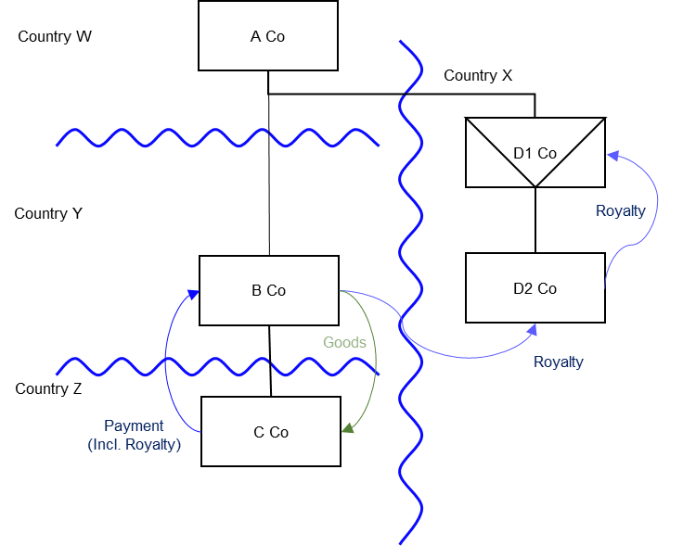

Background
- A Co is a company resident in Country W
- B Co is a company resident in Country Y, and A Co owns its entire shareholding
- C Co is a company resident in Country Z, and B Co owns its entire shareholding
- D1 Co is a corporate entity established and resident in Country X, with A Co as its sole member
- D1 Co is regarded as transparent in Country X but opaque by Country W. As such its profits are subject to tax in neither Country X nor Country W
- D2 Co is a company resident in Country X, and D1 Co owns its entire shareholding
- This group (including A Co, B Co, C Co, D1 Co and D2 Co) holds intellectual property (IP) in D1 Co
- D1 Co grants a licence to D2 Co to exploit that IP in exchange for royalties
- B Co produces and sells goods exploiting the IP - granted by D2 Co in exchange for royalties
- B Co sells some of those goods to C Co
- Country Z grants C Co a deduction for the cost of those goods purchased, which includes an amount that can be attributed to the IP
- Country Y subjects B Co to tax on the corresponding receipt, but its profits are reduced by a deduction corresponding to the royalty paid to D2 Co
- D2 Co, in turn, pays D1 Co a royalty under the licence agreement, for which Country X allows a deduction.
- As D1 Co is treated as transparent in Country X but opaque in Country W, D1 Co is in effect a hybrid payee. Chapter 7 may have applied if the UK were Country X or Country W.

For the purposes of this example, however, the UK is not Country X or Country W, as neither Country X nor Country W have rules based on the OECD Final Report on Neutralising the Effects of Hybrid Mismatch Arrangements published by on 5 October 2015 or any replacement or supplementary publication

Analysis - Applying the tests in s259KA TIOPA 2010
Are the relevant conditions satisfied to bring this example within the scope of the imported mismatches rules?

Condition A: Are there payments or quasi-payments made under, or in connection with, an arrangement?
Both the royalty paid by B Co to D2 Co (the B/D2 arrangement) and the payment (including an element of royalty) from C Co to B Co (the C/B arrangement) are payments made under, or in connection with, an arrangement.
Condition A is satisfied.

Condition B: Is the payer in relation to that imported mismatch arrangement within the charge to corporation tax for a relevant payment period?
Where the UK is Country Y, B Co is a payer in relation to the B/D2 arrangement and is within the charge to corporation tax.
Where the UK is Country Z, C Co is a payer in relation to the C/B arrangement and is within the charge to corporation tax.
Condition B is satisfied.

Condition C: Is this arrangement one of a number of arrangements which are each entered into in pursuance of, or in relation to, an over-arching arrangement (a series of arrangements)?
As identified in Condition A the royalty paid by B Co to D2 Co, and the payment (including the element of royalty) from C Co to B Co, are relevant arrangements, and both of these form a number of related arrangements that includes the royalty payment from D2 Co to D1 Co.
The over-arching arrangement here, as defined in s259KA(5), includes the payment from C Co to B Co, the royalty payment from B Co to D2 Co and the royalty payment from D2 Co to D1 Co.
Condition C is satisfied for either the B Co to D2 arrangement or the C Co to B Co arrangement in relation to the royalty payment from D2 Co to D1 Co.

Condition D: Is there a relevant mismatch?
As D1 Co is transparent in Country X but opaque in Country W, D1 Co is a hybrid entity and would have been subject to the rules in Chapter 7 TIOPA 2010.
The relevant arrangement in the series is therefore the royalty paid from D2 Co to D1 Co and the mismatch payment would be a hybrid payee deduction/non-inclusion mismatch within Chapter 7.
Condition D is satisfied in respect of the royalty paid from D2 Co to D1 Co.
The relevant mismatch is the extent of the mismatch as computed under Chapter 7.

Condition E: After amendment in Finance Act 2021, Condition E is whether it is it reasonable to suppose that the relevant mismatch is not capable of counteraction?
Neither Country W nor Country X is OECD mismatch compliant as they have not adopted rules based on the OECD’s Final Report on Neutralising the Effects of Hybrid Mismatch Arrangements published on 5 October 2015 or any replacement or supplementary publication Condition E is satisfied.

Condition G: Is the payer in relation to the imported mismatch payment within the same control group as the payee (D1 Co) of the mismatch payment within the relevant period, or is there a structured arrangement?
All the companies are within the same control group, as defined at s259NB.
Condition G is met.
There is no need to consider whether this is a structured arrangement.

Conclusion
As all the relevant conditions are satisfied to characterise the imported mismatch payments under either (or both) the C Co to B Co arrangement and the B Co to D2 Co arrangement as giving rise to a relevant mismatch. The relevant counteraction under the Imported Mismatch rules must be considered.

Counteraction
Where there is more than one relevant payment in relation to the relevant mismatch arising, each company’s share of the relevant mismatch will be determined by apportioning it on a just and reasonable basis, having regard to the extent that it funds the Imported Mismatch.

Counteraction where the UK is in the position of Country Y
Where the UK is in the position of Country Y, then s259KC will apply to deny B Co a deduction to the extent that it directly or indirectly funds the relevant mismatch.
Therefore, s259KC will apply to deny B Co a deduction for the royalty payments made to D2 Co, to the extent that they do not exceed the royalty payments made by D2 Co to D1 Co. As D2 Co would be exposed to tax in Country X on any excess it is not part of the mismatch payment.

Counteraction where the UK is in the position of Country Z
Where the UK is in the position of Country Z, then s259KC will apply only to the extent that the mismatch payment attributed to B Co has not been fully counteracted in Country Y by a provision equivalent to the Imported Mismatches rule. Any counteraction taken in Country Y will reduce the extent to which the mismatch is imported into Country Z.
If the relevant mismatch has been fully counteracted in Country Y then there is no remaining imported mismatch to be addressed in Country Z. S259KB will therefore not apply to deny C Co from deducting an amount in relation to that part of the payment which is attributable to the IP.
Return to contents

