INTM559405: Hybrids: Imported mismatches (Chapter 11): Examples: Series of arrangements
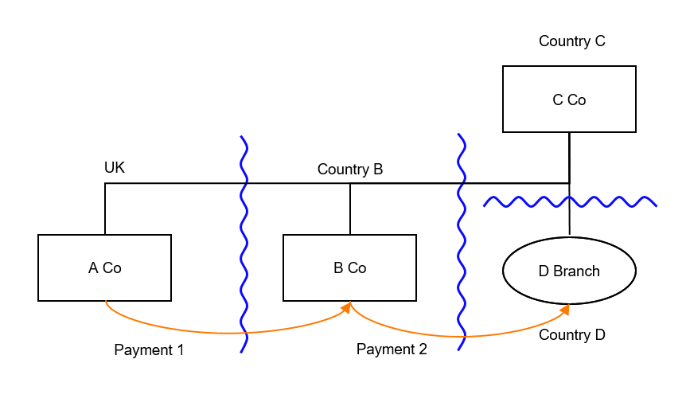

Background
- C Co is resident in Country C and is the 100% shareholder of A Co, resident in the UK, and B Co, resident in Country B. C Co also operates a branch in Country D.
- Under the laws of Country C, C Co is regarded as carrying on a business through a permanent establishment (PE) in Country D.
- Under the laws of Country D, C Co is not regarded as carrying on a business through a PE in Country D.
- A Co is the distributor for the group. A Co makes payments of 100 (payment 1) for goods to B Co. The UK allows a deduction for the payment made by A Co.
- Country B treats the receipt as taxable on B Co.
- B Co sources products from the group manufacturing divisions including D Branch of C Co. B Co makes payments of 100 for goods to Branch D. Country B allows a deduction against income for the payment made by B Co.

- Country C treats the receipt under Payment 2 as attributable to its PE (D Branch) and exempts or excludes the income receipt from taxation. Country D, however, does not tax the income because C Co is not treated as having a PE under local law.
- The payment therefore gives rise to an intra-group mismatch (a D/NI outcome) because a deduction is available in Country B with no corresponding taxable income recognised in either Country C or Country D.
- Neither Country B nor Country C have rules based on the OECD’s Final Report on Neutralising the Effects of Hybrid Mismatch Arrangements published on 5 October 2015 or any replacement or supplementary publication .

Analysis – Applying the tests in s259KA TIOPA 2010
Are the relevant conditions satisfied to bring this example within the scope of the imported mismatches rules?

Condition A: Are there payments or quasi-payments made under, or in connection with, an arrangement?
Payment 1 and payment 2 are both payments made under, or in connection with, an arrangement.
Condition A is met.

Condition B: Is the payer in relation to that imported mismatch arrangement within the charge to corporation tax for a relevant payment period?
A Co is a payer in relation to the Payment 1 arrangement and is within the charge to corporation tax.
Condition B is met.

Condition C: Is this arrangement one of a number of arrangements which are each entered into in pursuance of, or in relation to, an over-arching arrangement (a series of arrangements)?
Payment 1 and payment 2 each constitute a relevant arrangement, and taken together form a series of arrangements (an over-arching arrangement). The over-arching arrangement here as defined in s259KA(5) includes the payment from A Co to B Co, and the payment from B Co to D Branch.
Condition C is satisfied for payment 1 in relation to payment 2.

Condition D: Under an arrangement within this series (other than the imported mismatch arrangement), is there a payment or quasi-payment in relation to which it is reasonable to suppose that there would be a relevant mismatch (as targeted by Part 6A rules)?
Neither C Co nor D Branch bring the payment into ordinary income, because the law of Country D does not regard C Co as carrying on a business in Country D, but the law of the parent jurisdiction does.
C Co meets the definition of a multinational company for the purposes of Chapter 8, so if the payment from B Co to D Branch gives rise to a mismatch, it would satisfy the conditions to fall within Chapter 8.
As the payee, C Co, is regarded as carrying on a business through a permanent establishment under the laws of the parent jurisdiction, but under the laws of the PE jurisdiction is not regarded as doing so, and a mismatch arises because the payee is a company with a permanent establishment, Chapter 8 of Part 6A TIOPA 2010 may have applied if the UK were Country B or Country C.
Condition D is met in respect of payment 2. The relevant mismatch is the extent as computed under Chapter 8, which is the entire deduction arising to B Co.

Condition E: After amendment in Finance Act 2021, Condition E is whether it reasonable to suppose that the relevant mismatch is not capable of counteraction?
As noted in the Background, neither Country B nor Country C have adopted rules based on the OECD’s Final Report on Neutralising the Effects of Hybrid Mismatch Arrangements published on 5 October 2015 or any replacement or supplementary publication and therefore are not territories that are OECD mismatch complaint for the purposes of (post Finance Act 2021) Condition E
Condition E is therefore met as the relevant mismatch is not capabale of counteraction.

Condition G: Is the payer (A Co) in relation to the imported mismatch payment within the same control group as the payee (C Co/D Branch) of the mismatch payment within the relevant period, or is there a structured arrangement?
All the companies are within the same control group, as defined at s259NB.
Condition G is met. It is not necessary to consider whether this is a structured arrangement.

Conclusion
All the relevant conditions are satisfied, so the relevant counteraction under the imported mismatch rules must be considered.

Counteraction under s259KC
The relevant deduction that may be deducted from A Co’s income for the payment period is to be reduced by the amount, and A Co’s share, of the relevant mismatch.
The share of the mismatch is to be determined on a just and reasonable basis by apportioning the extent to which the imported mismatch payment and any other relevant payment funds, directly or indirectly, the mismatch payment.
In this example, the relevant mismatch (payment 2) is 100 from B Co to D Branch, and is funded on a just and reasonable basis directly by 100 from A Co to B Co.
Return to contents

