INTM558220: Hybrids: Dual Territory Double Deduction (Chapter 10): Examples: Dual-resident company double deduction
This example illustrates a double deduction (DD) outcome arising as a result of a company being dual resident.
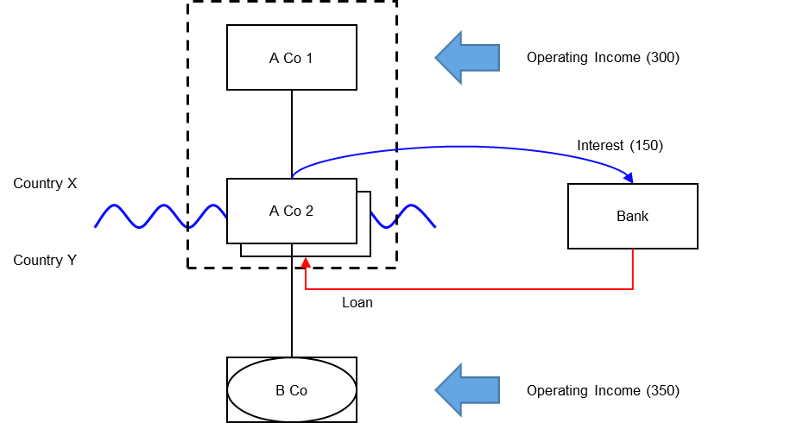

Background
- A Co 1 is resident in Country X. A Co 1 owns all the shares in A Co 2.
- A Co 2 is a dual–resident company that is resident for tax purposes in both Country X and Country Y.
- A Co 1 is consolidated with A Co 2 under Country X law.
- A Co 2 acquires all of the shares in B Co.
- B Co is treated as a separate entity under Country X law, but is recognised as fiscally transparent under Country Y law.
- A Co 2 borrows money from a bank. The loan interest (150) is deductible in both Country X and Country Y.
- Operating income of 300 arises to A Co 1, and 350 to B Co.
- A Co 2 has no other income or expenditure.
Without counteraction the combined position for the AB group is set out below:
Country X Country Y
A Co 1 and A Co 2 combined A Co 2 and B Co combined
 | Tax | Book |  | Tax | Book
Income |  |  | Income
Operating income of A Co 1 | 300 | 300 | Operating income of B Co | 350 | 350
Expenditure |  |  | Expenditure
Interest Paid by A Co 2 to bank | -150 |  | Interest Paid by A Co 2 to bank | -150 | -150
Net profit |  | 300 | Net profit |  | 200
Taxable profit | 150 |  | Taxable profit | 200

The net effect of the structure is that the AB group has a net return of 500 profits, but the taxable profits are only 350.

Analysis - Applying the tests at s259JA TIOPA 2010
Does the interest payment by A Co 2 satisfy the relevant conditions to fall within the scope of the dual territory double deduction rules?

Condition A: Is there a relevant multinational or a dual-resident company?
The definition of a dual resident company is given at s259JA(3).
Condition A is satisfied if the UK is either Country X or Country Y, as A Co 2 is resident for tax purposes in both countries.
If the UK is neither Country X nor Country Y then the condition is not satisfied. If this is the case then the imported mismatch rules within s259K TIOPA 2010 should be considered.

Condition B: Is it reasonable to suppose that there is a dual territory double deduction that arises because the company is a relevant multinational or dual resident company?
Under the laws of Country X, A Co 2 can deduct the 150 interest amount from its income for tax purposes.
Under the laws of Country Y, A Co 2 can also deduct the 150 interest amount from its income for tax purposes.
Condition B is satisfied. The extent of the dual territory double deduction amount is 150.

Conclusion
As both conditions are satisfied the relevant counteraction needs to be considered.

Counteraction
Where the dual territory double deduction mismatch arises because the company is a dual resident company, s259JB applies.
For periods beginning after 10 June 2021 (the date of Royal Assent of the Finance Bill 2021), where the UK is either Country X or Country Y the dual territory double deduction amount of 150 will be not be denied in the UK as an illegitimate overseas deduction because it is utilised only against the income of the the dual resident company. Instead the use of the deduction will be restricted for off setting any dual inclusion income received in the period. For periods beginning before that date, the entire 150 will be regarded as an illegitimate overseas deduction and so should be denied entirely in the UK.
If the UK is Country X, it is reasonable to suppose that the dual territory double deduction amount of 150 is in substance set against the income received by B Co in Country Y (which is treated in Country Y as the income of A Co 2), and that income is not dual inclusion income of A Co 2.
If the UK is Country Y, it is reasonable to suppose that the dual territory double deduction amount of 150 is in substance set against the income of A Co 1 in Country X, and that the income of A Co 1 is not dual inclusion income of A Co 2.
If the non-UK jurisdiction has also adopted a provision equivalent to s259JB TIOPA 2010, then that jurisdiction too may also deny the deduction for the interest payment (150).

The position following such a counteraction in both territories is set out below:
Country A Country B
A Co 1 and A Co 2 combined A Co 2 and B Co combined
 | Tax | Book |  | Tax | Book
Income |  |  | Income
Operating income of A Co 1 | 300 | 300 | Operating income of B Co | 350 | 350
Adjustment | 150 |  | Adjustment | 150
Expenditure |  |  | Expenditure
Interest Paid by A Co 2 to bank | -150 |  | Interest Paid by A Co 2 to bank | -150 | -150
Net profit |  | 300 | Net profit |  | 200
Taxable profit | 300 |  | Taxable profit | 350

The net effect under the counteraction is that the AB group realises 500 of net profit, but its taxable profit has increased to 650. The 150 excess taxable income is a result of both countries applying the same rule and both restricting the use of the dual territory double deduction amount, thus resulting in some double taxation. The AB group will need to engage with the tax administrations of Country X and Country Y to see if they can resolve this situation, for example through the mutual agreement procedure.

Return to contents

