INTM557240: Hybrids: Hybrid entity double deduction mismatches (Chapter 9): Example: Double deduction mismatch offset against deemed dual inclusion income
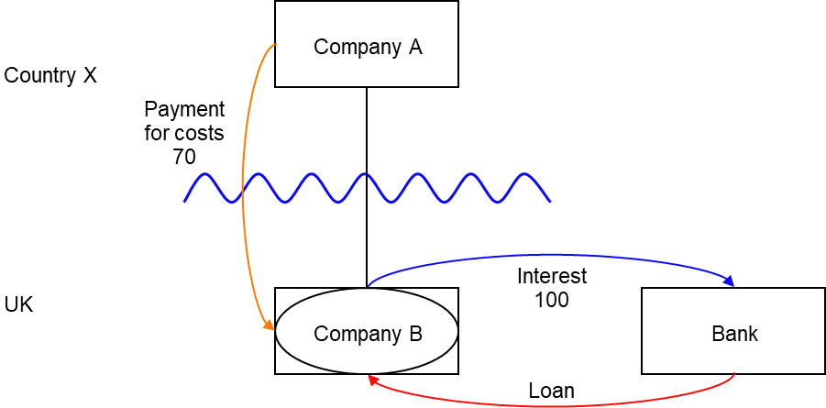

Background
- Company A is a company resident in Country X, which is not a zero-tax territory.
- Company B is a company resident in the UK, and Company A owns its entire share capital
- Company B is treated as a separate person for tax purposes in the UK, but as a disregarded entity for tax purposes in Country X.
- Company B borrows money from a bank, also resident in the UK, and pays interest of 100 a year.
- Country X allows Company A a deduction for the underlying interest, as it sees Company B as a branch of Company A.
- The UK allows a deduction for the interest payments made by Company B.
- Under a separate agreement, Company A makes a payment for costs of 70 a year to Company B, reimbursing it for costs incurred by Company B for services on behalf of Company A.
- Country X does not allow a deduction for this amount in Company A, as it does not see the two companies as distinct taxable persons.
- The UK taxes the amount as ordinary income of Company B, chargeable to UK corporation tax.

Analysis
Do the hybrid entity double deduction mismatch rules in Chapter 9 apply to the interest payment made by Company B?

Condition A: Is it reasonable to suppose that there is an amount that could be deducted both from the income of a hybrid entity and also from the income of an investor?
Company B is a hybrid entity, as its profits are treated as the profits of Company A under Country X’s law, but it is regarded as being a separate person for tax purposes under UK law.
Company A is an investor in relation to Company B.
It is reasonable to suppose that deductions for interest payments could be deducted from the income of both Company A and Company B for the purposes of calculating their taxable profits.
Condition A is satisfied. The extent of the hybrid entity double deduction is the full amount of the interest payments under the Loan.

Condition B: Is either Company A (an investor in the hybrid entity) or Company B (the hybrid entity) within the charge to corporation tax for the deduction period?
Company B is resident in the UK and so is within the charge to corporation tax.

Condition C: Are the hybrid entity and its investor related, or is there a structured arrangement?
The hybrid entity (Company B) and its investor (Company A) are related within the definition at s259NC by virtue of being in the same control group.
Condition C is satisfied.

Conclusion
All the conditions are satisfied to characterise the payments of interest as a hybrid entity double deduction mismatch, so the relevant counteractions must be considered.

Counteraction
This example concerns a case where only the hybrid entity is resident in the UK, so it is only necessary to consider the secondary response.

Counteraction where the UK is the hybrid entity jurisdiction

Secondary response
Where the UK is the hybrid entity jurisdiction, and the hybrid entity double deduction mismatch has either not been counteracted in Country X, or it has been counteracted only in part, then s259IC will apply to counteract the mismatch in the hybrid entity if the secondary counteraction condition is met.
The secondary counteraction condition is met in this case as Company A and Company B are in the same control group throughout the hybrid entity deduction period.
In this example, there is no illegitimate overseas deduction.
The UK will deny Company B a deduction for the hybrid entity double deduction amount (100) to the extent it cannot be offset against dual inclusion income.

For payments in accounting periods beginning on or after 10 June 2021
Subsection 259IC(10) defines dual inclusion income as income that is (a) ordinary income of Company A and (b) ordinary income of an investor (i.e. Company B). The payment for costs is not dual inclusion income under that definition because the condition at paragraph (b) is not met, however that condition is deemed to be met if the further requirements of s259ICA are met. The extended definition is designed to allow an amount of income that is taxable in Company A, but not deductible in Company B, or any other jurisdiction, to be treated as dual inclusion income. This is also sometimes called ‘inclusion/non-deduction income’.
The first requirement is that the amount is not deductible from the income of Company A, or from the income of any other person in any territory.
In this example, Company A cannot have a deduction from its income for the payment and there is no other entity that could deduct the amount from its income. This means the first requirement is met.
Company A is not resident in a zero-tax territory, so the second requirement is not relevant.
The third requirement is that the amount would be deductible against the income of Company A in Country X, on the assumption that Company B was not a hybrid entity. This condition ensures an amount can only be treated as deemed dual inclusion income if Company A is denied a deduction in Country X because of the hybrid nature of Company B.
In this example, if Company B was treated as a distinct entity from Company A in Country X, then Company A would be able to deduct an amount paid to Company B in respect of services provided from its income. Therefore the third requirement is met.
This means that s259ICA applies and some of the counteracted double deduction amount (100) can be set against an amount of dual inclusion income (70).
Company B may carry forward the unused hybrid entity double deduction amount (30) and deduct it from dual inclusion income (or deemed dual inclusion income) arising in subsequent accounting periods.

For payments in accounting periods beginning before 10 June 2021
The deemed dual inclusion income from the payment for costs will not be treated as dual inclusion income as a result of s259ICA unless Company B makes an election to treat that legislation as having always had effect. If Company B does make an election, the analysis will be as above.
Return to contents

