INTM557230: Hybrids: Hybrid entity double deduction mismatches (Chapter 9): Example: Calculating dual inclusion income under a CFC regime
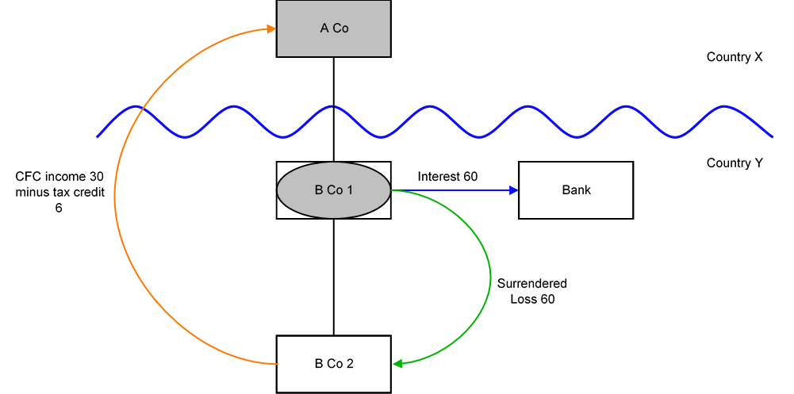

Background
- A Co is resident in Country X and owns 100% of the shares in B Co 1.

- B Co 1 has no income during the period and owns 100% of the shares in its trading company, B Co 2. Both are resident in Country Y.

- B Co 1 takes out a loan (the ‘Loan’) from a local Bank, with interest of 60 arising in the period. As it has no income, this leads to a trading loss of 60 which it can surrender to B Co 2 to relieve against its ordinary income.

- B Co 1 income or profits are treated as income or profits of A Co under Country X law and therefore A Co can also claim a deduction of 60 in relation to the interest.

- B Co 2 has other income during the period of 90. After the deduction of 60 this leaves B Co 2 with profits of 30.

- A Co is subject to a CFC charge on B Co 2’s profits of 90, with relief available for the relevant tax suffered on those profits in Country Y. (Note that A Co cannot be subject to a CFC charge on the profits of B Co 1 since B Co 1 is a disregarded entity under the tax law of Country X so cannot be a controlled foreign company).

Analysis - Applying the tests in s259IA TIOPA 2010
Do the hybrid entity double deduction mismatch rules apply to the interest payment made by B Co 1?
Condition A: Is it reasonable to suppose an amount could be deducted both from the income of a hybrid entity and also from the income of an investor?
B Co 1 is recognised as a separate taxable person for tax purposes under the law of Country Y, but its income or profits are treated as the profits of A Co under the law of Country X. B Co 1 is a hybrid entity and A Co is the investor.
Given the facts above, it is reasonable to suppose that a deduction in relation to the interest arising under the Loan will be permitted as a deduction against the ordinary income of both A Co and B Co 1 in calculating their taxable profits.
Condition A is satisfied.
The hybrid entity double deduction is the full amount of the interest deduction under the Loan.

Condition B: Is either A Co (the investor in the hybrid entity) or B Co (the hybrid entity) within the charge to corporation tax for the deduction period?
The charge to corporation tax is the charge to the corporation tax in the UK.
If the UK is Country X, Country Y or both (i.e. a wholly domestic transaction), Condition B is satisfied, as either Co.1, Co.2 or both are within the charge to corporation tax.
If the UK is neither Country X nor Country Y, then Condition B is not satisfied, as neither Co.1 nor Co.2 are within the charge to corporation tax. You will need to consider the remaining conditions only if the imported mismatch rules in Chapter 11 apply.

Condition C: Are B Co 1 (the hybrid entity) and A Co 1 (the investor) related, or is there a structured arrangement?
A Co 1 and B Co 1 are related within the definition at s259NC.
Condition C is satisfied.

Conclusion
As all the conditions are satisfied, the relevant counteraction must be considered in respect of amounts identified as hybrid entity double deductions.

Counteractions
The counteraction applied will depend upon whether the UK is in the position of Country X or Country Y.

Counteraction where UK is in the position of Country X (the investor jurisdiction)

Primary response
Where the UK is in the position of Country X, s259IB will apply
The hybrid entity double deduction amount of 60 is in substance deducted from the income of B Co 2 in Country Y, so there is an illegitimate overseas deduction to the extent that it is deducted from income that is not dual inclusion income of the investor.
Dual inclusion income only includes amounts included in the taxable profits of both the investor and the hybrid entity i.e. A Co and B Co 1 respectively. The income recognised in the CFC charge in A Co, being 90, is that arising to B Co 2 and therefore is not dual inclusion income.
Consequently there is an illegitimate overseas deduction of 60, and A Co will be denied a deduction for that amount.
The illegitimate overseas deduction is treated as if it were deducted in an earlier period. Consequently there is no amount for A Co to carry forward.

Counteraction where the UK is in the position of Country Y (the hybrid entity jurisdiction)

Secondary response
Where the UK is in the position of the payer jurisdiction (B Co 1), and the hybrid entity double deduction amount has not been fully counteracted by Country X, then s259IC applies if the secondary counteraction condition is met.
The secondary counteraction condition is met in this case as B Co 1 and A Co are in the same control group throughout the hybrid entity deduction period.
In this instance there is no illegitimate overseas deduction as amounts surrendered to B Co 2 are deducted from the income of B Co 2 under UK law.

B Co 1 is denied a deduction for the hybrid entity double deduction of 60 as it has no dual inclusion income to set it against. B Co. 1 may carry forward the 60 and deduct it from dual inclusion income of B Co 1 arising in subsequent accounting periods.
If the Commissioners are satisfied that B Co 1 will not have any future dual inclusion income (i.e. entity struck off / ceased), any unused hybrid entity double deductions become stranded deductions. B Co 1 may deduct these stranded deductions from total taxable profits of subsequent accounting periods.
As B Co 1 no longer has a trading loss, there is nothing to surrender to B Co 2. B Co 2 is taxable on its full profits of 90.
Return to contents

