INTM557220: Hybrids: Hybrid entity double deduction mismatches (Chapter 9): Example: Grant of share options
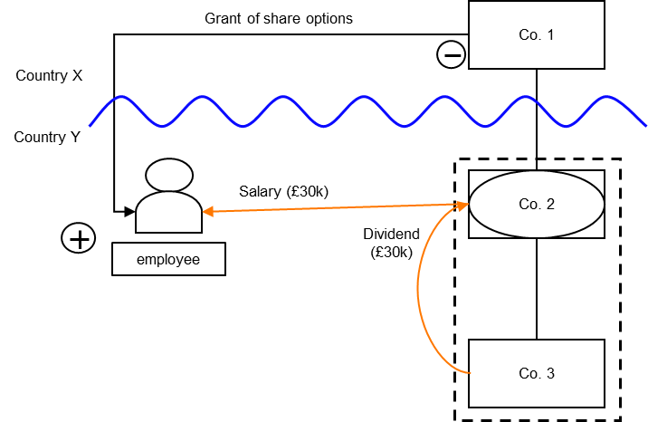

Background
- Co. 1 establishes Co. 2 as the holding company for its operating subsidiary Co. 3.
- Co. 2 is treated as a separate person for tax purposes in Country Y but income or profits are treated as income or profits of Co. 1 for tax purposes by Country X.
- Co. 2 and Co. 3 are members of the same tax group and therefore, under the tax laws of Country Y, the net loss of Co. 2 can be set-off against ordinary income of Co. 3.
- Co. 2 has a single employee who is entitled to an annual salary of £30k. The salary cost is funded by a dividend payment from Co. 3 that is exempt from taxation in both Country Y and Country X.
- The employee also participates in a share incentive scheme which provides the employee with an option to acquire shares in Co. 1. The grant of the share option is deductible under the laws of both countries, but Country X values the grant of share option as £20k and Country Y values it as £15k.
Note: In this scenario the UK will only allow a deduction for the grant of share options once the shares are awarded. In addition the accounting deduction in the UK would be denied by virtue of sections 1038 CTA 2009 and 1038A CTA 2009, with any relief being granted by Part 12 CTA 2009 and measured by reference to the market value of the shares and the income tax position of the recipient.

Analysis - Applying the tests in s259IA TIOPA 2010
Does the payment of salary and grant of share options to the employee give rise to a hybrid entity double deduction amount?

Condition A: Is it reasonable to suppose an amount could be deducted both from the income of a hybrid entity and also from the income of an investor?
Co. 2 is a separate taxable person under the tax law of Country Y. Income or profits of Co. 2 are treated as the income or profits of Co. 1 under the tax law of Country X. Co. 2 is a hybrid entity, provided by s259BE, with Co. 1 being the relevant investor.
Given the facts above, it is reasonable to suppose that Co. 1 will receive a £30k deduction against its income for the salary payment and a £20k deduction for the granting of the share options, under the laws of Country X (the investor jurisdiction).
It is also reasonable to suppose that, under the laws of Country Y (the hybrid entity jurisdiction), Co. 2 will receive a £30k deduction against its income for the salary payment and a £15k deduction for the granting of Co. 1’s share options by Co. 1 to the employee of Co. 2.
Condition A is satisfied
The extent of the hybrid entity double deduction amount is
- the salary cost of £30k, and
- the amount of £15k in relation to the grant of Co. 1’s share options to the employee of Co. 2 (that is, the £15k deducted by Co. 2 which is also included in the £20k deducted by Co. 1).

Condition B: Is either Co. 1 (investor in the hybrid entity) or Co. 2 (the hybrid entity) within the charge to corporation tax for the deduction period?
The charge to corporation tax is the charge to the corporation tax in the UK.
If the UK is Country X, Country Y or both (i.e. a wholly domestic transaction), Condition B is satisfied, as either Co.1, Co.2 or both are within the charge to corporation tax.
If the UK is neither Country X nor Country Y, then Condition B is not satisfied, as neither Co.1 nor Co.2 are within the charge to corporation tax. You will need to consider the remaining conditions only if the imported mismatch rules in Chapter 11 apply.

Condition C: Are the hybrid entity and one or more investors in it related, or is there a structured arrangement?
The hybrid entity (Co. 2) and its investor (Co. 1) are related within the definition of s259NC.
Condition C is satisfied.

Conclusion
As all the conditions are satisfied, the relevant counteraction must be considered in respect of amounts identified as hybrid entity double deductions.

Counteraction
The counteraction applied will depend upon whether the UK is in the position of Country X or Country Y.

Counteraction where UK is in the position of Country X (the investor jurisdiction)

Primary response
Where the UK is in the position of Country X, s259IB will apply
As the hybrid entity double deduction amount is in substance deducted from the income of Co 3 in Country Y, and that income is not dual inclusion income of Co 2, there is an illegitimate overseas deduction for all of the hybrid entity double deduction amount. Co. 1 will be denied a deduction for the entire amount.
The illegitimate overseas deduction is treated as if it were deducted in an earlier period. Consequently there is no amount for Co. 1 to carry forward.

Counteraction where the UK is in the position of Country Y (the hybrid entity jurisdiction)

Secondary response
Where the UK is in the position of the payer jurisdiction (Co. 2), and the hybrid entity double deduction amount has not been fully counteracted by Country X, then s259IC applies if the secondary counteraction condition is met.
The secondary counteraction condition is met in this case as Co 1 and Co 2 are in the same control group throughout the hybrid entity deduction period.
In this instance there is no illegitimate overseas deduction as amounts surrendered to Co 3 are deducted from the income of Co 3 under UK law.
Co. 2 is denied the deduction for the salary payment of £30k and the grant of share options of £15k, because Co. 2 has no dual inclusion income to set it against. Co. 2 may carry forward the £45k and deduct it from any dual inclusion income arising in subsequent accounting periods.
If the Commissioners are satisfied that Co 2 will not have any dual inclusion income again (i.e. entity ceased, struck off), any unused hybrid entity double deductions become stranded deductions. Co 2 may deduct these stranded deductions from total taxable profits of subsequent accounting periods.
As Co. 2 no longer has a deduction for the £45k, there is no loss for it to surrender to Co. 3.
Note: If the share options have not yet been awarded then under UK law they will not be considered as allowable deductions until they have been awarded.
Return to contents

