INTM557210: Hybrids: Hybrid entity double deduction mismatches (Chapter 9): Example: Timing and recognition differences – permitted periods – illegitimate overseas deduction
This example demonstrates how the permitted periods operate when calculating dual inclusion income along with the consequences of illegitimate overseas deductions.
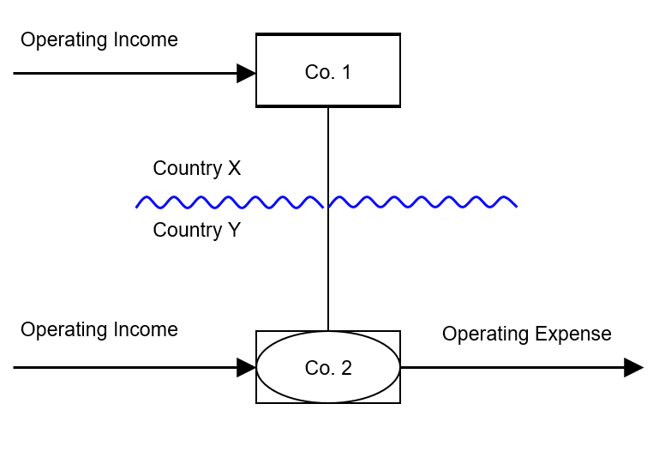
Typically, the UK would be in the position of Country Y and so this example treats Co. 2 as being in the UK.

Background
- Co. 1 is resident in Country X and owns all the issued shares in Co.2, which is resident in Country Y (UK).

- Co. 2 is treated as a taxable person in Country Y (UK) but is not a separate taxable person under the tax law in Country X.

- Co. 2’s income or profits are taxable in Country X (as income or profits of Co.1) and in Country Y (UK) (as income or profits of Co. 2).

- Co. 1 has 500 of operating income spread evenly over a two year period.

- Co. 2 has 500 of operating income over a two year period.

- Co. 2 has 320 of operating expenses in each year.

- Co. 2’s income and expenses are treated as taxable income and deductible expenditure under the laws of both Country X and Country Y.

- Co. 2’s income and expenditure are recognised in different amounts and in different periods in Country X and Country Y (UK).

Under Country X law
Co. 2’s operating income is treated as arising:
- Year 1 100, and
- Year 2 400
Co. 2’s operating expenses are treated as:
- Year 1 (220), and
- Year 2 (420)

Under Country Y (UK) law
Co. 2’s operating income is treated as arising:
- Year 1 300
- Year 2 200
Co. 2’s operating expenses are treated as:
- Year 1 (320)
- Year 2 (320)
The position for Co. 1 and Co. 2 before any consideration of Chapter 9 is –

YEAR 1 - Co. 1 (Investor) – Country X YEAR 1 - Co. 2 (Hybrid entity) – UK

INCOME |  | INCOME
Operating income Co. 1 | 250 | Operating income Co. 2 | 300
Operating income Co. 2 | 100
EXPENDITURE |  | EXPENDITURE
Operating expenses Co. 2 | (220) | Operating expenses Co. 2 | (320)
TAXABLE INCOME | 130 | TAXABLE INCOME (LOSS) | (20)

YEAR 2 - Co. 1 (Investor) – Country X YEAR 2 - Co. 2 (Hybrid entity) – UK

INCOME |  | INCOME
Operating income Co. 1 | 250 | Operating income Co. 2 | 200
Operating income Co. 2 | 400
EXPENDITURE |  | EXPENDITURE
Operating expenses Co. 2 | (420) | Operating expenses Co. 2 | (320)
TAXABLE INCOME | 230 | TAXABLE INCOME (LOSS) | (120)

Analysis - Applying the tests in s259IA TIOPA 2010
Does Chapter 9 apply to restrict any hybrid entity double deduction arising under this structure?

Condition A: Is it reasonable to suppose an amount could be deducted both from the income of a hybrid entity for a taxable period, and also from the income of an investor for a taxable period?
Co. 2 is regarded as a separate person for tax purposes under the law of Country Y (UK) but its income and expenses are treated as income and expenses of Co. 1 under Country X’s law. Co. 2 is therefore a hybrid entity. Co.1 is the investor in Co. 2.
It is reasonable to suppose that operating expenses incurred by Co. 2 could be deducted from income of both Co. 2 and Co. 1 for the purposes of calculating their taxable profits.
Condition A is satisfied.

Condition B: Is either Co. 1 (an investor in the hybrid entity) or Co. 2 (the hybrid entity) within the charge to corporation tax for the deduction period?
The charge to corporation tax is the charge to the corporation tax in the UK.
Assuming for this example that Country Y is UK. Condition B is satisfied.
[If the UK was Country X, or both Country X and Country Y (i.e. a wholly domestic transaction), Condition B would be satisfied, as either Co.1 or both Co. 1 and Co. 2 would be within the charge to corporation tax.
If the UK was neither Country X nor Country Y, then Condition B would not be not satisfied, as neither Co.1 nor Co.2 would be within the charge to corporation tax. You would then need to consider the remaining conditions only if the imported mismatch rules in Chapter 11 applied.]

Condition C: Are the hybrid entity and its investor related, or is there a structured arrangement?
Co. 1 is related to Co. 2 within the definition at s259NC through its 100% investment.
Condition C is satisfied.

Conclusion
As all the conditions are satisfied, the relevant counteraction must be considered in respect of amounts identified as hybrid entity double deductions.

Counteraction
The counteraction applied depends on whether the UK is in the position of Country X or Country Y.

Counteraction where the UK is Country Y (the hybrid entity jurisdiction)

Secondary Response
If Country X has fully counteracted the hybrid entity double deduction under provisions equivalent to those at Part 6A, no further action is necessary in the UK.
Where the hybrid entity double deduction amount is not fully counteracted in Country X, or Country X does not have provisions equivalent to those in Part 6A, the UK counteraction is under s259IC. The hybrid entity double deduction amount may only be deducted from dual inclusion income of the hybrid entity for the hybrid entity deduction period.
Year 1
In this example it is assumed that Country X has no provisions equivalent to those under Part 6A.
Expenses paid in Year 1 by the hybrid entity 320.
The 320 is an amount or part of an amount that –
- could be deducted from the income of the hybrid entity for the purposes of calculating the taxable profits of that entity for a taxable period, and
- could also be deducted, under the law of the investor jurisdiction, from the income of an investor in the hybrid entity for the purposes of calculating the taxable profits of that investor for a taxable period.
The fact that part of the amount is deducted in one taxable period and another part of the amount may be deducted in another taxable period in Co.1 does not prevent identification and counteraction of the double deduction amount.
Consequently, the hybrid entity double deduction amount is 320.
Dual inclusion income of the hybrid entity for an accounting period is defined at s259IC(10) as an amount that is ordinary income of both -
- the hybrid entity for that accounting period for corporation tax purposes, and
- the investor for a permitted taxable period under the law of the investor jurisdiction.
(see also the introduction of Deemed Dual Inclusion income in s259ICA)
A taxable period of the investor is permitted where it begins within 12 months of the end of the hybrid entity’s accounting period (or later in certain circumstances, on a claim).
In Year 1 there is an amount of 300 included in ordinary income of Co. 2 in the accounting period that is also included in ordinary income of Co. 1 in a permitted period. Co. 1 includes 100 operating income of Co.2 in Year 1 and 400 operating income of Co. 2 in Year 2. The 300 ordinary income of Co. 2 in Year 1 is therefore included to the extent that 100 is regarded by Co. 1 in Year 1 and to the extent that 200 is regarded by Co. 1 in Year 2.
Dual inclusion income is 300 in Year 1.
The restricted deduction is 320, that is the hybrid entity double deduction amount. There is a counteraction in respect of the full hybrid entity double deduction amount of 320, however 300 of the counteracted amount may be deducted from dual inclusion income for that period.
Illegitimate Overseas Deduction in Year 1
We must then consider whether the remaining 20 is an “illegitimate overseas deduction” as defined at s259IC(8).
Co. 1 has operating income of 250 in Year 1, which is not dual inclusion income, and against which 20 of the hybrid entity double deduction amount is deducted under the law of Country X. The remaining 20 is therefore an “illegitimate overseas deduction” and so it is taken to have already been deducted for a previous accounting period of the hybrid entity and is not carried forward.
However following the change in legislation in Finance Bill 2021, as the amount is deducted against the income of the investor in the hybrid entity, the 20 will not be an illegitimate overseas deduction for periods beginning after 10 June 2021 (the date of Royal Assent of the Finance Bill).
Year 2
The hybrid entity double deduction amount is 320.
In Year 2, there is 200 included in ordinary income of Co.2 in the accounting period that is also ordinary income of Co. 1 in a permitted period (200 of the ordinary income of 400 of Co. 2 as regarded by Co.1 in Year 2 has already been accounted for as dual inclusion income within the permitted period for Year 1). There may be further dual inclusion income in Year 3 that would be within the permitted period, but there is nothing to suggest that is the case from the figures presented.
Dual inclusion income is 200 in Year 2.
The restricted deduction is 320 (= hybrid entity double deduction amount). There is a counteraction in respect of the full hybrid entity double deduction amount of 320, however, 200 may be deducted from dual inclusion income for that period.
Illegitimate Overseas Deduction in Year 2
We must then determine whether the excess hybrid entity double deduction amount of 120 (calculated as the total of 320 - less the amount of 200 set against the dual inclusion income) is available to carry forward by Co. 2.
Co. 1 has operating income of 250 in Year 2, which is not dual inclusion income, and against which the remaining 120 of the hybrid entity double deduction amount is deducted under the law of Country X. The remaining 120 is therefore an “illegitimate overseas deduction” and so it is taken to have already been deducted for a previous accounting period of the hybrid entity and is not carried forward.
Again though following the amendment in Finance Bill 2021, as the amount is deducted against the income of the investor in the hybrid entity, the 120 will not be an illegitimate overseas deduction for periods beginning after 10 June 2021 (the date of Royal Assent of the Finance Bill).
Return to contents

