INTM557200: Hybrids: Hybrid entity double deduction mismatches (Chapter 9): Example: No dual inclusion income

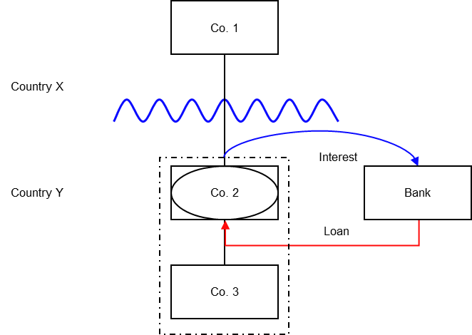

Background
- Co. 1 is a company resident in Country X.
- Co. 2 is a company resident in Country Y, and Co. 1 owns its entire shareholding
- Co. 2 is treated as a separate person for tax purposes in Country Y but as a disregarded entity for tax purposes in Country X.
- Co. 3 is also resident in Country Y, and Co. 2 owns its entire shareholding
- Country Y operates a tax consolidation regime such that Co. 2 may surrender its deductions to Co. 3 for tax purposes
- Co. 2 borrows money from a bank resident in Country Y (the Loan).
- Country X allows Co. 1 a deduction for the underlying interest, as it sees Co. 2 as a branch of Co. 1.
- Country Y allows a deduction for the interest payments made by Co. 2, which can be surrendered to Co. 3.

Analysis - Applying the tests in s259IA TIOPA 2010
Do the hybrid entity double deduction mismatch rules in Chapter 9 apply to the interest payment made by Co. 2?

Condition A: Is it reasonable to suppose that there is an amount that could be deducted both from the income of a hybrid entity and also from the income of an investor?
Co. 2 is a hybrid entity, as its profits are treated as the profits of Co. 1 under Country X’s law, but it is regarded as being a separate person for tax purposes under the law of Country Y.
Co. 1 is the investor in Co. 2.
It is reasonable to suppose that deductions arising under the Loan could be deducted against the income of both Co. 2 and Co. 1 for the purposes of calculating their taxable profits.
Condition A is satisfied. The extent of the hybrid entity double deduction is the full amount of the interest payments under the Loan.

Condition B: Is either Co. 1 (an investor in the hybrid entity) or Co. 2 (the hybrid entity) within the charge to corporation tax for the deduction period?
The charge to corporation tax is the charge to the corporation tax in the UK.
If the UK is Country X, Country Y or both (i.e. a wholly domestic transaction), Condition B is satisfied, as either Co.1, Co.2 or both are within the charge to corporation tax.
If the UK is neither Country X nor Country Y, then Condition B is not satisfied, as neither Co.1 nor Co.2 are within the charge to corporation tax. You will need to consider the remaining conditions only if the imported mismatch rules in Chapter 11 apply.

Condition C: Are the hybrid entity and its investor related, or is there a structured arrangement?
The hybrid entity (Co. 2) and its investor (Co. 1) are related within the definition at s259NC by virtue of being in the same control group.
Condition C is satisfied.

Conclusion
All the conditions are satisfied to characterise the payments of interest as a hybrid entity double deduction mismatch, so the relevant counteractions must be considered.

Counteraction
The counteraction applicable will depend upon whether the UK is in the position of Country X or Country Y.

Counteraction where UK is in the position of Country X (the investor jurisdiction).

Primary Response
Where the UK is in the position of the investor jurisdiction, s259IB applies.
As the hybrid entity double deduction amount is in substance deducted from the income of Co 3 in Country Y, and that income is not dual inclusion income of Co 2, there is an illegitimate overseas deduction for all of the hybrid entity double deduction amount. Co. 1 will be denied a deduction for the entire amount.
The illegitimate overseas deduction is treated as if it were deducted in an earlier period. Consequently there is no amount for Co. 1 to carry forward.

Counteraction where the UK is in the position of Country Y (the hybrid entity jurisdiction)
The UK does not operate a consolidation regime, but a similar result to that described above could arise if Co 2 had no income and surrendered its losses to Co 3.

Secondary response
Where the UK is in the position of the payer jurisdiction (Co. 2), and the hybrid entity double deduction amount has not been fully counteracted by Country X, then s259IC applies if the secondary counteraction condition is met.
The secondary counteraction condition is met in this case as Co 1 and Co 2 are in the same control group throughout the hybrid entity deduction period.
In this instance there is no illegitimate overseas deduction as amounts surrendered to Co 3 are deducted from the income of Co 3 under UK law.
The UK will deny Co. 2 a deduction for the hybrid entity double deduction amount as there is no dual inclusion income Co. 2 may carry forward the unused hybrid entity double deduction and deduct it from any dual inclusion income arising in subsequent accounting periods.
If the Commissioners are satisfied that Co 2 will not have any dual inclusion income any unused hybrid entity double deductions become stranded deductions. Co 2 may deduct these stranded deductions from total taxable profits of subsequent accounting periods.
As Co 2 no longer has a deduction, there is no loss to surrender to Co 3.
Return to contents

