INTM556100: Hybrids: Multinational payee (Chapter 8): Example: Branch exemption – Only one country recognises a PE
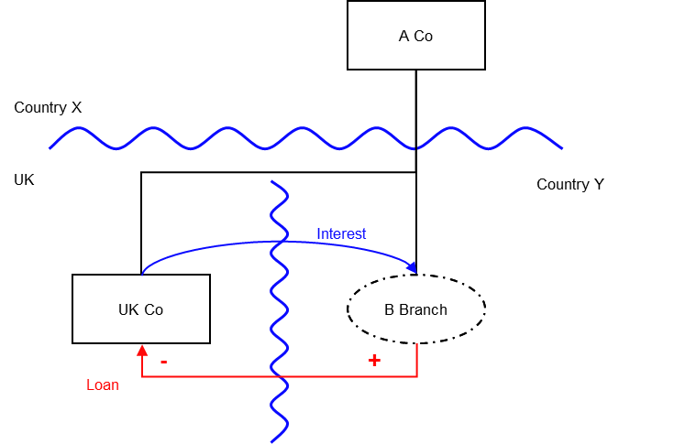

Background
- A Co is a company resident in Country X
- UK Co is a company resident in the UK, and A Co owns its entire shareholding
- A Co lends money to UK Co (the Loan) through a branch located in Country Y (B Branch)
- The UK allows a deduction for the interest payments made by UK Co
- Country X treats the Loan as attributable to a permanent establishment (B Branch) and exempts or excludes the interest receipts from taxation. This exemption or exclusion could be under Country X’s domestic law or as a result of the application of the Country X-Y treaty
- Country Y, however, does not tax the interest income because A Co is not treated as having a sufficient taxable presence in Country Y to constitute a permanent establishment under local law. The payment of interest therefore gives rise to an intra-group mismatch (a D/NI outcome).

Analysis - Applying the tests in s259HA TIOPA 2010
Do the interest payments from UK Co to the B Branch under the Loan satisfy the relevant conditions to fall within the scope of this chapter?

Condition A: Is a payment made under, or in connection with, an arrangement?
A transaction took place resulting in an interest payment directly from UK Co (payer) to A Co (payee). The interest payment is in relation to the Loan made from A Co to UK Co. The arrangement is therefore the Loan and the resulting interest payment.
Condition A is therefore satisfied.

Condition B: Is a payee a multinational company, according to the definition at s259HA(4)?
A Co is resident in Country X (the parent jurisdiction) for the purposes of a tax charged under the law of that territory, and it is also regarded as carrying on a business in another territory - Country Y (the PE jurisdiction) - through a permanent establishment (B Branch) in that territory.
Therefore A Co (the payee) is a multinational company and Condition B is satisfied.

Condition C: Is the payer or the multinational company within the charge to Corporation Tax for the payment period?
UK Co is the payer and within the charge to Corporation Tax.
Condition C is therefore satisfied.

Condition D: Is it reasonable to suppose that there would be a multinational payee deduction/non-inclusion mismatch in relation to the payment?
There will be a multinational payee deduction/non-inclusion mismatch if the relevant deduction exceeds the amount of ordinary income arising to each payee for a permitted taxable period, and all or part of that excess arises by reason of one or more of the payees being a multinational company.
Given the facts above, it is reasonable to suppose that UK will permit UK Co an interest deduction (the relevant deduction) under the Loan against its ordinary income.
It is also reasonable to suppose that no ordinary income will arise in either A Co or B Branch as:
- Country X treats the interest receipt as attributable to B Branch and exempts or excludes it from taxation. This could be under Country X’s domestic law or as a result of the application of the Country X-Y treaty.
- Country Y does not treat A Co is having a sufficient taxable presence in Country Y to constitute a permanent establishment under local law, and therefore does not extend its domestic law to tax that receipt.
Therefore the relevant interest deduction is in excess of the ordinary income recognised (nil). This excess arises from the fact that A Co is a multinational entity, as Country X gives up its taxing rights over this interest income for this reason. There is therefore a multinational payee deduction/non-inclusion mismatch of the full value of the interest payment.
Condition D is satisfied.

Condition E: Are the payer and the multinational company in the same control group, or is the arrangement a structured arrangement?
A Co and UK Co are in the same control group within the definition at s259NB, and therefore this condition is satisfied.
Condition E would also be met if A Co and UK Co were not in the same control group, but it was reasonable to suppose that this was a structured arrangement designed to secure a multinational company deduction/non-inclusion mismatch (even if it were also designed to secure a commercial or other objective).

Conclusion
All the conditions are satisfied to characterise the arrangement involving the payment of interest under the Loan as a multinational payee deduction/non-inclusion mismatch under Chapter 8, and the relevant counteractions therefore need to be considered after first considering the extent of the mismatch.

Extent of the mismatch
Section 259HB (2) states that the extent of the multinational payee deduction/non-inclusion mismatch is equal to the excess that arises by reason of the payee being a multinational company.
Section 259HB (2A) sets out how to arrive at the amount of the excess which arises by reason of the payee being a multinational company. A comparison is made to the position which would arise if A Co was not a multinational company, i.e. it did not have a branch in the PE jurisdiction, and all amounts of ordinary income arising by reason of the payment of interest were to arise to A Co in the parent jurisdiction.
In this case, if under the law of Country X the ordinary income would not result in a multinational payee deduction/non-inclusion mismatch, we can conclude that the whole of the mismatch arises by reason of A Co being a multinational company.

Counteraction
S259HC applies to reduce UK Co’s allowable deduction by the amount of the mismatch.
Where the deduction allowed to the payer exceeds the amount of ordinary income arising to the payee, and that excess arises by reason of one or more payees being multinational companies (regardless of any other reason), the extent of the mismatch is equal to that excess.

Return to contents

