INTM555240: Hybrids: Hybrid payee (Chapter 7): Example: Payment to reverse hybrid caught by CFC regime

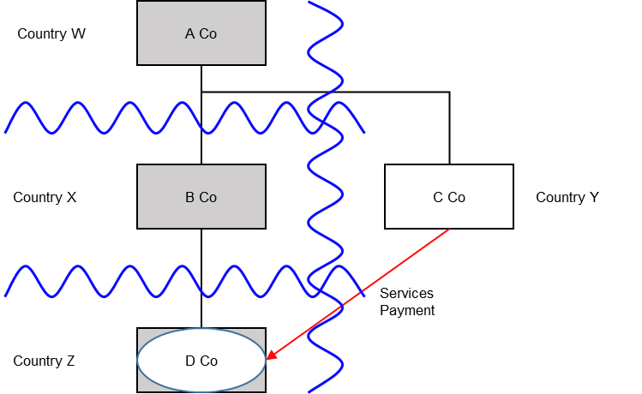

Background
- A Co is resident in Country W.
- A Co owns all shares in B Co, which is a company resident in Country X.
- A Co also owns all shares in C Co, which is a company resident in Country Y.
- B Co has established D Co under the laws of Country Z.
- D Co is regarded as transparent for tax purposes under the law of Country Z, such that Country Z treats the income and profits of D Co as attributable to B Co. However, D Co is regarded as a person for tax purposes under the law of Country X. It is therefore a reverse hybrid.
- D Co receives a services payment from C Co, but receives no other income.
- Country W’s CFC regime treats service income paid by a related party as attributable income and subjects such income, where all other relevant conditions are met (assumed to be satisfied here), to taxation. In this case, Country W’s CFC rules extend to the service income received by D Co, which it also regards as a person for tax purposes under the law of Country W.

Analysis - Applying the tests in s259GA TIOPA 2010
Do the interest payments satisfy the relevant conditions and thus fall within the scope of the hybrid payee deduction/non-inclusion mismatches rules?

Condition A: Are payments made under, or in connection with, an arrangement?
The services payment is a transfer of money from C Co to D Co and it is made under the arrangement, which includes the transaction involving the provision of the relevant services by D Co and the subsequent compensation.
Condition A is satisfied.

Condition B: Is the payee a hybrid entity?
D Co is the payee and is regarded as a person for tax purposes under the law of Country X.
Country Z treats D Co’s service payment receipts as the income of B Co for tax purposes.
Therefore D Co is a hybrid entity, and Condition B is met.

Condition C: Is the payer or investor within the charge to corporation tax for a relevant period or is the hybrid payee a limited liability partnership?
In the event the UK is in the position of Country Y, C Co is the payer and would be within the charge to corporation tax.
In the event the UK is in the position of Country X, B Co is the relevant investor and would be within the charge to corporation tax.
Condition C will therefore be satisfied under either of the above scenarios.
In the event that D Co is an LLP, Condition C will also be satisfied.

Condition D: Is it reasonable to suppose that there is, or will be, a hybrid payee deduction/non-inclusion mismatch in relation to the payment?
It is reasonable to suppose that Country Y will permit C Co a full deduction for the service payments (the relevant deduction). It is also reasonable to suppose that the payment received by D Co will not be included in its ordinary income. D Co is regarded as transparent under Country Z’s jurisdiction, but as a taxable entity (opaque) in Country X, so neither are likely to bring it into charge.
This mismatch arises as a consequence of the contrasting treatment of D Co for tax purposes in Country X and Country Z, so is directly attributable to the fact that D Co is a hybrid entity. If either:
- D Co had been recognised as an entity separate from B Co in Country Z, or
- D Co had not been recognised as an entity separate from B Co in Country X
then it is reasonable to suppose that either D Co (in the former situation) or B Co (in the latter situation) would have included the interest payments in its ordinary income. It therefore arises by reason of D Co (a payee) being a hybrid entity.
Condition D is satisfied.

Extent of the mismatch
The excess of the deduction over the amount not included in this example is equal to the total payment for services.
However, A Co subjects the service payments to a CFC charge (either a UK CFC charge or its foreign equivalent). Where there is a hybrid payee deduction/non-inclusion mismatch between the parties that are directly involved in the transaction, then recognition should be given to any CFC charge suffered on that same receipt per s259BD TIOPA 2010.
In this case, the receipt has been wholly brought into account by A Co in calculating D Co.’s chargeable profits for the purpose of that charge.
Having recognised the CFC charge, the result is that no hybrid payee deduction/non-inclusion mismatch remains. There is therefore no need to consider the remaining conditions.
Return to contents

