INTM555210: Hybrids: Hybrid Payee (Chapter 7): Example: Calculating the mismatch where there are multiple payees

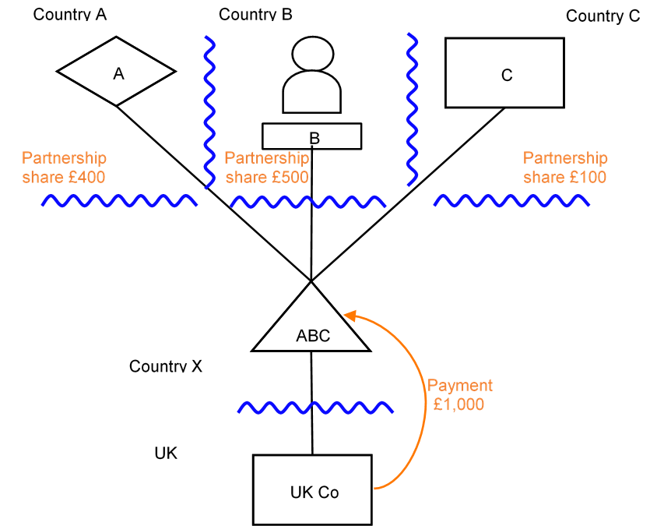

Background
- ABC Partnership is established in Country X, which regards it as transparent for tax purposes.
- ABC Partnership holds all the issued share capital in UK Co, which is resident in the UK and liable to tax there. The UK regards ABC Partnership as transparent for tax purposes.
- Trust A, which is established in Country A, is a partner in ABC Partnership. Country A regards ABC Partnership as transparent for tax purposes.
- Trust A is entitled to a 40% share of the profits etc. of ABC Partnership.
- Trust A is a tax exempt entity in Country A, and is not taxed on profits etc. derived from ABC Partnership.
- Individual B, who is resident in Country B, is a partner in ABC Partnership. Country B regards ABC Partnership as transparent for tax purposes.
- Individual B is entitled to a 50% share of the profits etc. of ABC Partnership.
- Individual B is liable to tax in Country B on the profits etc. derived from ABC Partnership.
- C Co, resident in Country C, is a partner in ABC Partnership. Country C regards ABC Partnership as opaque.
- C Co is entitled to a 10% share of the profits etc. of ABC Partnership.
- C Co is liable to tax on its own profits etc. in Country C, but is not liable to tax on profits etc. derived from ABC Partnership.
- UK Co makes a payment of interest to ABC Partnership in respect of a loan from ABC Partnership.

Analysis – Applying the tests in s259GA TIOPA 2010
Does the interest payment satisfy the relevant conditions and fall within the scope of the hybrid payee deduction/non-inclusion mismatch rules?

Condition A: Is a payment made under, or in connection with, an arrangement?
There is a payment of interest by UK Co to ABC Partnership under the loan agreement. The loan agreement is an arrangement.
Condition A is satisfied.

Condition B: Is a payee a hybrid entity?
ABC Partnership is a hybrid entity because Country C regards it as a person for tax purposes, whilst Countries A, B, X and Z treat some or all of its income or profits as belonging to another person/persons for tax purposes.
Condition B is satisfied.

Condition C: Is the payer or an investor within the charge to corporation tax for the relevant period, or is the hybrid payee a limited liability partnership?
The charge to corporation tax is the charge to corporation tax in the UK. UK Co, the payer, is liable to corporation tax in the UK.
Condition C is satisfied.

Condition D: Is it reasonable to suppose that there is, or will be, a hybrid payee deduction/non-inclusion mismatch in relation to the payment?
It is reasonable to suppose that UK Co will be permitted a deduction of £1,000 from income for the interest payment made (the relevant deduction) for a taxable period.
It is also reasonable to suppose that ABC Partnership does not have any ordinary income arising as a result of the payment, but that Individual B will have ordinary income of £500 representing 50% of the payment. Neither Trust A nor C Co have ordinary income arising as a result of the payment made by UK Co.
There is a hybrid payee deduction/non-inclusion mismatch under s259GB(1) if
- the relevant deduction exceeds the sum of ordinary income arising to each payee, and
- all or part of the excess arises by reason of one or more payees being hybrid.
In this case, the relevant deduction of £1,000 is matched by ordinary income of £500 arising to a payee (Individual B). The excess is therefore £500, representing the amounts attributable to Trust A and C Co by ABC Partnership.
The next step is to test whether that excess of £500 arises by reason of ABC Partnership being a hybrid entity. Part of the excess, the amount of £100 allocated to C Co, arises by reason of ABC Partnership being a hybrid entity. If Country C viewed ABC Partnership as transparent, then the amount allocated to C Co would be ordinary income of C Co and no mismatch would arise.
The £400 allocated to Trust A, does not arise by reason of ABC Partnership being a hybrid entity as both Country X and Country A view ABC Partnership as transparent.
However, the provisions at section 259GB(3) that may apply to treat part of the excess as arising by reason of ABC Partnership being a hybrid entity (to the extent that is not already the case).
Section 259GB(3) treats a relevant amount of the excess as arising by reason of one of the payees being a hybrid entity where -
- a payee is a hybrid entity, and
- that payee is not resident for tax purposes in any territory,
- that payee does not have ordinary income from a permanent establishment in any territory as a consequence of the payment, and
- income arising to that payee is not brought into account in computing profits for a CFC charge.
Applying these tests to the facts given –
- ABC Partnership is a payee
- ABC Partnership is a hybrid entity,
- there is no territory where ABC Partnership is resident for the purposes of a tax charged under the law of that territory,
- there is no territory where ABC Partnership has ordinary income arising from a permanent establishment and
- no income arises to ABC Partnership which is brought into account for the purposes of a CFC charge.

As the conditions for s259GB(3) are met the next step is to establish what the relevant amount of the excess is that needs to be considered. The relevant amount is computed as set out in s259GB(4), as amended by s259GB(4A) in partnership cases.
Section 259GB(4) defines the relevant amount of the excess as the lower of –
- the amount of the excess, and
- an amount equal to the amount of ordinary income that it is reasonable to suppose would arise to the payee if the payee were a company trading in the UK through a UK permanent establishment and the payment was received in connection with that trade.
This amount of ordinary income to be used in this comparison is amended by s259GB(4A) where –
- the payee is a partnership,
- a partner in the partnership is entitled to an amount of the payment, and
- the partnership would not be regarded as a hybrid entity under the laws of the territories where the partnership and the relevant partner are tax resident/established.
If these conditions are met, it is assumed that no ordinary income arises to the payee for the amount of the payment to which the partner is entitled when carrying out the comparison at s259GB(4).

In this example, the conditions under s259GB(4A) are met in relation to Trust A as -
- ABC Partnership is a payee and is a partnership
- Trust A is entitled to £400 of the payment of £1,000 received by ABC Partnership
- ABC Partnership would not be regarded as a hybrid entity if only the laws of Country A and Country X applied.
Consequently, for the purposes of the comparison at s259GB(4) it is assumed that no ordinary income arises to the ABC Partnership to the extent of the amount of £400 to which Trust A is entitled.

The conditions under s259GB(4A) are also met in relation to Individual B as -
- ABC Partnership is the payee and is a partnership
- Individual B is entitled to £500 of the payment of £1,000 received by ABC Partnership
- ABC Partnership would not be regarded as a hybrid entity if only the laws of Country B and Country X applied.
Consequently, for the purposes of the comparison at s259GB(4) it is assumed that no ordinary income arises to the ABC Partnership to the extent of the amount of £500 to which Individual B is entitled.

The conditions under s259GB(4A) are not met in relation to C Co as ABC Partnership is regarded as a hybrid entity if the laws of Country C and the UK are applied.

Returning to comparison under s259GB(4) the relevant amount of the excess is £100, that is, the lower of –
- £500, the excess, and
- £100, the amount of ordinary income that would arise to ABC Partnership in respect of the payment of £1,000, as reduced in respect of Trust A and Individual B under s259GB(4A).
As the relevant amount of the excess is the £100 already identified as a hybrid payee deduction / non-inclusion mismatch under s259GB(1)(b), there is no need to deem a further amount of the excess as arising by reason of the hybridity of ABC Partnership.
Condition D is satisfied, and the extent of the hybrid payee deduction/non-inclusion mismatch is £100.
For payments made after 10 June 2021 (the date of Royal Assent of the Finance Bill 2021), any excess arising to Qualifying Institutional Investors (“QIIs”) should not be taken account of for the purposes of calculating the hybrid payee deduction/non-inclusion mismatch if the conditions in s259GB(2A) and (2B) are met. This would be relevant in considering the excess attributable to Trust A, due to its tax-exempt status, which means it is likely to meet the definition of a QII provided in Paragraph 30A of Schedule 7AC TCGA 1992. However in this example, as the conditions were met in 259GB(4A) in relation to Trust A, Trust A’s potential classification as a QII will not impact on the quantum of the mismatch.

Condition E: Are the payer and the hybrid payee or investor in the same control group or is there a structured arrangement?
UK Co (the payer) and ABC Partnership (the hybrid payee) are in the same control group as ABC Partnership owns 100% of the issued shares in UK Co.
UK Co (the payer) and Individual B (an investor in the hybrid payee) are in the same control group as Individual B has a 50% investment in UK Co.
Condition E is satisfied.
There is no indication that this is a structured arrangement.

Conclusion
All the relevant conditions are satisfied to characterise the arrangement as a hybrid payee deduction/non-inclusion mismatch, so the relevant counteractions will need to be considered.

Counteraction

Counteraction where the UK is the payer jurisdiction

Primary Response
As the UK is the payer jurisdiction, s259GC applies to reduce the deduction available to UK Co by the extent of the hybrid payee deduction/non-inclusion mismatch.
In this instance, UK Co would be denied £100 of the £1,000 deduction.

Counteraction where the UK is in the position of Country B (investor jurisdiction)

Secondary Response
If the UK were in the position of Country B, counteraction under s259GD should be considered to the extent that the mismatch is not countered under s259GC (or a non-UK equivalent provision).
In this instance, s259GD cannot apply as Individual B includes their share of the income from the partnership as ordinary income, and in any case an individual is not within the charge to corporation tax.
[If Individual B were a company (B Co), it did not include its 50% share of partnership income in ordinary income and there was no primary response to counter this mismatch, s259GD(4) would apply to treat the hybrid payee deduction/non-inclusion mismatch as income of B Co].

Counteraction where a hybrid payee is a UK Limited Liability Partnership (LLP) (UK is Country X)

Tertiary response
If ABC Partnership were a UK LLP then, to the extent that the hybrid payee deduction / non-inclusion mismatch has not already been fully counteracted under s259GC or s259GD (or non-UK equivalent provisions), s259GE applies.
Under s259GE(4) an amount equal to the hybrid payee deduction / non-inclusion mismatch (that is, £100 of the deduction claimed by UK Co) is treated as income of ABC Partnership arising on the last day of the payment period. This income is brought within the charge to corporation tax on ABC Partnership under Chapter 8 of Part 10 of CTA 2009.
S259GE(8) dis-applies s863 ITTOIA 2005 (treatment of certain limited liability partnerships for income tax purposes) and s1273 CTA 2009 (treatment of certain limited liability partnerships for corporation tax purposes) in relation to ABC Partnership to the extent needed to give effect to the counteraction under s259GD.
Return to contents

