INTM554080: Hybrids: Transfers by UK permanent establishments of multinational companies (Chapter 6): Example

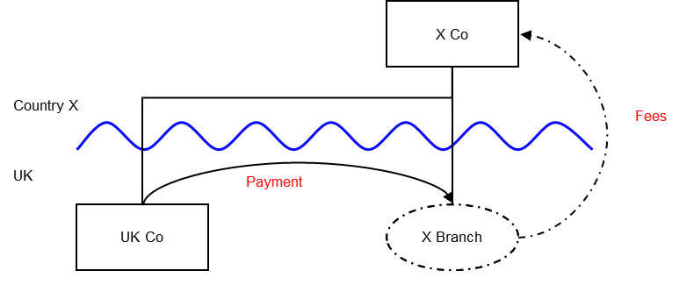

Background
- X Co is a non-UK resident company resident in Country X
- X Co has a UK permanent establishment, X Branch
- UK Co is a UK resident company that is entirely owned by X Co
- The profits of X Branch are taxable in the UK only, as Country X’s domestic legislation has an exemption for foreign branches
- UK Co pays fees to X Branch, which are brought into account as income of X Branch in the UK
- The accounts for X Branch show a deduction for the transfer of money or money’s worth to X Co
- That transfer to X Co is not brought into account when calculating the profits of X Co under its domestic tax regime.

Analysis - Applying the tests in s259FA TIOPA 2010
Does the deemed payment by X Branch to X Co satisfy the relevant conditions to fall within the scope of Chapter 6?

Condition A: Is the company a multinational company?
X Co is a company resident for tax purposes in a territory outside the UK, Country X. X Co carries on a business in the UK through a permanent establishment, X Branch, and is within the charge to corporation tax in the UK on the profits attributable to X Branch.
Condition A is satisfied in respect of X Co.

Condition B: Is there a PE deduction?
X Branch either makes a transfer of money or money’s worth to X Co, or is treated as doing so as it is in recognition of that transfer for which the deduction is permitted. X Branch may deduct that amount from its income when calculating its profits chargeable to corporation tax in the UK.
Condition B is satisfied.

Condition C: Is it reasonable to suppose that the circumstances giving rise to the PE deduction is not matched by an increase in taxable profits?
In this example it is reasonable to suppose that the circumstances giving rise to the PE deduction for X Branch in the UK do not result in any increase in the taxable income of X Co in Country X. This is because Country X’s legislation exempts income from foreign branches.
Condition C is satisfied.

Conclusion
As all the relevant conditions are satisfied the PE deduction is subject to a counteraction under Chapter 6.

Counteraction
There is no recognition of the transfer when calculating the profits of X Co. Therefore, the extent of the mismatch (termed the excessive PE deduction) is the entire amount of the PE deduction of X Branch.
The excessive PE deduction may be deducted only from dual inclusion income of X Co. In this example X Co does not have any dual inclusion income, so X Branch cannot deduct any of the excessive PE deduction. The unused deduction is carried forward to subsequent accounting periods, and may be used against dual inclusion income of those periods.

Return to contents

