INTM553260: Hybrids: Hybrid payer (Chapter 5): Example: Restricted deduction carried forward
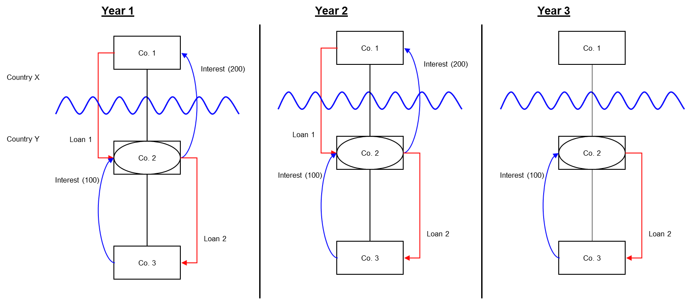

Background
This continues from the example at INTM553250. All the relevant conditions are satisfied to characterise the deductions claimed under Loan1 as ‘hybrid payer deduction/non-inclusion mismatches’ for each payment period, and the income from Loan2 satisfies the requirements to be considered dual inclusion.
Year 1:
- Co.1 and Co.2 have corresponding payment periods
- the interest payment of 200 under Loan 1 is the restricted deduction
- interest of 100 payable under Loan 2 and is included in the ordinary income of both Co.1 and Co.2.
Year 2:
- the mismatch arising under Loan 1 in Year 2 remains at 200
- 100 is payable under Loan 2 is included in the ordinary income of both Co.1 and Co.2.
Year 3:
- Loan 1 has ceased and there is no longer any mismatch
- 100 is payable under Loan 2 and is included in the ordinary income of both Co.1 and Co.2.

YEAR 1
Loan 1:
- 200 paid by Co.2 is a relevant deduction
- The mismatch amount is the excess of the relevant deduction (200) over the amount taxable as income by Co.1 (nil)
- The mismatch is 200.
Loan 2:
- 100 is payable by Co.2
- The receipt of 100 is included as taxable income by both Co.1 and Co.2 and therefore satisfies the definition of dual inclusion income.
Restricted deduction for Co.2 is 200 as this is the relevant deduction (200) capped at the level of the mismatch (also 200). As there is dual inclusion income of 100 we can allow 100 of the restricted deduction against the 100 dual inclusion income.
The restricted deduction carried forward to subsequent period becomes 100 and may be utilised against any future dual inclusion income.
Relevant Deduction | Mismatch amount | Restricted Deduction | Dual inclusion income | Restricted deduction c/f
200 | 200 | 200 | 100 | 100

YEAR 2
- Nothing changes in year 2 in respect of Co.2
- The restricted deduction brought forward is 100
- The dual inclusion income remains at 100
- The relevant deduction remains at 200
- The mismatch amount also remains at 200.
The restricted deduction of 200 is utilised against the dual inclusion income of 100 so that the restricted deduction carried forward is again 100 and is added to the restricted deduction brought forward from previous payment period.
The total restricted deduction carried forward becomes 200 and may be utilised against any future dual inclusion income.
Relevant Deduction | Restricted deduction b/f | Mismatch amount | Restricted Deduction | Dual inclusion income | Restricted deduction c/f
200 | 100 | 200 | 200 | 100 | 200

YEAR 3
- Loan 1 has ceased so there is no longer a hybrid payer/non-inclusion mismatch
- 100 payable under Loan 2 continues to satisfy the definition of dual income for Co.2.
Co.2 can utilise 100 of the 200 restricted deduction brought forward against that dual inclusion income.
The remaining 100 would continue to be carried forward to subsequent periods of the hybrid payer and may be utilised against any future dual inclusion income.
Relevant Deduction | Restricted deduction b/f | Mismatch amount | Restricted Deduction | Dual inclusion income | Restricted deduction c/f
nil | 200 | Nil | Nil | 100 | 100

If Loan 2 ceases in Year 4, so that there is no future dual inclusion income, then the 100 restricted deduction brought forward will no longer be relievable. As the corresponding receipt to Loan 1 will remain non-included, this does not create a double taxation issue, and is line with the underlying principles of the rule.
Return to contents

