INTM553250: Hybrids: Hybrid payer (Chapter 5): Example: Dual inclusion income – Debt passed down to subsidiary

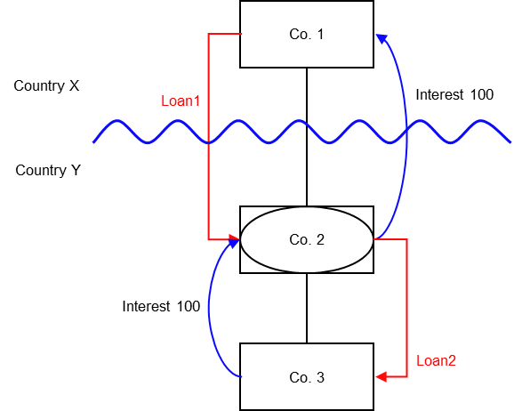

Background
- Co. 1 is a company resident in Country X
- Co. 2 is a company resident in Country Y
- Co. 1 owns the entire issued shareholding of Co. 2
- Co. 2 is treated as a distinct and separate person for tax purposes under the law of Country Y
- Co. 2 is a disregarded entity for tax purposes under the law of Country X
- Co. 3 is also resident in Country Y
- Co. 2 owns the entire issued shareholding of Co. 3
- Co. 3 is treated as a separate person for tax purposes under the law of both Country Y and Country X
- Co. 2 borrows money from Co.1 (Loan 1)
- Co. 2 is acting as a group treasury company and, as intended, this debt is passed down to Co. 3 at the same interest rate (Loan 2) to finance its ongoing operations
- Country Y allows a deduction for the interest payments made by Co. 3 under Loan 2
- Country Y allows a deduction for the interest payments made by Co. 2 under Loan 1
- Country Y subjects to tax the interest receipt to Co. 2 under Loan 2 at the full marginal rate
- Country X ignores the interest receipt to Co.1 under Loan 1 as it sees Co.2 as a branch of Co.1
- Country X subjects to tax the interest receipt from Loan 2 at the full marginal rate in Country X

Analysis - Applying the tests in s259EA TIOPA 2010
Do the interest deductions satisfy the relevant conditions to fall within the scope of Chapter 5?

Condition A: Are the payments made under, or in connection with, an arrangement?
A transaction took place resulting in a transfer of money (the interest payment) directly from Co. 2 (payer) to Co. 1 (payee), which represents a payment.
There is an arrangement (Loan 1), and the payment is made under that arrangement.
The arrangement seems to encompass both Loan 1 and Loan 2, as the background suggests a dependency such that in the absence of Loan 2 then Loan 1 would not have occurred. However, the relevant payment here is that under Loan 1, with the payment under Loan 2 to be considered separately.
Condition A is satisfied in respect of Loan 1.
Loan 2 may itself also be tested to see if it also satisfies the conditions as a separate arrangement. For Loan 2 interest is paid by Co. 3 (the payer) to Co. 2 (the payee), assuming that a realistic view of the background does not suggest that Co. 1 is the true payee.
Condition A is satisfied in respect of Loan 2.

Condition B: Is the payer a hybrid entity?
For Loan 1 Country Y regards Co. 2 (the payer) as a person, separate and distinct from Co. 1. Country X does not recognise Co. 2 as a person, but as an extension of Co. 1 and consequently treats the income and profits of Co. 2 as the income and profits of Co. 1.
Co. 2 meets the conditions to be a hybrid entity as set out at s259BE, so Condition B is satisfied.
For Loan 2 Country Y regards Co. 3 (the payer) as a person, separate and distinct from Co. 2. No other jurisdiction is involved.
Co. 3 does not meet the conditions to be a hybrid entity, so Condition B is not satisfied for Loan 2. There is no need to consider conditions C to E in respect of Loan 2.

Condition C: Is the hybrid payer or a payee within the charge to corporation tax for a relevant payment period?
The charge to corporation tax is the charge to corporation tax in the UK, so in this example condition C is satisfied if the UK is either Country X or Country Y.
If the UK is neither Country X nor Country Y then condition C cannot be satisfied for Loan 1. There would be no need to consider the remaining conditions.

Condition D: Is it reasonable to suppose that there would be a hybrid payer deduction/non-inclusion mismatch in relation to this payment?
Given the background above, it is reasonable to suppose that, if the hybrids legislation did not apply –
- Co. 2 will deduct an amount from income for the interest paid on Loan 1 (relevant deduction), and
- Co. 1 will not include the interest received from Co. 2 in its ordinary income.
This mismatch arises as a consequence of the different treatment of Co. 2 for tax purposes in Country X and Country Y, so is directly attributable to the fact that Co. 2 is a hybrid entity. If Co. 2 had been recognised as an entity separate from Co. 1 it is reasonable to suppose that the excess would have been lower, as Co. 1 would have included an amount within ordinary income.
Condition D is satisfied.

Condition E: Are the payer and payee in the same control group, or is there a structured arrangement?
Co. 1 and Co. 2 are in the same control group as defined at s259NA TIOPA 2010. That is enough to satisfy Condition E in this example, and you need not go on to consider whether Loan 1 is a structured arrangement.
In some cases you may want to consider if Loan 1 is a structured arrangement where one of the other tests in Condition E is not obviously met. In this example there is insufficient information regarding the terms of the loan to make that determination.

Conclusion
As all the relevant conditions are satisfied to characterise the arrangement as a ‘hybrid payer deduction/non-inclusion mismatch’ the relevant counteractions need to be considered.

Amount of the mismatch
If conditions A to E are satisfied, the deduction of interest by Co. 2 under Loan 1 is a hybrid payer deduction/non-inclusion mismatch, and you will have to consider how it is counteracted.
You will need to calculate the amount of the mismatch. You begin by quantifying the excess, which in this example is given by
- the amount of Co. 2’s deduction from income for the interest paid, less
- the amount of that interest payment that Co. 1 includes in its ordinary income
- You then consider how much of that amount arises because Co. 2 is a hybrid entity. In this example it is clear that the mismatch that arises by reason of Co. 2 being a hybrid entity is the full amount of the interest deduction.

Counteractions
The counteraction applicable will depend upon whether the UK is in the position of Country X and Country Y.

Counteraction where the UK is in the position of Country Y (payer jurisdiction)

Primary response
The primary counteraction is against the hybrid payer.
If the UK is Country Y (the payer jurisdiction) you should restrict the deduction claimed by Co. 2 for interest payments under Loan 1, per 259EC. The amount of the restricted deduction may be allowed as a deduction only from dual inclusion income of Co. 2, the hybrid payer. It is set first against dual inclusion income arising in the same accounting period, with unused amounts carried forward to use against dual inclusion income of later accounting periods.

Is there dual inclusion income?
Dual inclusion income is defined at s259EC(4). In this example there would be dual inclusion income only if the income
- was ordinary income of Co. 2 for corporation tax purposes, and
- was also ordinary income of Co. 1 for the purposes of any tax under the law of Country X.

As the interest receipt on Loan 2 is recognised, and subject to tax, in both Co.1 and Co.2, it meets the criteria for being dual inclusion income. As the receipt for interest on Loans 2 equals the interest deduction on Loan 1, Co. 2 will be permitted to retain the deduction to offset against that dual inclusion income.

Counteraction where the UK is in the position of Country X (payee jurisdiction)

Secondary response
The secondary counteraction is against the payee.
In the UK action to counter the mismatch may be taken against the payee only if it is reasonable to suppose that provisions equivalent to s259EC in the payer jurisdiction
- do not apply to counteract the mismatch, or
- do apply but do not fully counteract the mismatch.
In this example, the dual inclusion income established above offsets the hybrid payer deduction/non-inclusion mismatch completely and therefore there is no counteraction.
Return to contents

