INTM553240: Hybrids: Hybrid payer (Chapter 5): Example: Dual inclusion income – Debt to fund 3rd party acquisition of business with operating income
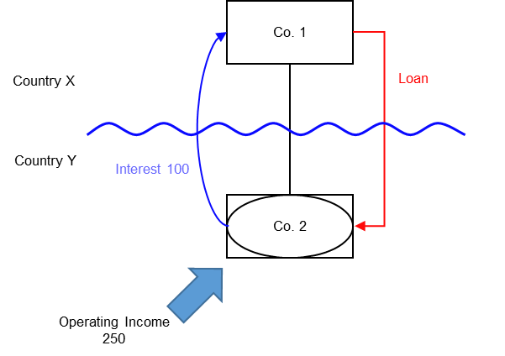

Background
- Co. 1 is a company resident in Country X
- Co. 2 is a company resident in Country Y
- Co. 1 owns the entire issued shareholding in Co. 2
- Co. 2 is treated as a distinct and separate person for tax purposes in Country Y
- Co. 2 is a disregarded entity for tax purposes in Country X
- Co. 2 borrows money from Co.1 (the ‘Loan’) to acquire a business from a 3rd party
- Country Y allows a deduction for the interest payments made by Co. 2
- Country X ignores the receipt to Co.1 as it recognises Co.2 as a branch of Co.1 for tax purposes
- Co. 2 has operating income of 250 during the relevant period only from the new business it used the funds to acquire
- The operating income of 250 is subject to tax at the full marginal rate in Country Y
- Co. 2 incurs no expenditure in earning this income.
Note: If Co. 2 did incur expenditure in earning this income, as would be expected, that expenditure should be considered under the hybrid entity double deduction rules to determine the extent that it gives rise to a hybrid entity double deduction amount.
This operating income of 250 is also recognised by Co. 1 and subject to tax at the full marginal rate in Country X.

Analysis - Applying the tests in s259EA TIOPA 2010
Do the interest deductions satisfy the relevant conditions for each payment period to fall within the scope of the hybrid payer deduction/non-inclusion mismatches rules?

Condition A: Are the payments made under, or in connection with, an arrangement?
A transaction took place resulting in a transfer of money (the interest payment) directly from Co. 2 (payer) to Co. 1 (payee), which represents a payment.
There is an arrangement (the Loan), and the payment is made under that arrangement.
Note that the purpose of the Loan – to acquire a business – is not part of the same arrangement. Co. 2’s acquisition of the business together with its operation to return a stream of operating income, is not part of the Loan arrangement but is derived from the carrying on an unrelated business. The Loan allowed Co. 2 to benefit from that opportunity, but was not determinate in the generation of those funds.
This should be contrasted with the example at INTM553250 (Dual inclusion income – Debt passed down to subsidiary) where the loan was determinate in providing that future income stream without material further action.
Condition A is satisfied in respect of the Loan.

Condition B: Is the payer a hybrid entity?
Country Y regards Co. 2 (the payer) as a person, separate and distinct from Co. 1. Country X does not recognise Co. 2 as a person, but as an extension of Co. 1 and consequently treats the income and profits of Co. 2 as the income and profits of Co. 1.
Co. 2 meets the conditions to be a hybrid entity as set out at s259BE TIOPA 2010, so Condition B is satisfied.

Condition C: Is the hybrid payer or a payee within the charge to corporation tax for a relevant payment period?
The charge to corporation tax is the charge to corporation tax in the UK, so in this example Condition C is satisfied if the UK is either Country X or Country Y.
If the UK is neither Country X nor Country Y then Condition C cannot be satisfied for the Loan. There would be no need to consider the remaining conditions. In these circumstances you should consider whether the imported mismatch rules in Chapter 11 apply.

Condition D: Is it reasonable to suppose that there would be a hybrid payer deduction/non-inclusion mismatch in relation to this payment?
Given the background above, it is reasonable to suppose that, if the hybrids legislation did not apply –
Co. 2 will deduct an amount from income for the interest paid on the Loan (relevant deduction), and
Co. 1 will not include the interest received from Co. 2 in its ordinary income.
This mismatch arises as a consequence of the different treatment of Co. 2 for tax purposes in Country X and Country Y, so is directly attributable to the fact that Co. 2 is a hybrid entity. If Co. 2 had been recognised as an entity separate from Co. 1 it is reasonable to suppose that the excess would have been lower, as Co. 1 would have included an amount within ordinary income.
Condition D is satisfied.

Condition E: Are the payer and payee in the same control group, or is there a structured arrangement?
Co. 1 and Co. 2 are in the same control group as defined at s259NA TIOPA 2010. That is enough to satisfy Condition E in this example, and you need not go on to consider whether the Loan is also a structured arrangement.
In some cases you may want to consider if the Loan is a structured arrangement where it is not clear whether any of the control tests are met. In this example there is insufficient information regarding the terms of the Loan to make that determination.

Conclusion
As all the relevant conditions are satisfied to characterise the arrangement as a ‘hybrid payer deduction/non-inclusion mismatch’ the relevant counteractions need to be considered.

Amount of the mismatch
If conditions A to E are satisfied, the deduction of interest by Co. 2 under the Loan is a hybrid payer deduction/non-inclusion mismatch, and you will have to consider how it is counteracted in the UK.
You will need to calculate the amount of the mismatch. You begin by quantifying the excess, which in this example is given by
- the amount of Co. 2’s deduction from income for the interest paid, less
- the amount of that interest payment that Co. 1 includes in its ordinary income.
You then consider how much of that amount arises because Co. 2 is a hybrid entity. In this example it is clear that the mismatch that arises by reason of Co. 2 being a hybrid entity is the full amount of the interest deduction.

Counteractions
The counteraction applicable will depend upon whether the UK is in the position of Country X and Country Y.

Counteraction where the UK is in the position of Country Y (payer jurisdiction)

Primary response
The primary counteraction is against the hybrid payer.
If the UK is Country Y (the payer jurisdiction) you should restrict the deduction claimed by Co. 2 for interest payments under the Loan, per s259EC. The amount of the restricted deduction may be allowed as a deduction only from dual inclusion income of Co. 2, the hybrid payer. It is set first against dual inclusion income arising in the same accounting period, with unused amounts carried forward to use against dual inclusion income of later accounting periods.

Is there dual inclusion income?
Dual inclusion income is defined at s259EC(4). In this example there would be dual inclusion income only if the income
- was ordinary income of Co. 2 for corporation tax purposes, and
- was ordinary income of Co. 1 for the purposes of any tax under the law of Country X.

In this example there is relevant dual inclusion income of 250 for the period, so all of Co. 2’s interest deduction of 100 can be set against that. Counteraction where the UK is in the position of Country X (payee jurisdiction)

Secondary response
The secondary counteraction is against the payee.
In the UK action to counter the mismatch may be taken against the payee only if it is reasonable to suppose that provisions equivalent to s259EC in the payer jurisdiction -
- do not apply to counteract the mismatch, or
- do apply but do not fully counteract the mismatch.
In this example, if the UK is Country X and you conclude that it is reasonable to suppose that Country Y has no provisions that apply to counteract the mismatch on the hybrid payer, then you apply s259ED to treat the entire mismatch as income of the payee, Co. 1.
If you conclude that it is reasonable to suppose that Country Y has provisions that apply but that they do not fully counteract the mismatch, then you apply s259ED to treat part of the mismatch as income of the payee, to ensure the hybrid payer deduction/non-inclusion mismatch is fully counteracted (to the extent it is not offset against dual inclusion income).
The amount treated as income of the payee is the amount of the mismatch less any dual inclusion income. In this example, the amount of the mismatch is 100 and the dual inclusion income is 0, so 100 will be treated as income of Co. 1.
Return to contents

