INTM553230: Hybrids: Hybrid payer (Chapter 5): Example: Dual inclusion income - Operating income in subsidiary of disregarded entity

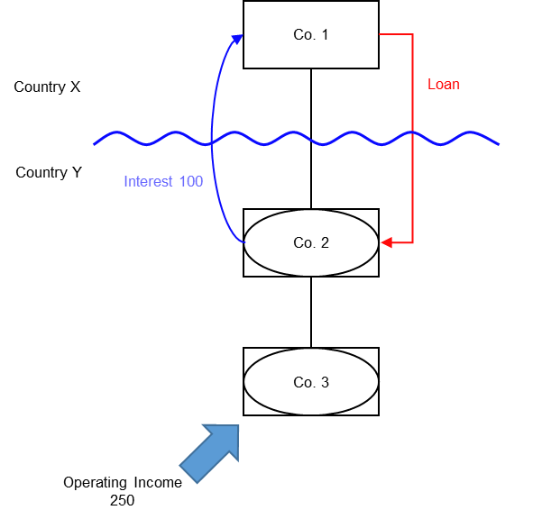

Background
- Co. 1 is a company resident in Country X
- Co. 2 is a company resident in Country Y
- Co. 1 owns the entire shareholding of Co. 2
- Co. 2 is treated as a distinct and separate person for tax purposes under the law of Country Y
- Co. 2 is a disregarded entity for tax purposes under the law of Country X
- Co. 3 is also resident in Country Y
- Co. 2 owns the entire shareholding of Co. 3
- Co. 3 is also treated as a distinct and separate person for tax purposes under the law of Country Y
- Co. 3 is also a disregarded entity for tax purposes under the law of Country X
- Co. 2 borrows money from Co. 1 to finance its ongoing operations in Country Y (the ‘Loan’)
- Country Y allows a deduction for the interest payments made by Co. 2
- Country X ignores the interest receipt to Co. 1 as it regards Co. 2 as a branch of Co. 1.
- Co. 2 has no operating income during the relevant period but recognises interest expenses of 100 arising on the Loan
- Co. 3 has operating income of 250 in the relevant period, subject to tax at the full marginal rate in Country Y. For the purposes of this example Co. 3 incurs no expenditure in earning this income
- This operating income of 250 is also recognised by Co. 1 and subject to tax at the full marginal rate in Country X
- Co. 2 receives regular distributions from Co. 3, but these are not subject to tax under the domestic legislation of either Country X or Country Y

Analysis - Applying the tests in s259EA TIOPA 2010
Do the interest deductions satisfy the relevant conditions to fall within the scope of Chapter 5?

Condition A: Are the payments made under, or in connection with, an arrangement?
A transaction took place resulting in a transfer of money (the interest payment) directly from Co. 2 (payer) to Co. 1 (payee), which represents a payment.
There is an arrangement (Loan), and the payment is made under that arrangement.
Condition A is satisfied.

Condition B: Is the payer a hybrid entity?
Co. 2 is the payer.
Country Y regards Co. 2 as a person, separate and distinct from Co. 1. Country X does not recognise Co. 2 as a person, but as a branch of Co. 1 and consequently treats the income and profits of Co. 2 as the income and profits of Co. 1.
Co. 2 meets the conditions to be a hybrid entity as set out at s259BE, so Condition B is satisfied.

Condition C: Is the hybrid payer or a payee within the charge to corporation tax for a relevant payment period?
The charge to corporation tax is the charge to corporation tax in the UK. In this example condition C is satisfied if the UK is either Country X or Country Y.
If the UK is neither Country X nor Country Y then condition C cannot be satisfied. There would be no need to consider the remaining conditions. In these circumstances you should consider whether the imported mismatch rules in Chapter 11 apply.

Condition D: Is it reasonable to suppose that there would be a hybrid payer deduction/non-inclusion mismatch in relation to this payment?
Given the background above, it is reasonable to suppose that, if the hybrids legislation did not apply –
- Co. 2 will deduct an amount from income for the interest paid on the Loan (relevant deduction), and
- Co. 1 will not include the interest received from Co. 2 in its ordinary income.
This mismatch arises as a consequence of the different treatment of Co. 2 for tax purposes in Country X and Country Y, so is directly attributable to the fact that Co. 2 is a hybrid entity. If Co. 2 had been recognised as an entity separate from Co. 1 it is reasonable to suppose that the excess would have been lower, as Co. 1 would have included an amount within ordinary income.
Condition D is satisfied.

Condition E: Are the payer and payee in the same control group, or is there a structured arrangement?
Co. 1 and Co. 2 are in the same control group as defined at s259NA. That is sufficient to satisfy condition E in this example, and you need not go on to consider whether the Loan is also a structured arrangement.
In some cases you may want to consider if the Loan is a structured arrangement where it is not clear whether any of the control tests are met. In this example, there is insufficient information regarding the terms of the loan to make that determination.

Conclusion
As all the relevant conditions are satisfied to characterise the arrangement as a ‘hybrid payer deduction/non-inclusion mismatch’ the relevant counteractions need to be considered.

Amount of the mismatch
You will also need to calculate the amount of the mismatch. You begin by quantifying the excess, which in this example is given by
- the amount of Co. 2’s deduction from income for the interest paid, less
- the amount of that interest payment that Co. 1 includes in its ordinary income
- You then consider how much of that amount arises because Co. 2 is a hybrid entity. In this example it is clear that the mismatch that arises by reason of Co. 2 being a hybrid entity is the full amount of the interest deduction.

Counteractions
The counteraction applicable will depend upon whether the UK is in the position of Country X or Country Y.

Counteraction where the UK is in the position of Country Y (payer jurisdiction)

Primary response
The primary counteraction is against the hybrid payer.
If the UK is Country Y (the payer jurisdiction) you should restrict the deduction claimed by Co. 2 for interest payments under the loan, per S259EC. The amount of the restricted deduction may be allowed as a deduction only from dual inclusion income of Co. 2, the hybrid payer. It is set first against dual inclusion income arising in the same accounting period, with unused amounts carried forward to use against dual inclusion income of later accounting periods.

Is there dual inclusion income?
Dual inclusion income is defined at s259EC(4). In this example there would be dual inclusion income only if the income -
- was ordinary income of Co. 2 for corporation tax purposes, and
- was also ordinary income of Co. 1 for the purposes of any tax under the law of Country X.
Although the operating income is included as ordinary income of Co. 1, Co. 3 is the other party including it as ordinary income, rather than Co 2. In this example therefore there is no relevant dual inclusion income for the period, so all of Co. 2’s interest deduction of 100 is a restricted deduction, and no relief is due.

Counteraction where the UK is in the position of Country X (payee jurisdiction)

Secondary response
The secondary counteraction is applied to the payee.
In the UK, action to counter the mismatch may be taken against the payee only if it is reasonable to suppose that provisions equivalent to s259EC in the payer jurisdiction
- do not apply to counteract the mismatch, or
- do apply but do not fully counteract the mismatch.
In this example, if the UK is Country X and it is reasonable to suppose that Country Y has no provisions that apply to the hybrid payer to counteract the mismatch, then s259ED applies to treat the entire mismatch as the income of the payee, Co. 1.
If it is reasonable to suppose that Country Y has provisions that apply but that they do not fully counteract the mismatch, s259ED applies to treat the part of the mismatch that has not been counteracted as the income of the payee (to ensure that the hybrid payer deduction/non-inclusion mismatch is fully counteracted).
The amount treated as income of the payee is the amount of the mismatch less any dual inclusion income. In this example, there is no dual inclusion income and the amount of the mismatch is 100, to be treated as the income of Co. 1.
Return to contents

