INTM553220: Hybrids: Hybrid payer (Chapter 5): Example: Dual inclusion income – Debt to fund acquisition of company with operating income
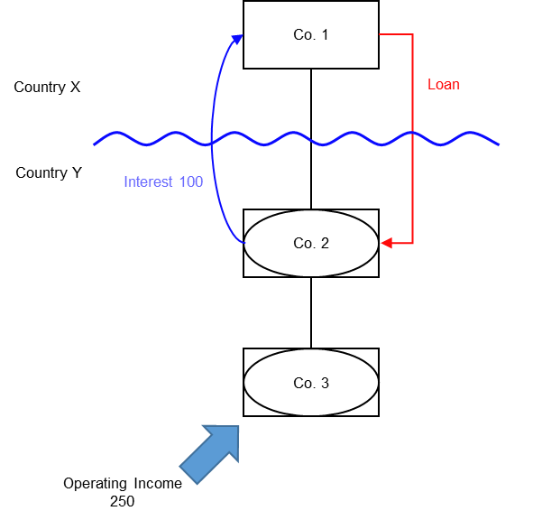

Background
- Co. 1 is a company resident in Country X
- Co. 2 is a company resident in Country Y
- Co. 1 owns the entire issued shareholding of Co. 2
- Co. 2 is treated as a distinct and separate person for tax purposes under the law of Country Y
- Co. 2 is a disregarded entity for tax purposes under the law of Country X
- Co. 2 borrows money from Co.1 (the ‘Loan’) to acquire the entire shareholding in Co. 3 from a 3rd party
- Co. 3 is also resident in Country Y
- Co. 3 is treated as a distinct and separate person for tax purposes in Country Y
- Co. 3 is a disregarded entity for tax purposes under the law of Country X
- Co. 2 has no operating income during the relevant period
- Co. 3 has operating income of 250 in the relevant period, which is subject to tax at the full marginal rate in Country Y
- Co. 2 receives regular distributions from Co. 3, but these are not subject to tax under the domestic legislation of either Country X or Country Y
- Country Y allows a deduction for the interest payments made by Co. 2.
- Country X ignores the receipt to Co.1 as it sees Co.2 as a branch of Co.1
- Country X recognises Co. 3’s operating income of 250 as income of Co. 1, which is subject to tax at the full marginal rate in Country X
During the relevant period Co. 2 recognises interest expenses of 100 arising from the Loan.

Analysis - Applying the tests in s259EA TIOPA 2010
Do the interest deductions satisfy the relevant conditions to fall within the scope of Chapter 5?

Condition A: Are the payments made under, or in connection with, an arrangement?
A transaction took place resulting in a transfer of money (the interest payment) directly from Co. 2 (payer) to Co. 1 (payee), which represents a payment.
There is an arrangement (the Loan), and the payment is made under that arrangement.
Note that the purpose of the Loan – to acquire Co.3 – is not part of the arrangement. Co. 2’s acquisition of Co. 3, together with the stream of operating income from Co. 3 is not part of the Loan arrangement.
Condition A is satisfied in respect of the Loan.

Condition B: Is the payer a hybrid entity?
Country Y regards Co. 2 (the payer) as a person, separate and distinct from Co. 1. Country X does not recognise Co. 2 as a person, but as an extension of Co. 1, and consequently treats the income and profits of Co. 2 as the income and profits of Co. 1.
Co. 2 meets the conditions to be a hybrid entity as set out at s259BE, so Condition B is satisfied.

Condition C: Is the hybrid payer or a payee within the charge to corporation tax for a relevant payment period?
The charge to corporation tax is the charge to corporation tax in the UK, so in this example Condition C is satisfied if the UK is either Country X or Country Y.
If the UK is neither Country X nor Country Y then Condition C cannot be satisfied for the Loan. There would be no need to consider the remaining conditions. In these circumstances you should consider whether the imported mismatch rules in Chapter 11 apply.

Condition D: Is it reasonable to suppose that there would be a hybrid payer deduction/non-inclusion mismatch in relation to this payment?
Given the background above, it is reasonable to suppose that, if the hybrids legislation did not apply –
- Co. 2 will deduct an amount from income for the interest paid on the Loan (relevant deduction), and
- Co. 1 will not include the interest received from Co. 2 in its ordinary income
This mismatch arises as a consequence of the different treatment of Co. 2 for tax purposes in Country X and Country Y, so is directly attributable to the fact that Co. 2 is a hybrid entity. If Co. 2 had been recognised as an entity separate from Co. 1 it is reasonable to suppose that the excess would have been lower, as Co. 1 would have included an amount within ordinary income.
Condition D is satisfied.

Condition E: Are the payer and payee in the same control group, or is there a structured arrangement?
Co. 1 and Co. 2 are in the same control group as defined at s259NA. That is enough to satisfy Condition E in this example, and you need not go on to consider whether the Loan is also a structured arrangement.
In some cases you may want to consider if the Loan is a structured arrangement where it is not clear whether any of the control tests are met. In this example there is insufficient information regarding the terms of the Loan to make that determination.

Conclusion
As all the relevant conditions are satisfied to characterise the arrangement as a ‘hybrid payer deduction/non-inclusion mismatch’ the relevant counteractions need to be considered.

Amount of the mismatch
If conditions A to E are satisfied, the deduction of interest by Co. 2 under the Loan is a hybrid payer deduction/non-inclusion mismatch, and you will have to consider how it is counteracted in the UK.
You will need to calculate the amount of the mismatch. You begin by quantifying the excess, which in this example is given by -
- the amount of Co. 2’s deduction from income for the interest paid, less
- the amount of that interest payment that Co. 1 includes in its ordinary income
You then consider how much of that amount arises because Co. 2 is a hybrid entity. In this example it is clear that the mismatch that arises by reason of Co. 2 being a hybrid entity is the full amount of the interest deduction.

Counteractions
The counteraction applicable will depend upon whether the UK is in the position of Country X and Country Y.

Counteraction where the UK is in the position of Country Y (payer jurisdiction)

Primary response
The primary counteraction is against the hybrid payer.
If the UK is Country Y (the payer jurisdiction) you should restrict the deduction claimed by Co. 2 for interest payments under the Loan, per s259EC. The amount of the restricted deduction may be allowed as a deduction only from dual inclusion income of Co. 2, the hybrid payer. It is set first against dual inclusion income arising in the same accounting period, with unused amounts carried forward to use against dual inclusion income of later accounting periods.

Is there dual inclusion income?
Dual inclusion income is defined at s259EC(4). In this example there would be dual inclusion income only if the income -
- was ordinary income of Co. 2 for corporation tax purposes, and
- was ordinary income of Co. 1 for the purposes of any tax under the law of Country X
The operating income is income of Co. 3 and not Co. 2 and would not meet the requirements for dual inclusion income.
In this example, therefore, there is no relevant dual inclusion income for the period, and so all of Co. 2’s interest deduction of 100 in respect of the Loan is a restricted deduction.

Counteraction where the UK is in the position of Country X (payee jurisdiction)

Secondary response
The secondary counteraction is against the payee.
In the UK action to counter the mismatch may be taken against the payee only if it is reasonable to suppose that provisions equivalent to s259EC in the payer jurisdiction
- do not apply to counteract the mismatch, or
- do apply but do not fully counteract the mismatch.
In this example, if the UK is Country X and it is reasonable to suppose that Country Y has no provisions that apply to counteract the mismatch on the hybrid payer, then you apply s259ED to treat the entire mismatch as income of the payee, Co. 1.
If it is reasonable to suppose that Country Y has provisions that apply, but that they do not fully counteract the mismatch, then you apply s259ED to treat part of the mismatch as income of the payee, to ensure the hybrid payer deduction/non-inclusion mismatch is fully counteracted (to the extent it is not offset against dual inclusion income).
The amount treated as income of the payee is the amount of the mismatch less any dual inclusion income. In this example, the amount of the mismatch is 100 and the dual inclusion income is 0, so 100 will be treated as income of Co. 1.
Return to contents

