INTM553200: Hybrids: Hybrid payer (Chapter 5): Example: Restricted deduction for interest payment

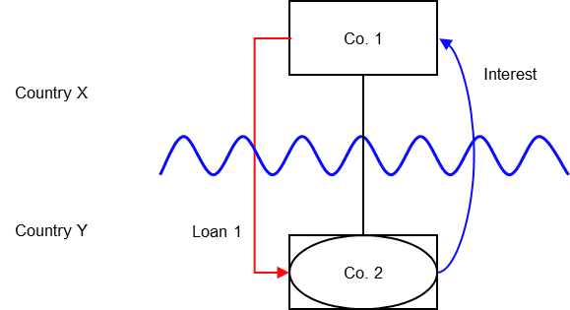

Background
- Co. 1 is resident in Country X
- Co. 1 establishes Co. 2, which is resident in Country Y
- Country Y treats Co. 2 as a distinct and separate person for tax purpose
- Country X considers Co. 2 to be a branch of Co.1, not a separate entity
- Co. 2 borrows money from Co. 1 on arm’s length terms (‘Loan 1’)
- Country Y allows Co. 2 a deduction for interest payments made under the loan
- Country X does not tax the interest receipt as it considers the loan is an intra-company transaction.

Analysis - Applying the tests in s259EA TIOPA2010
Do the interest deductions satisfy the relevant conditions to fall within the scope of Chapter 5?

Condition A: Are the payments made under, or in connection with, an arrangement?
A transaction took place resulting in a transfer of money (the interest payment) directly from Co. 2 (payer) to Co. 1 (payee), which represents a payment.
There is an arrangement (Loan 1), and the payment is made under that arrangement.
Condition A is satisfied.

Condition B: Is the payer a hybrid entity?
Country Y regards Co. 2 as a person, separate and distinct from Co. 1 under its domestic tax law. Country X treats the income and profits of Co. 2 as the income or profits of Co. 1.
Co. 2 meets the conditions to be a hybrid entity as set out at s259BE, so Condition B is satisfied.

Condition C: Is the hybrid payer or a payee within the charge to corporation tax for a relevant payment period?
The charge to corporation tax is the charge to corporation tax in the UK, so in this example condition C can be satisfied only if the UK is either Country X or Country Y.
If the UK is neither Country X nor Country Y, in this example then condition C cannot be satisfied. It is not necessary to consider the remaining conditions. In these circumstances you should consider whether the imported mismatch rules in Chapter 11 (s259K – s259KC) apply.

Condition D: Is it reasonable to suppose that there would be a hybrid payer deduction/non-inclusion mismatch in relation to this payment?
Given the information provided, it is reasonable to suppose that, if the hybrids legislation did not apply –
- Co. 2 will deduct an amount from income for the interest paid on Loan 1 (relevant deduction), and
- Co. 1 will not include the interest received from Co. 2 in its ordinary income.
This mismatch arises as a consequence of the different treatment of Co. 2 for tax purposes in Country X and Country Y, so is directly attributable to the fact that Co. 2 is a hybrid entity. If Co. 2 had been recognised as an entity separate from Co. 1 it is reasonable to suppose that the excess would have been lower, as Co. 1 would have included an amount within ordinary income.
Condition D is satisfied.

Condition E: Are the payer and payee in the same control group, or is there a structured arrangement?
Co. 1 and Co. 2 are in the same control group as defined in s259NA. This is sufficient to satisfy Condition E in this example, and you need not go on to consider whether Loan 1 is also a structured arrangement.
In some cases you may want to consider if Loan 1 is a structured arrangement where it is not clear whether any of the control tests are met. In this example, there is insufficient information regarding the terms of the loan to make that determination.

Conclusion
As all the relevant conditions are satisfied to characterise the arrangement as a hybrid payer deduction/non-inclusion mismatch the relevant counteractions need to be considered.
Amount of the mismatch
If conditions A to E are satisfied, the payment of interest by Co. 2 under Loan 1 is a hybrid payer deduction/non-inclusion mismatch, and you will have to consider how it is counteracted.
You will also need to calculate the amount of the mismatch. You begin by quantifying the excess, which in this example is given by
- the amount of Co. 2’s deduction from income for the interest paid, less
- the amount of that interest payment that Co. 1 includes in its ordinary income
- You then consider how much of that amount arises because Co. 2 is a hybrid entity. In this example, if Co. 2 were not a hybrid entity, a mismatch would not arise. The extent of the mismatch arising by reason of Co. 2 being a hybrid entity is the full amount of the interest deduction.

Counteraction
The counteraction applicable will depend upon whether the UK is in the position of Country X and Country Y.
Counteraction where the UK is in the position of Country Y (payer jurisdiction)

Primary Response
The primary counteraction is against the hybrid payer.
If the UK is Country Y (the payer jurisdiction) you should restrict the deduction claimed by Co. 2 for interest deductions under Loan 1, per s259EC.
The amount of the restricted deduction may be allowed as a deduction only from dual inclusion income of Co. 2, the hybrid payer. It is set first against dual inclusion income arising in the same accounting period, with unused amounts carried forward to use against dual inclusion income of later accounting periods. In this example there is insufficient information to determine whether there is any dual inclusion income.
Counteraction where the UK is in the position of Country X (payee jurisdiction)

Secondary Response
Action to counter the mismatch may be taken against the payee only if it is reasonable to suppose that provisions equivalent to s259EC in the payer jurisdiction
- do not apply to counteract the mismatch, or
- do apply but do not fully counteract the mismatch.
In this example, if the UK is Country X and you conclude that Country Y has no provisions that apply to counteract the mismatch on the hybrid payer, then you would apply s259ED to treat the entire mismatch as income of the payee.
If you conclude that Country Y has provisions that apply but they do not fully counteract the mismatch then s259ED applies to treat part of the mismatch as income of the payee, to ensure the hybrid payer deduction/non-inclusion mismatch is fully counteracted (to the extent it is not offset against dual inclusion income).
Return to contents

