INTM552550: Hybrids: Hybrid transfers (Chapter 4): Examples: Stock loan - UK financial trader borrows shares that are hybrid financial instruments
The facts in this example are essentially the same as in INTM552540, except that the dividend in respect of the I Co shares is taxable in Country L because the shares are hybrid financial instruments.
The stock loan provides a way round the Country L hybrid provisions equivalent to Chapter 3 of the UK provisions. Consequently, the financial trader exclusion cannot apply in the UK, even if the transactions between U Co and L Co are not a structured arrangement.
U Co is a financial trader. U Co and L Co are members of the same worldwide group and therefore related. I Co and L Co are also related parties. Country L exempts dividends, except where they are tax-deductible to the issuer of the shares. But those rules do not catch substitute payments in respect of such a dividend. If the dividend payment had been made directly to L Co, then Country L’s hybrid mismatch rules would have taxed L Co on the dividend.
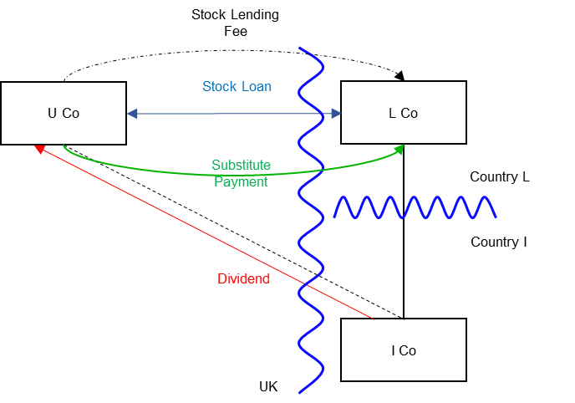

Background
- U Co is resident in the UK. It is a financial trader and all transactions in this arrangement are within its financial trade.

- L Co is incorporated and resident in Country L.

- L Co holds shares in I Co.

- I Co is incorporated and resident in Country I.

- U Co and L Co are in the same worldwide group and are related parties.

- L Co and I Co are related parties for the purposes of the tax laws of Country L.

- L Co enters into a stock lending transaction with U Co. Under the terms of the stock lending agreement, L Co transfers the I Co shares it holds to U Co. The agreement provides that U Co will transfer the same or similar shares to L Co 24 days later. U Co provides collateral (cash or high grade securities). L Co will return the collateral to U Co, along with any return made on the securities or interest due on cash, when the I Co shares are returned to L Co.

- The stock lending transaction might, in other circumstances, facilitate U Co selling these borrowed shares short or making a stock loan or repo to a customer who might intend to sell short. However, in this instance, U Co holds on to the shares until they are due for redelivery to L Co.

- U Co pays a stock lending fee to L Co.

- During the 24 day period the record date falls for the I Co shares. Under Country I tax law, the dividend payment is tax-deductible for I Co.

- U Co holds the stock on the record date and receives the actual dividend in respect of the I Co shares. Under the terms of the stock lending agreement U Co is required to make a substitute payment (manufactured dividend) to L Co. The amount of the substitute payment is related to the amount of the dividend received for the I Co shares but not necessarily the same.

- In the UK U Co takes the dividend received into account in computing the taxable profits of its financial trade. The substitute payment made by U Co is also taken into account in computing the taxable profits of its financial trade.

- Under the tax laws of Country L, L Co is not normally taxed on dividends. However, Country L has provisions equivalent to Chapter 3 of Part 6A. Under those provisions the I Co shares are hybrid financial instruments as dividends in respect of them are tax-deductible in Country I, but are not taxable income in Country L. Under those rules a dividend received from I Co is treated as taxable income of L Co.

- Under Country L tax law, substitute payments received in lieu of dividends are not taxable, and are not caught by the provisions equivalent to Chapter 3 in Country L.

- The benefits of any tax mismatch that might arise from the arrangements are not priced into the transaction.

Analysis – Applying the tests in s259DA TIOPA 2010

Condition A: Is there a hybrid transfer arrangement in relation to an underlying instrument?
This is a stock lending arrangement that may be a hybrid transfer arrangement if it is an arrangement that provides for, or relates to, the transfer of a financial instrument and
- the dual treatment condition is met, or

- a substitute payment could be made.

The I Co shares are a financial instrument, as defined at s259N. The stock loan is, therefore, an arrangement providing for the transfer of a financial instrument.

Dual treatment condition
The dual treatment condition is met if, for tax purposes -
- one person regards the arrangement as equivalent to a transaction for the lending of money at interest, and a payment or quasi-payment made under or in connection with that arrangement is treated accordingly, and
- another person does not treat that payment or quasi-payment as equivalent to a transaction for the lending of money at interest.
On the facts given above, it is not clear that the dual treatment condition is met, so the substitute payment position must be considered.

Substitute payment
A payment or quasi-payment is a substitute payment if
- it consists of or involves an amount being paid or a benefit being given,
- the amount or value of the benefit is representative of a return of any kind arising on, or in connection with, the underlying financial instrument, and
- the amount is paid, or the benefit is given, to a person other than the recipient of the return on the underlying financial instrument.
In this case the stock lending arrangement requires U Co to make a substitute payment to L Co when U Co receives the dividend from I Co. U Co receives a return (the dividend) on the underlying financial instrument (the I Co shares). L Co receives an amount (from U Co) that is representative of that dividend and the payment to L Co is a payment made to a person who did not receive the dividend.
The payment to L Co by U Co in respect of the dividend from I Co is a substitute payment within the definition in s259DB(5).
Condition A is satisfied as a substitute payment could be made (and is, in fact, made) under the terms of the stock lending agreement.

Condition B: Is there a payment or quasi-payment made under, or in connection with, a hybrid transfer arrangement?
There are several payments made under or in connection with the stock lending arrangement in relation to which an amount may be deducted from the payer’s income. These include –
- payment of the stock lending fee
- payment of the substitute payment.
Condition B is satisfied.

Condition C: Is the payer or a payee within the charge to corporation tax for a relevant payment period?
U Co is within the charge to corporation tax in the UK, and is the payer of the stock lending fee and the substitute payment.
Condition C is satisfied.

Condition D: Is it reasonable to suppose that there would be a hybrid transfer deduction/non-inclusion mismatch in relation to the payment or quasi-payment?
There is no apparent mismatch in respect of the stock lending fee, so this is not considered further.
U Co is allowed a deduction for the substitute payment in the UK but the receipt of the substitute payment is treated as a non-taxable dividend in country L. This appears to result in a case 1 excess, because the relevant deduction by U Co exceeds the ordinary income brought into account by L Co. However, U Co is a financial trading company so the financial trader exclusion must also be considered.

Financial trader exclusion
Under s259DC(9) any part of excess to which the financial trader exclusion applies is to be disregarded.
The financial trader exclusion applies where conditions A, B and C set out at s259DE are satisfied.
- Condition A is met where one person treats a substitute payment as a return on the underlying instrument for tax purposes, and another person (the financial trader) brings that amount into account in calculating the profits of a trade.
- Condition B is met where the financial trader also brings any associated payments into account as trading income or expenses.
- Condition C is met if there would be no mismatch within Chapter 3 of the hybrids legislation (assuming the return on the underlying instrument arose and was paid direct to the payee), or any non-UK provisions equivalent to Chapter 3, or if the hybrid transfer arrangement is not a structured arrangement.
In this case, L Co treats the substitute payment as a return on the underlying instrument, that is, as a dividend. U Co is a financial trader and brings the substitute payment into account when calculating the profits of that trade. Condition A is met.
U Co also brings the dividend received from I Co into account when calculating trading profits, so condition B is met.
If the dividend payment were made directly from I Co to L Co then the Country L provisions equivalent to Chapter 3 of Part 6A would apply, because the underlying shares are hybrid financial instruments. Consequently condition C of the financial trader exclusion is not met, and the financial trader exclusion does not apply.
Condition D is satisfied.

Condition E: Are U Co and L Co related, or is the arrangement a structured arrangement?
U Co and L Co are related. There is no need to consider whether the arrangement is also a structured arrangement.
Condition E is satisfied.

Conclusion
All the conditions are satisfied so there is a hybrid transfer deduction/non-inclusion mismatch, the extent of which (as defined in s259DC(11)) is the full amount of the deduction for the substitute payment.

Counteraction
As the conditions are all satisfied the hybrid transfer deduction/non-inclusion mismatch is counteracted in the UK under s259DF. U Co is denied a deduction for the substitute payment.

Note: Application to structured arrangement
Counteraction under s259DF could also arise if U Co and L Co were not related parties, and if the stock loan were a structured arrangement (including a wider arrangement also involving I Co).
The arrangements here appear to be designed to sidestep counteraction in Country L of a deduction/non-inclusion mismatch that would have arisen if an actual dividend were received by L Co. If it were critical to the success of the arrangements to obtain a deduction/non-inclusion mismatch in relation to the substitute payment, then the arrangement will be a structured arrangement and the conditions for counteraction in the UK will still be met.

Return to contents

