INTM552540: Hybrids: Hybrid transfers (Chapter 4): Examples: Stock loan - UK financial trader and structured arrangement
In this stock lending transaction U Co is a financial trading company and is a related party of L Co. The substitute payment made by U Co is part of a structured arrangement.
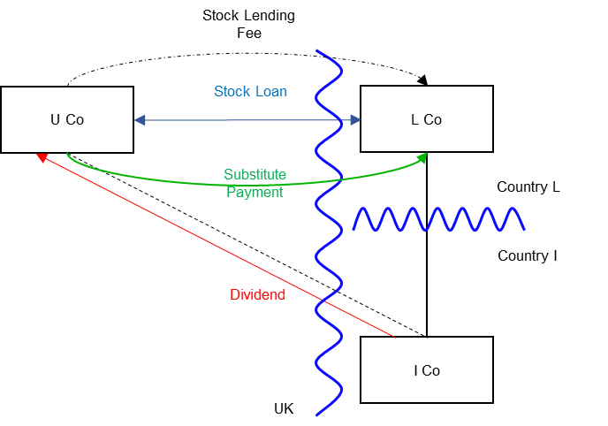

Background
- U Co is resident in the UK. It is a financial trader and all transactions in this arrangement are within its financial trade.

- L Co is incorporated and resident in Country L.

- L Co holds shares in I Co.

- I Co is incorporated and resident in Country I. I Co is not related to either U Co or L Co.

- U Co and L Co are in the same worldwide group, and are related parties.

- L Co enters into a stock lending transaction with U Co. Under the stock lending agreement, L Co transfers its I Co shares to U Co. The agreement provides that U Co will transfer the same or similar shares to L Co after 24 days. U Co provides collateral (cash or high grade securities). L Co will return the collateral to U Co, along with any return made on the securities or interest due on cash, when the I Co shares are transferred to L Co.

- The stock lending transaction might, in other circumstances, facilitate U Co selling these borrowed shares short or facilitate a stock loan or repo to a customer who might intend to sell short. However, in this instance, U Co holds the shares until they are due for redelivery to L Co.

- Under the stock lending agreement U Co pays a stock lending fee to L Co.

- During the 24 day period the record date falls for the I Co shares.

- On the record date U Co holds the shares, and so receives the dividend. Under the terms of the stock lending agreement U Co is required to make a substitute payment (manufactured dividend) to L Co. The amount of the substitute payment is related to the amount of the dividend received in respect of the I Co shares but not necessarily the same.

- In the UK U Co takes the dividend received into account when computing the taxable profits of its financial trade. The substitute payment made by U Co is also taken into account in computing the taxable profits of its financial trade.

- Under the tax laws of country L, L Co would not normally be taxed on dividends. However, under a specific tax rule (not in any way related to hybridity) the dividend on the I Co shares would have been taxable if actually received by L Co.

- Under the tax law of Country L the substitute payment received by L Co in lieu of the dividend is not taxable.

- The transactions in this case are part of a structured arrangement as the hybrid transfer arrangement is designed to secure a hybrid transfer deduction/non-inclusion mismatch. U Co has no particular need for the shares, but L Co benefits by receiving a tax-free substitute payment in lieu of a taxable dividend. U Co is neutral; it gets a tax deduction for the substitute payment but is taxed on the dividend received, because it is a financial trader. It is critical to the design of the arrangements that U Co is able to obtain a tax deduction for the substitute payment, and that L Co is not taxed upon the receipt of the substitute payment.

Analysis – Applying the tests in s259DA TIOPA 2010

Condition A: Is there a hybrid transfer arrangement in relation to an underlying instrument?
This is a stock lending arrangement that may be a hybrid transfer arrangement if it is an arrangement that provides for, or relates to, the transfer of a financial instrument and
- the dual treatment condition is met, or

- a substitute payment could be made.

The I Co shares are a financial instrument, as defined at s259N. The stock loan is, therefore, an arrangement providing for the transfer of a financial instrument.

Dual treatment condition
The dual treatment condition is met if, for tax purposes -
- one person regards the arrangement as equivalent to a transaction for the lending of money at interest, and a payment or quasi-payment made under or in connection with that arrangement is treated accordingly, and
- another person does not treat that payment or quasi-payment as equivalent to a transaction for the lending of money at interest.
On the facts given above, it does not appear that the dual treatment condition is met, so the substitute payment position must be considered.

Substitute payment
A payment or quasi-payment is a substitute payment if
- it consists of or involves an amount being paid or a benefit being given,
- the amount or value of the benefit is representative of a return of any kind arising on, or in connection with, the underlying financial instrument, and
- the amount is paid, or the benefit is given, to a person other than the recipient of the return on the underlying financial instrument.
In this case the stock lending arrangement requires U Co to make a substitute payment to L Co when U Co receives the dividend from I Co. U Co receives a return (the dividend) on the underlying financial instrument (the I Co shares). L Co receives an amount (from U Co) that is representative of that dividend and the payment to L Co is a payment made to a person who did not receive the dividend.
The payment to L Co by U Co in respect of the dividend from I Co is a substitute payment within the definition in s259DB(5).
Condition A is satisfied as a substitute payment could be made (and is, in fact, made) under the terms of the stock lending agreement.

Condition B: Is there a payment or quasi-payment made under, or in connection with, a hybrid transfer arrangement?
There are several payments made under or in connection with the stock lending arrangement in relation to which an amount may be deducted from the payer’s income. These include –
- payment of the stock lending fee
- payment of the substitute payment.
Condition B is satisfied.

Condition C: Is the payer or a payee within the charge to corporation tax for a relevant payment period?
U Co is within the charge to corporation tax in the UK, and is the payer of the stock lending fee and the substitute payment.
Condition C is satisfied.

Condition D: Is it reasonable to suppose that there would be a hybrid transfer deduction/non-inclusion mismatch in relation to a payment or quasi-payment?
There is no apparent mismatch in respect of the stock lending fee, so this is not considered further.
U Co is allowed a deduction for the substitute payment in the UK but the receipt of the substitute payment is treated as a non-taxable dividend in country L. This appears to result in a case 1 excess, because the relevant deduction by U Co exceeds the ordinary income brought into account by L Co. However, U Co is a financial trading company so the financial trader exclusion must also be considered.

Financial trader exclusion
Under s259DC(9) any part of excess to which the financial trader exclusion applies is to be disregarded.
The financial trader exclusion applies where conditions A, B and C set out at s259DE are satisfied.
- Condition A is met where one person treats a substitute payment as a return on the underlying instrument for tax purposes, and another person (the financial trader) brings that amount into account in calculating the profits of a trade.
- Condition B is met where the financial trader also brings any associated payments into account as trading income or expenses.
- Condition C is met if there would be no mismatch within Chapter 3 of the hybrids legislation (assuming the return on the underlying instrument arose and was paid direct to the payee) and the hybrid transfer arrangement is not a structured arrangement.
In this case, L Co treats the receipt of the substitute payment as a return on the underlying instrument, that is, as a dividend. U Co is a financial trader and brings the substitute payment into account as an expense when calculating the profits of that trade. Condition A is met.
U Co also brings the dividend receipt from I Co into account when calculating its trading profits, so condition B is met.
There is nothing to suggest that a non-UK provision equivalent to Chapter 3 of Part 6A would apply if the dividend payment were made directly from I Co to L Co. However, it is critical to the success of these arrangements that a hybrid transfer deduction/non-inclusion mismatch is secured in respect of the substitute payment. The facts make clear that this is a structured arrangement, so condition C of the financial trader exclusion is not met.
The statutory question is whether the hybrid transfer arrangement was “designed” to result in a hybrid transfer deduction/non-inclusion mismatch. This implies some active participation by U Co but it would be surprising if this were not the case where the parties are related. In this particular case, U Co works with L Co to secure a benefit for L Co in relation to the treatment of a substitute payment, and the mismatch is essential to the design of the arrangements. If, for example, entry into such a tax beneficial transaction could increase the bonuses of the U Co employees concerned, this would be a clear marker of a structured arrangement.
If L Co were replaced by an unrelated third party to the transaction and U Co received no economic benefit from the arrangements, then it is less likely that the arrangement is a structured arrangement. If, however, U Co were to actively market such a transaction to third parties, seeking to benefit from an increased volume of transactions, it would then be party to the design and there would be a structured arrangement. In that event, the financial trader exclusion would not apply.
In this example, the financial trader exclusion does not apply, so condition D is satisfied.

Condition E: Are U Co and L Co related, or is the arrangement a structured arrangement?
U Co and L Co are related. There is no need to consider whether the arrangement is also a structured arrangement.
Condition E is satisfied.

Conclusion
All the conditions are satisfied and there is a hybrid transfer deduction/non-inclusion mismatch, the extent of which is the full amount of the deduction for the substitute payment.

Counteraction
As the conditions are all satisfied the hybrid transfer deduction/non-inclusion mismatch is counteracted in the UK under s259DF. U Co is denied a deduction for the substitute payment.
Note. Would the position be different if U Co did not receive the actual dividend on the I Co shares?
The fact that U Co receives the real dividend is not critical. The analysis would be the same if U Co were to pass on the I Co shares to some other party, related or unrelated, by means of a stock loan or repo for the same period of time. The essential deduction/non-inclusion mismatch and overall tax benefit to U Co and L Co, taken together, would be exactly the same.
Return to contents

