INTM552530: Hybrids: Hybrid transfers (Chapter 4): Examples: Stock loan – UK financial trader borrows shares
In this stock lending arrangement U Co is a financial trader and is a related party of L Co.

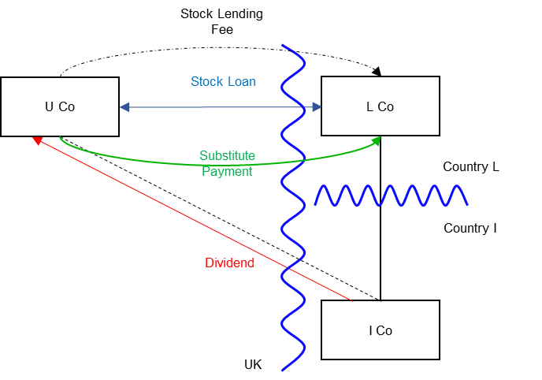

Background
- U Co is resident in the UK. It is a financial trader and all transactions in this arrangement are within its financial trade.

- L Co is incorporated and resident in Country L.

- L Co holds shares in I Co

- I Co is incorporated and resident in Country I. I Co is not related to either U Co or L Co.

- U Co and L Co are in the same worldwide group and are related parties.

- L Co enters into a stock lending transaction with U Co. Under the stock lending agreement L Co transfers its I Co shares to U Co. The agreement provides that U Co will transfer the same or identical shares to L Co after 24 days. U Co provides collateral (cash or high grade securities). L Co will return the collateral to U Co, along with any return made on the securities or interest due on cash when the I Co shares are transferred to L Co.

- Under the stock lending agreement U Co pays a stock lending fee to L Co.

- The stock lending transaction facilitates U Co selling the I Co shares short. (U Co is expecting the price of the shares to fall. Accordingly it hopes to make a profit by purchasing shares in the market to redeliver to L Co at the end of the stock loan for an amount lower than the proceeds from the earlier sale of the borrowed shares.)

- The record date for the I Co shares falls during the 24 day period.

- On the record date U Co still holds the shares and has not sold them yet. U Co receives the dividend, and makes a substitute payment (manufactured dividend) to L Co as set out in the terms of the stock lending agreement.

- In the UK U Co brings the dividend into account when calculating its taxable profits, as the dividend is income received in the course of its financial trade.

- U Co is allowed a deduction for the substitute payment made to L Co, as it is brought into account in calculating the profits of its financial trade (s814C(3), CTA 2010).

- Under the tax law of Country L the substitute payment received by L Co is treated as a non-taxable dividend.

- It is accepted for the purposes of this example that the transactions are not a structured arrangement.

Analysis – Applying the tests in s259DA TIOPA 2010

Condition A: Is there a hybrid transfer arrangement in relation to an underlying instrument?
This is a stock lending arrangement that may be a hybrid transfer arrangement if it is an arrangement that provides for, or relates to, the transfer of a financial instrument and
- the dual treatment condition is met, or

- a substitute payment could be made.

The I Co shares are a financial instrument, as defined at s259N. The stock loan is, therefore, an arrangement providing for the transfer of a financial instrument.

Dual treatment condition
The dual treatment condition is met if, for tax purposes -
- one person regards the arrangement as equivalent to a transaction for the lending of money at interest, and a payment or quasi-payment made under or in connection with that arrangement is treated accordingly, and
- another person does not treat that payment or quasi-payment as equivalent to a transaction for the lending of money at interest.
On the facts given above, there is no reason to expect either party to treat the stock loan as a funding transaction, so the substitute payment position must be considered.

Substitute payment
A payment or quasi-payment is a substitute payment if
- it consists of or involves an amount being paid or a benefit being given,
- the amount or value of the benefit is representative of a return of any kind arising on, or in connection with, the underlying financial instrument, and
- the amount is paid, or the benefit is given, to a person other than the recipient of the return on the underlying financial instrument.
In this case the stock lending arrangement requires U Co to make a substitute payment to L Co when U Co receives the dividend from I Co. U Co receives a return (the dividend) on the underlying financial instrument (the I Co shares). L Co receives an amount (from U Co) that is representative of that dividend and the payment to L Co is a payment made to a person who did not receive the dividend.
The payment to L Co by U Co in respect of the dividend from I Co is a substitute payment within the definition in s259DB(5).
Condition A is satisfied as a substitute payment could be made (and is, in fact, made) under the terms of the stock lending agreement.

Condition B: Is there a payment or quasi-payment made under, or in connection with, a hybrid transfer arrangement?
There are several payments made under or in connection with the stock lending arrangement in relation to which an amount may be deducted from the payer’s income. These include –
- payment of the stock lending fee
- payment of the substitute payment.
Condition B is satisfied.

Condition C: Is the payer or a payee within the charge to corporation tax for a relevant payment period?
U Co is within the charge to corporation tax in the UK, and is the payer of the stock lending fee and the substitute payment.
Condition C is satisfied.

Condition D: Is it reasonable to suppose that there would be a hybrid transfer deduction/non-inclusion mismatch in relation to a payment or quasi-payment?
There is no apparent mismatch in respect of the stock lending fee, so this is not considered further.
The facts given above state that U Co is allowed a deduction for the substitute payment in the UK but the receipt of the substitute payment is treated as a non-taxable dividend by L Co in Country L. This appears to result in a case 1 excess, because the relevant deduction by U Co exceeds the ordinary income brought into account by L Co. However, U Co is a financial trading company so the financial trader exclusion must also be considered.

Financial trader exclusion
Under s259DC(9) any part of the excess to which the financial trader exclusion applies is to be disregarded.
The financial trader exclusion applies where conditions A, B and C, set out at s259DE, are satisfied.
- Condition A is met where one person treats a substitute payment as a return on the underlying instrument for tax purposes, and another person (the financial trader) brings that amount into account in calculating the profits of a trade.
- Condition B is met where the financial trader also brings any associated payments into account as trading income or expenses.
- Condition C is met if there would be no mismatch within Chapter 3 of the hybrids legislation (assuming the return on the underlying instrument arose and was paid direct to the payee) and the hybrid transfer arrangement is not a structured arrangement.
In this case, L Co treats the substitute payment as a return on the underlying instrument, that is, as a dividend. U Co is a financial trader and brings the substitute payment into account when calculating the profits of that trade. Condition A is met.
U Co also brings the dividend received from I Co into account when calculating trading profits, so condition B is met.
There is nothing to suggest that a non-UK provision equivalent to Chapter 3 of Part 6A would apply if the dividend payment were made directly from I Co to L Co. The facts also make clear that this is not a structured arrangement. Condition C is met.
As all the conditions are met, the financial trader exclusion applies, and the excess arising under s259DC(2) is reduced accordingly. In this example the financial trader exclusion applies to the entire excess, so the remaining excess under s259DC(2) is nil.
Condition D is not satisfied, as the entire mismatch is disregarded under the financial trader exclusion. It is not necessary to consider the other conditions.

Conclusion
The conditions are not all satisfied, so no hybrid transfer deduction/non-inclusion mismatch arises under Chapter 4 and there is no counteraction under Chapter 4.
Note 1: U Co sells shares cum-dividend and buys equivalent shares ex-dividend
The background given states that U Co held the I Co shares on the record date. However, as U Co is trading in these shares it may not hold the I Co shares on the record date. Assume that -
- U Co delivers the shares, cum dividend (before the record date) to a third party in a normal market sale. It is not known what happens to the shares after that sale.

- Later, and after the record date, U Co buys equivalent shares from a third party in the market, ex-dividend (after the record date) and delivers these shares to L Co as a repayment of the stock loan.
As part of the stock loan agreement U Co still has to make a substitute payment to a related party, L Co. The analysis for Chapter 4 is therefore unchanged. Condition D in s259DA(5) is again not satisfied as a result of the financial trader exclusion in s259DC(9) and s259DE.
The key point is that the deduction arises only because of U Co’s financial trader status. It is not dependent on matching the tax treatment of U Co on the dividend received and the substitute payment made. U Co is unlikely to be aware of who received the actual dividend on the shares sold and the shares later purchased in the market or how the dividends are taxed. U Co is taxed on its commercial profits from the trading. Whether shares were bought cum-dividend and purchased ex-dividend will already be recognised in the valuation of the shares and be reflected in the profits of the transaction.

Note 2: Withholding tax benefits priced into the arrangement
This example can present issues where there are different withholding tax rates on dividends paid from Country I to Country L and from Country I to the UK. For example
- if L Co received the dividend directly from I Co, a withholding tax rate of 30% would apply.
- on the dividend payment date, U Co is the registered holder of the I Co shares, and the Country I dividend withholding tax is 15% to the UK.
- under UK tax law U Co is not required to withhold UK income tax from the overseas manufactured dividend.
Therefore there is a potential benefit in routing the dividend through the UK to Country L as this would allow less withholding tax on the dividend.
It is then assumed that the amount of the substitute payment is such that the withholding tax benefit is split between the parties and on a gross dividend of 100, the substitute payment is, say, 77, more than the 70 that L Co would have received in respect of a direct dividend, but less than the 85 received by U Co.
The analysis for Chapter 4 remains essentially the same as in the main example above. There is no structured arrangement. Although the economic benefit relating to the withholding tax treatment is reflected in the amount of the substitute payment, that economic benefit does not arise from the deduction/non-inclusion mismatch. This type of tax rate arbitrage is outside the scope of the hybrid and other mismatches provisions.
Return to contents

