INTM552520: Hybrids: Hybrid transfers (Chapter 4): Examples: Stock loan – UK company lends shares
An example of a stock loan that may result in a hybrid transfer mismatch. U Co transfers I Co shares to L Co under a stock lending agreement, and receives collateral and a stock lending fee. L Co receives dividends in respect of the shares, and makes a substitute payment to U Co. L Co later transfers the I Co shares to U Co, and U Co returns the collateral to L Co, with interest.
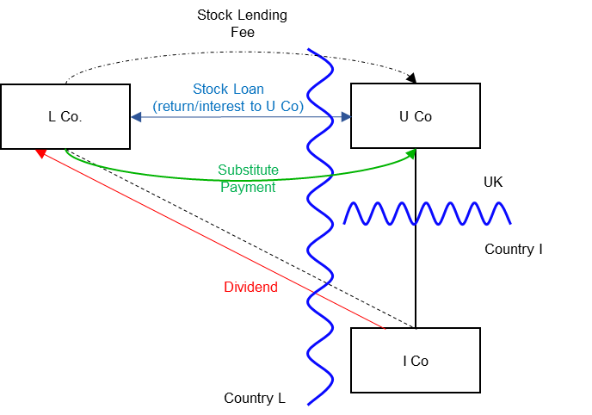

Background
- U Co is incorporated and resident in the UK.

- U Co holds shares in I Co, a company incorporated and resident in Country I.

- L Co is incorporated and resident in Country L.

- I Co is not a related party of either U Co or L Co at any time as these transactions are carried out.

- U Co enters into a stock lending transaction with L Co. Under the stock lending agreement U Co transfers the I Co shares to L Co. The agreement provides that L Co is required to transfer the same or identical shares to U Co 24 days later. L Co provides collateral (cash or high grade securities) to U Co, and this is transferred back to L Co when the shares are returned to U Co. U Co is also required to pay L Co any profit made while it held the collateral, for example, any return on securities, or to pay interest due on cash.

- L Co pays a stock lending fee to U Co. In this instance the fee is larger than would be expected for a simple commercial stock lending transaction.

- The record date for the I Co shares falls during the 24 day period, so
L Co holds the stock on the record date and receives the actual dividend for the I Co shares. L Co is not taxed on the dividend received.

- Under the terms of the stock lending agreement L Co is required to make a substitute payment (manufactured dividend) to U Co. The amount of the substitute payment is related to the amount of the dividend received in respect of the I Co shares but not necessarily the same amount.

- Under Country L law, L Co is allowed a deduction when calculating its profits chargeable to tax for the substitute payment made to U Co.

- Under s814D(2) CTA 2010 the substitute payment received by U Co is treated as a dividend.

Analysis – Applying the tests in s259DA TIOPA 2010

Condition A: Is there a hybrid transfer arrangement in relation to an underlying instrument?
This is a stock lending arrangement that may be a hybrid transfer arrangement if it is an arrangement that provides for, or relates to, the transfer of a financial instrument and
- the dual treatment condition is met, or

- a substitute payment could be made.

The I Co shares are a financial instrument, as defined at s259N. The stock loan is, therefore, an arrangement providing for the transfer of a financial instrument.

Dual treatment condition
The dual treatment condition is met if, for tax purposes -
- one person regards the arrangement as equivalent to a transaction for the lending of money at interest, and a payment or quasi-payment made under or in connection with that arrangement is treated accordingly, and
- another person does not treat that payment or quasi-payment as equivalent to a transaction for the lending of money at interest.
On the facts given above, it is not clear whether the dual treatment condition is met, so the substitute payment position must be considered.

Substitute payment
A payment or quasi-payment is a substitute payment if
- it consists of or involves an amount being paid or a benefit being given,
- the amount or value of the benefit is representative of a return of any kind arising on, or in connection with, the underlying financial instrument, and
- the amount is paid, or the benefit is given, to a person other than the recipient of the return on the underlying financial instrument.
In this case the stock lending arrangement requires L Co to make a substitute payment to U Co when L Co receives the dividend from I Co. L Co receives the return on the underlying financial instrument when the dividend is paid in respect of the I Co shares. U Co receives an amount (from L Co) that is representative of that dividend and the payment to U Co is a payment made to a person who did not receive the dividend.
The payment to U Co by L Co in respect of the dividend from I Co is a substitute payment within the definition in s259DB(5).
Condition A is satisfied as a substitute payment could be made (and is, in fact, made) under the terms of the stock lending agreement.

Condition B: Is there a payment or quasi-payment made under, or in connection with, a hybrid transfer arrangement or the underlying instrument?
There are several payments made under or in connection with the stock lending arrangement in relation to which an amount may be deducted from the payer’s income. These include –
- payment of the stock lending fee
- payment of the substitute payment.
Condition B is satisfied.

Condition C: Is the payer or a payee within the charge to corporation tax for a relevant payment period?
U Co is within the charge to corporation tax in the UK, and is a payee in respect of the substitute payment and the stock lending fee
Condition C is satisfied.

Condition D: Is it reasonable to suppose that there would be a hybrid transfer deduction/non-inclusion mismatch in relation to a payment or quasi-payment?
There is no apparent mismatch in respect of the stock lending fee, so this is not considered further.
The facts set out above indicate that L Co is allowed a deduction for the substitute payment in Country L. In the UK the receipt of the substitute payment is treated as receipt of a dividend by U Co (s814D, CTA 2010). There may be a mismatch if U Co’s receipt of the substitute payment is not taxable in the UK.
Where the substitute payment is treated as a distribution within the terms of Part 9A CTA 2009 and a deduction is allowed to a non-UK resident in respect of that payment, the UK will usually apply the Part 9A rules and bring the distribution into charge. In most circumstances this means there will be no mismatch to consider, and condition D will not be satisfied.
If the substitute payment is treated as an exempt distribution in the UK, there will be a hybrid transfer deduction/non-inclusion mismatch, and condition D will be satisfied.

Condition E: Are U Co and L Co related, or is the arrangement a structured arrangement?
U Co and L Co are related. There is no need to consider whether the arrangement is also a structured arrangement.
Condition E is satisfied.

Conclusion
Where all the conditions are satisfied and there is a hybrid transfer deduction/non-inclusion mismatch, the extent of that mismatch is the full amount of the substitute payment received by U Co.
Where condition D is not satisfied, there is no hybrid transfer arrangement and Chapter 4 will not apply.

Counteraction
Where all the conditions are satisfied, the hybrid transfer deduction/non-inclusion mismatch is counteracted in the UK under s259DG. The amount of substitute payment is treated as income arising to U Co.
Return to contents

