INTM552510: Hybrids: Hybrid transfers (Chapter 4): Examples: In-substance loan to UK company - case 1 mismatch
This arrangement is an unusual variation of a repo in which a financing return on an in-substance loan from C Co to U Co is delivered by arranging for C Co to retain the dividend on repo-ed shares.
This is not a typical market transaction: a repo of shares in a subsidiary is unlikely, because the shares might not represent reliable security for the in-substance lender and the arrangement appears to be designed to ensure that the sale and repurchase price are the same. Such a highly structured repo is more likely to be designed to deliver a cross-border tax arbitrage.
In this example, U Co accounts for the repo as a loan and is taxed on this basis. C Co’s jurisdiction treats the sale and repurchase as on capital account and as the sale and repurchase price are the same, no gain nor loss is taken into account for tax purposes. The dividend received by C Co is not taxed.
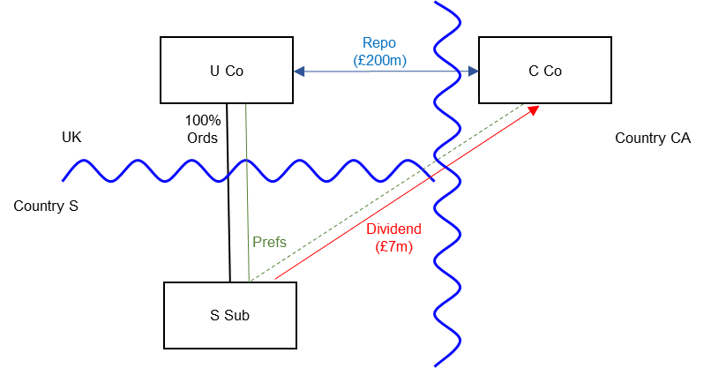

Background
- U Co is resident in the UK.

- U Co has a 100% subsidiary (S sub), which is incorporated and resident in Country S.

- S Sub has issued to U Co 3.5% fixed rate preference shares carrying 10% of the voting rights (the Prefs).

- U Co sells the entire holding in Prefs for £200m to an unrelated company, C Co, resident in Country CA. This is subject to an agreement (the Repo) that U Co will repurchase the Prefs for £200m 12 months later.

- S Sub pays a dividend of £7m to C Co while C Co holds the Prefs. C Co is not required to make a substitute payment to U Co under the terms of the Repo.

- S Sub is not entitled to a tax deduction in Country S in respect of this dividend.

- U Co accounts for the transactions as a borrowing of £200m, secured on the Prefs in S Sub, recognising a financing cost of £7m (being the dividend foregone) as accruing over the 12 month term of the Repo. Under UK tax law U Co deducts the £7m from its income when calculating its profits for tax purposes.

- The expected arm’s length borrowing cost for U Co on a secured loan, commercially similar to the Repo, would be 4.0%.

- Under Country CA tax law, C Co treats the Repo as an acquisition and sale of shares for £200m, giving rise to no profit or loss. The dividend received by C Co. is exempted from tax.

Analysis – Applying the tests in s259DA TIOPA 2010

Condition A: Is there a hybrid transfer arrangement in relation to an underlying instrument?
The transaction has abnormal features that depart from those of a typical market repo; most notably the engineering of the arrangements such that the repurchase and sale prices are identical. This is done by ensuring that the retention of the real dividend by C Co, without obligation to make a substitute payment to U Co provides it with a return from the transaction which is approximately commensurate with the interest that might be expected on a one year loan from C Co. to U Co.
It is unclear whether the Repo is a repo in the ordinary sense of the term as used in the context of financial transactions. It is an arrangement within the meaning at s259NF that provides for the transfer of a financial instrument (the Prefs) and is a hybrid transfer arrangement as defined at s259DB(2) if it provides for, or relates to, the transfer of a financial instrument and
- the dual treatment condition is met, or

- a substitute payment could be made.
The dual treatment condition is met if, for tax purposes -
- one person regards the arrangement as equivalent to a transaction for the lending of money at interest, and a payment or quasi-payment made under or in connection with that arrangement is treated accordingly, and
- another person does not treat that payment or quasi-payment as equivalent to a transaction for the lending of money at interest.
On the facts given above, the dual treatment condition is met because
- U Co has a deduction of £7m for tax purposes. That deduction is a payment or quasi-payment (as defined at s259BB) that arises because the UK treats the Repo as an arrangement equivalent to the lending of money at interest, and
- C Co does not treat its return (the dividend of £7m received on the repo-ed shares) as a transaction under an arrangement equivalent to the lending of money at interest.
Condition A is satisfied because the dual treatment condition is met. It is not necessary to consider whether a substitute payment could arise.

Condition B: Is there a payment or quasi-payment made under, or in connection with, a hybrid transfer arrangement?
U Co may claim a deduction for the interest accrual against its ordinary income for the purposes of calculating its taxable profits, and it would be reasonable to expect that an amount of ordinary income would have arisen to C Co had it adopted the same accounting approach and been within the charge to tax in the UK.
The accrued interest expense satisfies the definition of a quasi-payment within s259BB(2).
Condition B is met.

Condition C: Is the payer or a payee within the charge to corporation tax for a relevant payment period?
U Co is the payer of the accrued interest expense, and is within the charge to corporation tax in the UK.
Condition C is satisfied.

Condition D: Is it reasonable to suppose that there would be a hybrid transfer deduction/non-inclusion mismatch in relation to the payment or quasi-payment?
Given the background above it is reasonable to suppose that, but for the hybrid mismatch provisions, U Co would be entitled to a deduction of £7m (the relevant deduction) for the in-substance interest accrual when computing its profits for corporation tax purposes.
It is also reasonable to suppose that C Co will not treat any amount of the £7m dividend received as ordinary income, because in Country CA the Repo is not treated as an arrangement for the lending of money at interest, and the dividend is not taxable.
Condition D is satisfied.

Condition E: Are U Co and C Co related, or is the arrangement a structured arrangement?
U Co and C Co are not related in this example, so it is necessary to consider whether the Repo is a structured arrangement.
The Repo is a structured arrangement as defined at s259DA(7) if it is reasonable to suppose that
- it is designed to secure a hybrid transfer deduction/non-inclusion mismatch, or
- the terms of the Repo share the economic benefit of the mismatch between the parties to the arrangement, or otherwise reflect the fact that the mismatch is expected to arise.
In this example the features of the design (for instance its elaborate nature which contrasts with a normal market repo and in particular, the contrived equality of sale and repurchase price) suggest that the transaction was designed to create a mismatch. In a real scenario other factors such as a reorganisation of the share capital of S Sub to facilitate the transaction would reinforce this.
Further the tax mismatch benefit appears to be priced into the transaction. U Co is able to raise funding at 3.5% (£7m cost on a loan of £200m) a lower rate than under conventional funding at 4%; C Co appears to get a lower return than under a conventional loan, but that return is not taxable (unlike a more conventional return on lending).
Condition E is satisfied.

Conclusion
All the conditions are satisfied so there is a hybrid transfer deduction/non-inclusion mismatch, the extent of which (as defined in s259DC(11)) is the full amount of the relevant deduction.

Counteraction
As the conditions are all satisfied, the mismatch is subject to counteraction in the UK under s259DF. U Co is denied a deduction for the entire in-substance interest accrual of £7m.
Return to contents

