INTM552165: Hybrids: Hybrid transfers (Chapter 4): The extent of the mismatch: Example
Example illustrating under-taxed amount: Repo, UK payer, dual treatment condition satisfied, counterparty entitled to underlying tax credit relief
This example is similar to that at INTM552510, except that here the dividend is not exempted by Country Y; instead it is taxed, but underlying tax credit is given. It should be noted that this not a straightforward repo: it is a rather unusual transaction which would probably have been specifically designed to achieve the tax arbitrage.
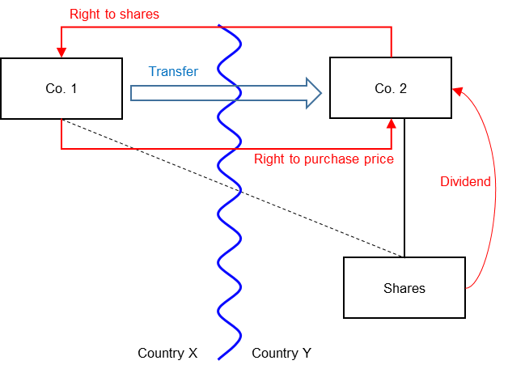
- A UK payer (Co. 1) sells shares to a counterparty (Co. 2) under a repo.

- Co. 1 gets a deduction for a financing cost of 80 under the repo, which is equal to a dividend retained by the repo counterparty (a net-paying repo).

- The sale and repurchase prices are equal once the dividend retained by the counterparty (Co. 2) is deducted from the purchase price (i.e. the finance cost = the expected distribution).

- It is also assumed that the dividend is paid out of profits which have suffered tax in the share issuer’s source jurisdiction of 20%.

- The normal rate of tax on financing income on Co. 2 would be 30%. But it is able to treat the dividend retained as gross income of 100. Its gross tax liability would be 30, but this is reduced by credit for underlying tax of 20, leaving net tax of 10 payable. (It is assumed that no withholding tax arises.)
- As there is only the one payer the under-taxed amount is 80, which is an amount equal to Co. 1’s tax deduction.
Position of counterparty Co. 2:
- Co. 2’s financing income from the hybrid transfer is 80 (the ordinary income that would be expected to be received under the repo is equal to the cash dividend received).

- The maximum rate of tax on that income (or at least the cash dividend) is 10/80 = 12.5%. This compares with a normal rate of tax (and FMR in the formula) on financing income of 30%. So R equals 12.5%.
The tax saved by Co. 2 as compared with the return on a conventional loan to Co. 1 is 80x (30%-12.5%) = 14. This is reconciled as 24 tax at 30%, on normal loan interest of 80, less 10, the net tax under the net-paying repo.
Applying the formula, the amount of the deduction/non-inclusion mismatch is:
$$\frac{(UTA ×\left(FMR-R\right))}{FMR}$$
Where -
- UTA is 80, the under-taxed amount

- R is 12.5%, as determined above

- FMR is 30%, being the payee’s full marginal rate

The deduction denied would be 46.67, calculated as below
$$\frac{80×(30\%-12.5\%)}{30\%}$$
This is the tax saving to Co. 2 of 14, divided by its full marginal rate of tax, 30%, to give the measure of a notional non-inclusion that would provide the same tax-saving.
The primary counteraction, see INTM552220, is to deny the UK payer (Co. 1) a deduction of the same amount, 46.67.
Co. 1 is therefore only able to deduct 33.33 of its repo interest expense of 80.
Return to contents

