INTM551380: Hybrids: Financial instruments (Chapter 3): Example: Interest paid on the purchase of shares from a share trader
This example looks at situations where a company transfers shares to a related company in exchange for payment. The company selling the shares is a share trader. The payment is deferred and interest is applied to the unpaid amount.
The example shows both that the cost price of the shares should be included in ordinary income in computing the share trader’s profits and that if the interest receipt is brought into charge at the full marginal rate, albeit in a different character, there will be no hybrid mismatch to be counteracted under the hybrid and other mismatches from financial instruments rules.

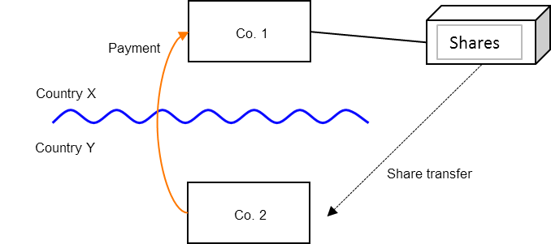

Background
- Co. 1 is a share trader and resident in Country X.
- Co. 2 is resident in Country Y and is related to Co. 1.
- Co. 1 transfers shares to Co. 2, which pays market value for the shares (subject to a price adjustment for the consideration being deferred).
- The consideration given for the shares is deferred for a year. The purchase price is fair market value on the date of the agreement plus an amount equal to a market rate of interest on the unpaid purchase price.
- Under the laws of Country Y, Co. 2 is allowed to treat the in-substance interest portion of the purchase price as a separate deductible expense for tax purposes. Co. 2 is not a share trader and is therefore not able to claim a deduction for the cost of the shares acquired.
- Under the laws of Country X, Co. 1 treats the entire purchase price (including the interest element) as consideration for the transfer of the asset. However, as it is a share trader, Co. 1 is required to bring the entire amount of the payment into account as ordinary income when computing its taxable profits.

Analysis - Applying the tests in s259CA TIOPA 2010
Do the interest payments satisfy the relevant conditions to fall within the scope of the hybrid and other mismatches from financial instruments rules?

Condition A: Is there a payment made under, or in connection with, a financial instrument?
The definition of a ‘financial instrument’ within s259N TIOPA 2010 includes anything else that ‘has the meaning that it has for UK generally accepted accounting practice’. Therefore if the UK is in the position of Country X then it can usually be supposed that UK GAAP has determined the agreement to be merely a transfer of the asset, and therefore not a financial instrument.
By contrast, where the UK is in the position of Country Y, the transfer agreement includes a finance element and is therefore a financial instrument under UK GAAP.
Condition A is satisfied only if the UK is in the position of Country Y.

Condition B: Is the payer or payee within the charge to corporation tax for a relevant payment period?
In the event the UK is in the position of Country X, Co. 1 is the payee and is within the charge to corporation tax.
In the event the UK is in the position of Country Y, Co. 2 is the payer and within the charge to corporation tax.
Condition B will therefore be satisfied providing either of the above is satisfied.
If the UK was neither Country X nor Country Y then this condition would not be satisfied and no further analysis is required as neither Co. 1 nor Co. 2 will be within the charge to corporation tax.
If Co. 1 and Co. 2 were both within the charge to corporation tax, then condition B would be satisfied since both payer and payee companies were within the charge to corporation tax.

Condition C: Is it reasonable to assume that there is, or will be, a ‘hybrid or otherwise impermissible deduction/ non-inclusion mismatch’ in relation to this payment?
The payment is made up of two distinct and separable elements: the payment for the shares and the payment of interest.
The separate and identifiable payment for the shares will not result in a hybrid or otherwise impermissible deduction/ non-inclusion mismatch as Country Y will not permit a deduction for the cost of the shares in calculating Co. 2’s trading profits (because it is not a share trader).
The interest payment also does not result in a hybrid mismatch because the relevant deduction does not exceed the amounts of ordinary income arising to each payee for the permitted taxable period. Co. 2 has benefitted from a deduction in Country Y, but it is reasonable to assume that the corresponding receipt has been taxed in Country X as ordinary income – it is income that has been brought into charge by Country X under a tax corresponding to the UK’s charge to corporation tax on income.
Co. 1’s receipt is not accounted for as finance income, but that does not prevent the amount being recognised as ordinary Income under the definition at s259BC.
As the rate charged on that element of ordinary Income is not lower than that charged in Country X on all ordinary income arising from financial instruments, it is not under-taxed for the purpose of case 2.
Condition C is not satisfied, and no further analysis is required.

Conclusion
There is no hybrid or otherwise impermissible deduction/non-inclusion mismatch to counteract.
Return to contents

