INTM551360: Hybrids: Financial instruments (Chapter 3): Example: Consideration for the purchase of a trading asset
This example looks at situations where a company acquires shares on trading account from a related company in exchange for payment. This payment is deferred and interest is applied to the unpaid amount.
The example considers whether the asset sale agreement falls within the hybrid and other mismatches from financial instruments rules.

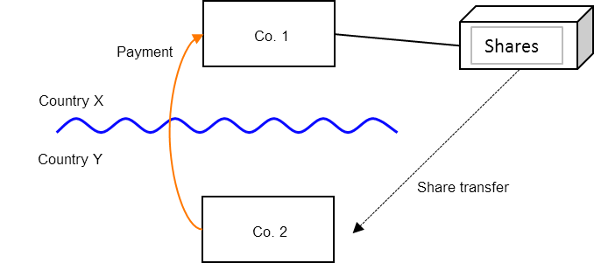

Background
- Co. 1 is resident in Country X.
- Co. 2 is resident in Country Y.
- Co. 1 transfers shares to Co. 2, who pays fair market value for the shares.
- The share transfer occurs on the same day as the payment.
- Co. 2 acquires the shares as part of its activities as a trader and will be able to include the purchase price as expenditure when calculating any taxable gains/loss on the disposal of the shares.

Analysis – Applying the rules in s259CA TIOPA 2010
Do the interest payments satisfy the relevant conditions to fall within the scope of the hybrid and other mismatches from financial instruments rules?

Condition A: Are the payments or quasi-payments made under, or in connection with, a financial instrument?
The asset sale agreement is not a financial instrument as it does not fall within any of the definitions provided in s259N.
Although shares are included, an agreement to acquire them will only be a financial instrument if it satisfies one of the tests in s259N, for instance that amounts are brought into account in respect of it under Part 6 CTA 2010 – see s259N(1)(b). That is not the case here.
Condition A is not satisfied, and no further analysis is required.

Conclusion
There is no hybrid or otherwise impermissible deduction/non-inclusion mismatch to counteract.
Note that if a substitute payment is made in connection with the transfer, Chapter 4 dealing with hybrid transfers may apply.
Return to contents

