INTM551330: Hybrids: Financial instruments (Chapter 3): Example: Interest payment to a person holding instrument through tax exempt accounts (e.g. ISAs)
This example looks at situations where an individual receives interest from a company. The interest payment is deductible but the interest receipt is not taxed because it is held in a tax exempt account.
The example considers whether the interest receipt is ordinary income within the hybrid and other mismatches from financial instruments rules and how it should be treated.
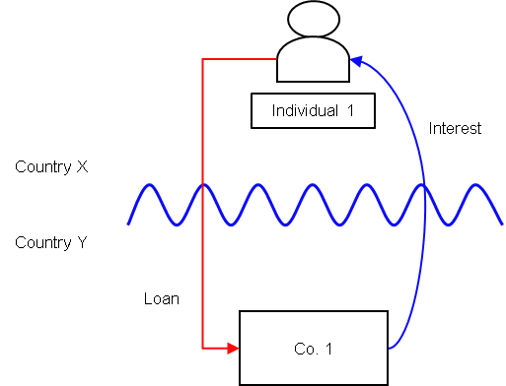

Background
- Co. 1 is resident in Country Y.
- Individual 1 is resident in Country X and, except as specified below, there is no other relationship between the parties.
- Individual 1 subscribes for a bond issued by Co. 1 that pays regular interest.
- The bond is treated as a debt instrument under the laws of Countries X and Y.
- Under the law of Country Y Co. 1 is allowed a deduction for the interest payments.
- Under the law of Country X the interest receipts would usually be treated as ordinary income of the recipient.
- In this case, the bond is held by Individual 1 through a tax exempt personal savings account that entitles the individual to an exemption on any income and gains in respect of qualifying investments held in the account. To be eligible as a ‘qualifying investment’ they must be stocks and shares listed or traded on a recognised stock exchange, akin to a UK ISA.
- The savings account is available to individuals only, and there are limits on the amounts that can be put into the account.

Analysis – Applying the test in s259CA TIOPA 2010:
Do the interest payments satisfy the relevant conditions to fall within the scope of the hybrid and other mismatches from financial instruments rules?
Note: Individuals are not subject to these rules, so the counteraction at s259CE is not applicable.

Condition A: Are the payments made under, or in connection with, a financial instrument?
There are payments of interest made in satisfaction of the obligations arising under the bond. The bond is defined as a financial instrument for the purposes of UK GAAP, and is therefore within the definition of a financial instrument in s259N.
Condition A is satisfied.

Condition B: Is either Co. 1 or Individual 1 within the charge to corporation tax for a relevant payment period?
The charge to corporation tax is the charge to the corporation tax in the UK.
If the UK is Country Y, then Co. 1 will be within the charge to corporation tax. Condition B will be satisfied.
If the UK is Country X, then condition B will not be satisfied as Individual 1 is not within the charge to corporation tax.
Condition B will be satisfied only if the UK is in the position of Country Y.

Condition C: Is it reasonable to suppose that there would be a ‘hybrid or otherwise impermissible deduction/ non-inclusion mismatch’ in relation to this payment?
The background suggests it is reasonable to suppose that Country Y will allow Co. 1 a deduction (relevant deduction) for the regular interest payments under the bond. It is also reasonable to suppose that Country X will not require Individual 1 to bring the interest receipt into account as ordinary income for tax purposes.
This creates a potential Case 1 mismatch as defined at s259CB(2). Applying the relevant assumption at s259CB(4)(a) the mismatch does not arise by reason of the terms or any other feature of the financial instrument, but because of unilateral relief granted by Country X to Individual 1 for investments that are held within a specified account.
Condition C is not satisfied. No further analysis is needed

Application to similar circumstances
The analysis provided above in respect of tax exempt accounts would also be applicable in relation to other mismatches where the mismatch arises from a unilateral relief granted by Country Y.
For example, Excluded Indexed Securities (EIS) which are designed to meet the requirements of section 433 ITTOIA 2005 and produce a capital return for individual investors.
An impermissible mismatch occurs only if either Case 1 at s259CB(2) or Case 2 at s259CB(7) apply. Case 2 is not relevant, as there is no under-taxed amount. Case 1 is not satisfied because, when considering the relevant assumptions at s259CB(5), there would not be a mismatch if the issuance did not meet the EIS requirements of s433 ITTOIA 2005.
Return to contents

