INTM551310: Hybrids: Financial instruments (Chapter 3): Example: Interest payment with underlying foreign tax credit
This example looks at situations where a company issues a loan to a related company and it is treated as debt in one country and equity in the other. The interest payment is deductible and the dividend receipts are also taxable but attract an underlying foreign tax credit.
The example considers whether the dividend receipts are undertaxed within the hybrid and other mismatches from financial instruments rules and to what extent.
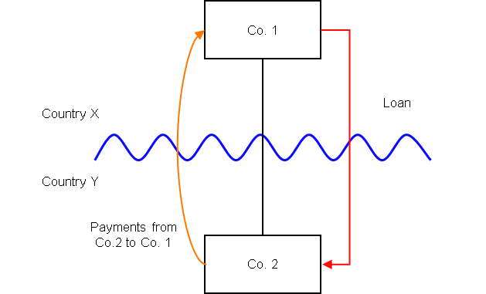

Background
- Co. 2 is a company resident in Country Y
- Co. 1 is a company resident in Country X and owns all the shares in Co. 2
- Co. 1 lends money to Co. 2 on arm’s length terms (the ‘Loan’), but the terms of the Loan are such that it is subordinated to the ordinary creditors of Co. 2 and can be suspended in the event Co. 2 fails to meet certain solvency requirements
- Under the laws of Country Y the Loan is treated as a debt instrument, and the payments of interest under the Loan are deductible in calculating Co. 2’s ordinary income for a taxable period
- Under the law of Country X the Loan is treated as an equity instrument (i.e. shares), and payments under the Loan are treated as dividends. Country X taxes dividends at the same rate as any other income received from a financial instrument but allows a foreign tax credit to reflect the underlying foreign tax suffered on profits from which a dividend is paid
- If the Loan had been treated as a debt instrument in Country X, Co. 1 would be taxable on those receipts at the full marginal rate for ordinary income, without the benefit of a foreign tax credit for underlying tax.
- The payee is not a relevant investment fund as defined in s259NA.
- The Loan is not a regulatory capital security for the purposes of the Taxation of Regulatory Capital Securities Regulations 2013 (SI 2013/3209)

Analysis - Applying the tests in s259CA TIOPA 2010:
Do the interest payments satisfy the relevant conditions to fall within the scope of the hybrid and other mismatches for financial instruments rules?

Condition A: Are the payments made under, or in connection with, a financial instrument?
There are payments of interest made in satisfaction of the obligations arising under the Loan. The Loan is defined as a financial instrument for the purposes of UK GAAP, and is therefore within the definition of a financial instrument in s259N.
Condition A is satisfied.

Condition B: Is either Co. 1 or Co. 2 within the charge to corporation tax for a relevant payment period?
The charge to corporation tax is the charge to the corporation tax in the UK.
If the UK is Country X, Country Y or both (i.e. a wholly domestic transaction), Condition B is satisfied, as either Co. 1, Co. 2 or both are within the charge to corporation tax.
If the UK is neither Country X nor Country Y, then Condition B is not satisfied, as neither Co. 1 nor Co. 2 are within the charge to corporation tax. You will need to consider the remaining conditions only if the imported mismatch rules in Chapter 11 apply.
Note: if Co.1 and Co.2 were both within the charge to corporation tax it would be unusual for UK legislation to allow such a domestic mismatch. The group mismatch schemes rules in s938A CTA 2010 would also be likely to apply.

Condition C: Is it reasonable to suppose that there would be a ‘hybrid or otherwise impermissible deduction/ non-inclusion mismatch’ in relation to this payment?
The background suggests it is reasonable to suppose that Country Y will allow Co. 2 a deduction (relevant deduction) for the payment of interest. It is also reasonable to assume that, by reason of the terms of the Loan, Co. 1 will treat the receipt as dividend income chargeable to tax at the full marginal rate, but with the benefit of a foreign tax credit for underlying tax.
The tax credit, which applies specifically to the receipt of dividend income, reduces the effective tax suffered on the amount of ordinary income received so that that effective tax falls below that which would be payable at the full marginal rate applicable to ordinary income. This creates a potential Case 2 mismatch as defined at s259CB(7).
The Loan is treated as equity in Country X because of the relationship between the parties and the fact that the debt is subordinated. The under-taxed amount is therefore attributable to the terms or any other feature of the financial instrument, and a Case 2 mismatch arises.
(Note that there is no Case 1 mismatch because the entirety of the dividend receipt is included within Co. 1’s ordinary income).
Condition C is satisfied.

Condition D: Are the two companies related or is the Loan, or any arrangement connected with it, a structured arrangement?
Co. 1 owns all the shares in Co. 2, so the companies are related as defined at s259NC.
Condition D is satisfied.
There is no need to consider whether the arrangement is also a structured arrangement.

Conclusion
All the conditions are satisfied to characterise the arrangement involving the payment of interest under the Loan as a ‘hybrid or otherwise impermissible deduction/ non-inclusion mismatch’ and the relevant counteractions need to be considered.

Counteractions

Extent of the mismatch
The extent of the ‘hybrid or otherwise impermissible deduction/ non-inclusion mismatch’ is calculated by means of the formula in s259CB(11), which is as follows:
$$\frac{(UTA ×\left(FMR-R\right))}{FMR}$$
Where:
- UTA is the under-taxed amount. This is the amount of dividend benefitting from the underlying foreign tax credit.
- FMR is the payee’s full marginal rate (expressed as a %) for the permitted taxable period in which the under-taxed amount arises. This is the highest rate which would have been charged on taxable profits of the payee which include ordinary income that arises from, or in connection with, a financial instrument. Under the background of this example it would equate to the rate that would be applied to the dividend in the absence of any foreign tax credit.
- R is the highest rate (expressed as %) at which tax is charged on the taxable profits in which the under-taxed amount is included, taking into account the effect of any credit for underlying tax.
The counteraction applied will depend upon whether the UK is in the position of Country X or Country Y (or both).
If the dividend received by Co. 1 was 100, the tax rate in Country X for ordinary income (including dividend income) was 40% (and thus Co. 1’s full marginal rate was 40%), and the amount of underlying tax on the profits taxed in Country Y out of which the dividend was paid was 10, then the highest rate at which tax would be paid by Co. 1 (R) would be 30%. Using the formula above, the amount of the impermissible deduction/non-inclusion mismatch would be 25.

Counteraction where the UK is in the position of Country Y (the payer jurisdiction)

Primary response
Where the UK is Country Y (the payer jurisdiction) s259CD applies to reduce the allowable deduction by an amount equal to the ‘hybrid or otherwise impermissible deduction/ non-inclusion mismatch’, calculated according to the equation above.

Counteraction where the UK is in the position of Country X (the payee jurisdiction)

Secondary response
Where the UK is Country X (the payee jurisdiction) and the deduction has been fully counteracted under s259CD or an equivalent provision, no further action will be taken by the UK.
If the ‘hybrid or otherwise impermissible deduction/ non-inclusion mismatch’ has not been fully counteracted, s259CE applies to counteract the remaining mismatch by including that amount as income arising to Co. 1 for the counteraction period.
Return to contents

