INTM551270: Hybrids: Financial instruments (Chapter 3): Example: Interest-free loan – deemed interest
This example looks at situations where a company issues an interest free loan to a related company and it is treated as debt in one country and equity in the other. The loan recipient gets a deduction for deemed interest and there is no deemed interest receipt.
The example considers whether the deemed interest payment is within the hybrid and other mismatches from financial instruments rules and how it should be treated.
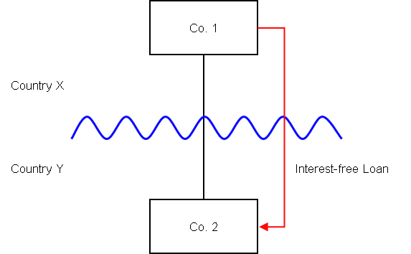

Background
- Co. 1 is resident in Country X
- Co. 1 owns 100% of the equity in Co. 2
- Co. 2 is resident in Country Y
- Co. 1 provides Co. 2 with an interest free loan (the ‘Loan’), which is repayable in full at the end of the five years.
- The law of Country Y allows Co. 2 to claim a deduction for tax purposes for the deemed interest it would have paid to Co. 1 at a market rate. It does not re-characterise the Loan to treat an element of it as relating to a discount.
- Under the law of Country X, due to the relationship between the relevant parties, the Loan is treated as an equity instrument and there is no corresponding interest imputed in that country. The entire value of the Loan on repayment is treated as a return of capital.
- The payee is not a relevant investment fund as defined in s259NA.
- The loan is not a regulatory capital security for the purposes of the Taxation of Regulatory Capital Securities Regulations 2013 (SI 2013/3209).

Analysis - Apply the tests in s259CA
Do the interest payments satisfy the relevant conditions to fall within the scope of the hybrids and other mismatches from financial instruments rules?

Condition A: Are there payments or quasi-payments made under, or in connection with, a financial instrument?
The Loan satisfies the definition of a financial instrument for the purposes of UK GAAP, so falls within the definition of a financial instrument provided in s259N.
As the deduction allowed for interest is deemed, it does not fall within the definition of a payment at s259BB(1). Therefore, we must consider whether the deemed interest is a quasi-payment under s259BB(2).
Co. 2 may claim a deduction for the deemed interest in Country Y. Making the assumptions at s259BB it may be reasonable to expect that an amount of ordinary income would have arisen to Co. 1 had it been resident in Country Y and carrying on a business there.
However, we need to consider whether the deemed deduction falls within s259BB(3), in order to determine whether there is a quasi-payment. . In this situation there is no value transfer as a consequence of the Loan and the circumstances giving rise to the deduction do not include the creation or amendment of any economic rights in relation to interest between Co. 1 and Co. 2. In these circumstances we consider the deemed deduction is within s259BB(3) and is not a quasi-payment
Condition A is not satisfied, and so no further analysis is required.
Return to contents

