INTM551250: Hybrids: Financial instruments (Chapter 3): Example: Interest payment – debt re-characterised as equity
In this example, under existing UK corporate tax law, a mismatch should not arise where Country X is the UK because of the impact of other domestic law. This example is included to illustrate how Part 6A would apply in this hypothetical scenario.
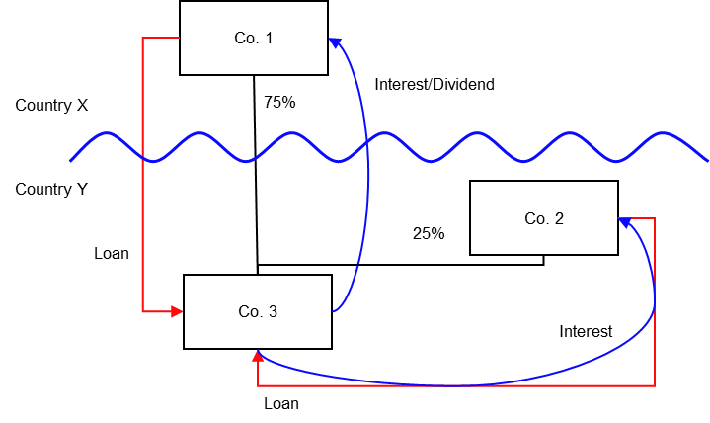

Background
- Co. 3 is resident in Country Y
- Co. 2 owns 25% of the equity in Co. 3, and is also resident in Country Y
- Co. 1 owns 75% of the equity in Co. 3, but is resident in Country X
- Co. 3 needs additional debt financing, and Co. 1 and Co. 2 agree to fund this in proportion to their shareholding in Co. 3 (‘the Loans’).
- Country Y treats both Loans as debt instruments, and allows Co. 3 to claim a deduction for the relevant interest payments. Co. 2 is liable to tax on the interest payments it receives.
- Country X regards the Loans as equity, as they are established by reference to equity held.
- Co. 1 does not pay tax on the interest receipt as the payment is treated as a dividend in Country X and this income is exempt.
- The payees are not relevant investment funds as defined in s259NA.
- The Loans are not regulatory capital securities for the purposes of the Taxation of Regulatory Capital Securities Regulations 2013 (SI 2013/3209).

Analysis - Applying the tests in s259CA TIOPA 2010
Do the interest payments satisfy the relevant conditions to fall within the scope of the hybrid and other mismatches from financial instruments rules?

Condition A: Are the payments of interest made under, or in connection with, a financial instrument?
There are payments of interest made in satisfaction of the obligations arising under the Loans. The Loans are defined as financial instruments for the purposes of UK GAAP, and are therefore within the definition of a financial instrument in s259N.
Condition A is satisfied.

Condition B: Is Co. 1 or are Co. 2 and Co. 3 within the charge to corporation tax for a relevant payment period?
The charge to corporation tax is the charge to the corporation tax in the UK.
If the UK is Country X, Country Y or both (i.e. a wholly domestic transaction), Condition B is satisfied, as either Co. 1, Co. 2 or both are within the charge to corporation tax.
If the UK is neither Country X nor Country Y, then Condition B is not satisfied, as neither Co. 1 nor Co. 2 are within the charge to corporation tax. You will need to consider the remaining conditions only if the imported mismatch rules in Chapter 11 apply.

Condition C: Is it reasonable to suppose that there would be a ‘hybrid or otherwise impermissible deduction/ non-inclusion mismatch’ in relation to these payments?
The background suggests it is reasonable to suppose that Country Y will allow Co. 3 a deduction (the relevant deduction) for the payment of interest on each of the Loans.
Country Y will also require Co. 2 to bring the interest receipt into account in calculating its taxable income. No mismatch arises in respect of this Loan.
It is also reasonable to suppose that, by reason of a feature of the Loans (the relationship and proportionality to the relevant shareholding interests), Country X will not require Co. 1 to bring the interest receipt on its Loan into account as income for tax purposes.
This creates a Case 1 mismatch in respect of the Loan from Co. 1, as defined in s259CB(2).
Note: If the UK is Country X then the rules at s931B(c) and s931D(c) CTA09 will apply to deny an exemption to Co.1. This is because the interest, the receipt of which is treated as a dividend, has been allowed as a deduction to a resident company of any territory outside the UK under the law of that territory. See INTM650000 for more details.
Where the distribution exemption is denied in these circumstances and the receipt becomes ordinary income of Co. 1, no mismatch will arise.
The result is that if the UK is Country X, then UK legislation should mean that Condition C is not satisfied. If the UK is Country Y, Condition C is satisfied.

Condition D: Are the two companies related or are the Loans, or any arrangement connected with them, structured arrangements?
Although neither Co. 1 nor Co. 2 owns all the shares in Co. 3, the companies are related as each of Co. 1 and Co. 2 satisfies the 25% investment condition at s259NC in relation to Co. 3.
Condition D is satisfied.
There is no need to consider whether the arrangement is also a structured arrangement.

Conclusion
As all the relevant conditions are satisfied to characterise the arrangement as a ‘hybrid or otherwise impermissible deduction/ non-inclusion mismatch’, the relevant counteractions need to be considered.

Counteraction
The appropriate counteraction to counteract this mismatch will depend upon whether the UK is in the position of Country X or Country Y.

Counteraction where the UK is in the position of Country Y (the payer jurisdiction)

Primary response
According to the background, the payment of the interest from Co. 3 to Co. 2 (all within Country Y) does not give rise to a ‘hybrid or otherwise impermissible deduction/ non-inclusion mismatch’ as an interest payment is matched with corresponding ordinary income.
With regard to the payment of interest between Co. 3 and Co. 1, since Country X treats the payment received by Co. 1 as a dividend, it is reasonable to suppose a ‘hybrid or otherwise impermissible deduction/ non-inclusion mismatch’ will arise to the extent of the relevant payment.
Where the UK is Country Y (the payer jurisdiction), then s259CD will apply. Co. 3’s allowable deduction in relation to the payments of interest will be restricted in proportion to the amounts payable to Co. 1. From the background this is likely to result in a denial of 75% of the relevant deduction, representing the full amount of the payment to Co. 1.

Counteraction where the UK is in the position of Country X (the payee jurisdiction)
Note: The following will only apply where, exceptionally, the restrictions in relation to distribution exemption, as detailed under condition C above, do not apply.

Secondary response
Where the UK is Country X (a payee jurisdiction) it is assumed that the receipt is regarded as an equity dividend in nature and that, but for Part 6A, the dividend would be exempted from tax, creating a mismatch.
If the mismatch has been fully counteracted in the payer jurisdiction under s259CD or an equivalent provision, no further action is required in the UK.
If the ‘hybrid or otherwise impermissible deduction/ non-inclusion mismatch’ has not been fully counteracted, however, the UK will generally apply the rules at s931B(c) and s931D(c) CTA 2009. Those provisions deny the distributions exemption for Co. 1 where the dividends have been allowed as a deduction for a company outside the UK - see INTM650000 for more details.
If for whatever reason s931B(c) or s931D(c) do not apply, s259CE TIOPA 2010 applies. The UK will counteract the remaining ‘hybrid or otherwise impermissible deduction/ non-inclusion mismatch’ by treating that amount as taxable income of the payee arising in the counteraction period.
Return to contents

