INTM551240: Hybrids: Financial instruments (Chapter 3): Example: Interest payment – payee in territorial tax regime
This example illustrates the principle that the payment of interest to a payee in a territorial tax regime resulting in a mismatch may not be a hybrid mismatch (depending on the facts) as it may not arise from the terms or any other feature of the financial instrument but from the nature of the territorial tax regime.

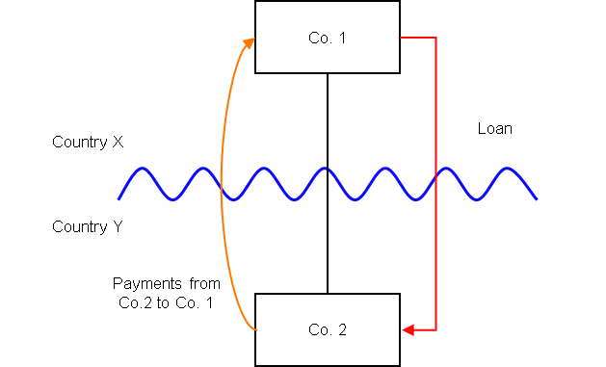

Background
- Co. 1 is a company resident in Country X, and owns all the shares in Co. 2
- Co. 2 is a company resident in Country Y
- Co. 1 lends money to Co. 2 on arm’s length terms.
- Under the laws of Country Y, the Loan is treated as a debt instrument, and payment of interest under the Loan is deductible in calculating Co. 2’s profits.
- Country X has a territorial tax system and does not tax income unless it has a domestic source.
- Co. 1’s receipt of the interest payment is not subject to tax as income, profit or gains in Country X because it does not have a domestic source from Country X’s perspective. If the interest were received from a source in Country X it would be taxable at the full rate of tax in Country X.
- The payee is not a relevant investment fund as defined in s259NA.
- The loan is not a regulatory capital security for the purposes of the Taxation of Regulatory Capital Securities Regulations 2013 (SI 2013/3209).

Analysis - Applying the tests in s259CA TIOPA 2010
Do the interest payments satisfy the relevant conditions to fall within the scope of the hybrid and other mismatches from financial instruments rules?

Condition A: Are the payments of interest made under, or in connection with, a financial instrument?
There are payments of interest made in satisfaction of the obligations arising under the Loan. The Loan is defined as a financial instrument for the purposes of UK GAAP, and is therefore within the definition of a financial instrument in s259N.
Condition A is satisfied.

Condition B: Is either Co. 1 or Co. 2 within the charge to corporation tax for a relevant payment period?
The UK cannot be Country X, as it does not operate a pure territorial tax system.
Where the UK is Country Y, Co. 2 is the payer and within the charge to corporation tax.
Condition B is satisfied only where the UK is the payer jurisdiction.

Condition C: Is it reasonable to suppose that there would be a ‘hybrid or otherwise impermissible deduction/ non-inclusion mismatch’ in relation to this payment?
The background suggests it is reasonable to suppose that Country Y will permit Co. 2 a deduction (relevant deduction) for the payment of interest.
However, as Country X operates a pure territorial system and does not tax foreign source income, profits or gains, the interest payment received by Co. 1 is not taxable, (irrespective of whether the financial instrument is classified as debt or equity). It is reasonable to suppose that Co. 1 is not required to bring the corresponding receipt into tax as ordinary income.
There is a potential Case 1 mismatch - as defined in s259CB(2) - as the relevant deduction exceeds the ordinary income that, by reason of the payment, arises to the payee in the permitted taxable period. The mismatch will be within Case 1 only if all or part of it arises by reason of the terms or any other feature of the financial instrument. This is tested by applying the relevant assumptions at s259CB(5).
Applying the assumption at s259CB(5)(b), we need to test whether the mismatch would still have arisen if the payment were received in connection with a business carried on by Co.1 in Country X. If a mismatch would still have arisen, then it is to be treated as arising by reason of the terms, or any other feature, of the Loan.
On the facts given there would be no mismatch if the interest payment were received by Co. 1 from a source in Country X. The mismatch does not arise from the terms or any other feature of the financial instrument but from the nature of the tax regime in Co. 1’s territory of residence.
Condition C is not satisfied. There is no need to consider the other conditions.
Return to contents

