INTM551230: Hybrids: Financial instruments (Chapter 3): Example: Interest payment under a hybrid financial instrument – payee has no tax jurisdiction
This example looks at situations where a company which does not have a tax jurisdiction issues a loan to a related company. The company paying interest gets a deduction for the payment but the sum received is not taxable (as the recipient jurisdiction does not charge income, profits or gains to tax), and even if it did, the sum would be treated as an exempt distribution.
The example considers whether the deemed interest payment is within the hybrid and other mismatches from financial instruments rules and how it should be treated.
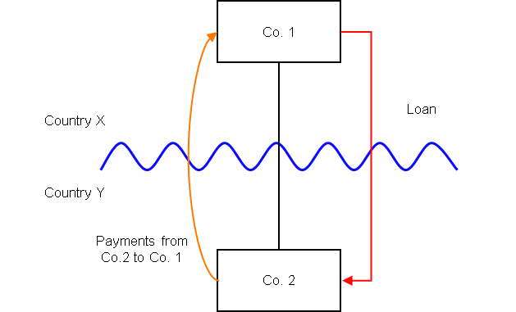

Background
- Co. 2 is a company resident in Country Y
- Co. 1 is a company resident in Country X, and owns all the shares in Co. 2
- Co. 1 lends money to Co. 2 on arm’s length terms (‘the Loan’), but the terms of the Loan are such that it is subordinated to the ordinary creditors of Co. 2 and can be suspended in the event Co. 2 fails to meet certain solvency requirements.
- Under the law of Country Y, the Loan is treated as a debt instrument, and payments of interest under the Loan are deductible in calculating Co. 2’s ordinary income for a taxable period.

- Country X does not tax income, profits or gains and Co. 1 does not have a taxable presence in any other jurisdiction.

- Co. 1’s receipt of the interest payment is not subject to tax as income, profit or gains.

- If Co. 1 were resident in Country Y, the terms of the instrument would lead to be it being characterised as an equity instrument in the hands of the holder.

- The payee is not a relevant investment fund as defined in s259NA.

- The loan is not a regulatory capital security for the purposes of the Taxation of Regulatory Capital Securities Regulations 2013 (SI 2013/3209).

Analysis - Applying the tests in s259CA TIOPA 2010
Do the interest payments satisfy the relevant conditions to fall within the scope of the hybrid and other mismatches from financial instruments rules?
Note: Under UK corporate tax law, a mismatch of this type should not arise. However, for the purposes of this example, the relevant sections of Part 6A are applied on the assumption that the UK is Country Y.

Condition A: Are the payments of interest made under, or in connection with, a financial instrument?
There are payments of interest made in satisfaction of the obligations arising under the Loan. The Loan is defined as a financial instrument for the purposes of UK GAAP, and is therefore within the definition of a financial instrument in s259N.
Condition A is satisfied.

Condition B: Is either Co. 1 or Co. 2 within the charge to corporation tax for a relevant payment period?
The charge to corporation tax is the charge to the corporation tax in the UK.
If the UK is Country X, Country Y or both (i.e. a wholly domestic transaction), Condition B is satisfied, as either Co. 1, Co. 2 or both are within the charge to corporation tax.
If the UK is neither Country X nor Country Y, then Condition B is not satisfied, as neither Co. 1 nor Co. 2 are within the charge to corporation tax. You will need to consider the remaining conditions only if the imported mismatch rules in Chapter 11 apply.
The background above suggests the UK cannot be Country X, as the UK taxes income, profits and gains.
As this example is presented for illustrative purposes only, it is assumed that the UK is Country Y, and that Co. 2 is the payer and within the charge to corporation tax.
Condition B is satisfied.

Condition C: Is it reasonable to suppose that there would be a ‘hybrid or otherwise impermissible deduction/ non-inclusion mismatch’ in relation to this payment?
The background suggests it is reasonable to suppose Country Y will permit Co. 2 a deduction (a relevant deduction) for the payment of interest. As Country X does not tax income, profits or gains, it is also reasonable to suppose that Co. 1 is not required to bring the interest receipt into account for tax purposes.
There is a potential Case 1 mismatch - as defined in s259CB(2) – as the relevant deduction exceeds the ordinary income that, by reason of the payment, arises to the payee in the permitted taxable period. The mismatch will be within Case 1 only if all or part of it arises by reason of the terms or any other feature of the financial instrument.
This is tested by applying the relevant assumptions at s259CB(5). As Co. 1 is not within the charge to a tax under the law of any territory, either as a resident or through a permanent establishment, s259CB(5)(c) applies to test whether the mismatch would still have arisen after making the assumption that Co. 1 is a company that is resident in Country Y (the UK) for tax purposes, and carries on a business here in connection with which the payment is made. If a mismatch would still have arisen, then it is to be treated as arising by reason of the terms, or any other feature, of the Loan.
For the purposes of this example it is assumed that if Co. 1 were resident in Country Y the receipt would have been treated as a distribution (and the return on it non-taxable) by reason of a term or feature of the Loan, and a mismatch would have arisen. The rules therefore recognise that there is hybridity in the financial instrument which is targeted by the legislation.
Condition C is satisfied.

Condition D: Are the two companies related or is the Loan, or any arrangement connected with it, a structured arrangement?
Co. 1 owns all the shares in Co. 2, so the companies are related as defined at s259NC.
Condition D is satisfied.
There is no need to consider whether the arrangement is also a structured arrangement.

Conclusion
As all the relevant conditions are satisfied to characterise the arrangement as a ‘hybrid or otherwise impermissible deduction/ non-inclusion mismatch’, the relevant counteractions need to be considered.

Counteraction

Counteraction where the UK is in the position of Country Y (the payer jurisdiction)

Primary response
In this hypothetical scenario, where the UK is in the position of Country Y (the payer jurisdiction), s259CD TIOPA 2010 will apply and Co. 2’s allowable deduction in relation to the payments of interest must be reduced by the amount of the ‘hybrid or otherwise impermissible deduction/ non-inclusion mismatch’. In this case, that is equal to the amount that is not chargeable to tax as a result of Country X not charging tax on income, profits or gains.
On the facts given counteraction under these provisions will apply only where the UK is in the position of the payer jurisdiction. The UK cannot be in the position of Country X.
Return to contents

