INTM551200: Hybrids: Financial instruments (Chapter 3): Example: Interest payment - debt/equity hybrid
This example looks at situations where a company issues a loan to a related company and it is treated as debt in one country and equity in the other. The interest payments are deductible and dividend receipts are exempt from tax.
The example considers whether the interest payment is within the hybrid and other mismatches from financial instruments rules and how it should be treated.
Counteraction in the UK is likely to be limited to the primary response as the UK’s distribution exemption rules are expected to apply so that no mismatch arises where the UK is the payee jurisdiction (see INTM551170).

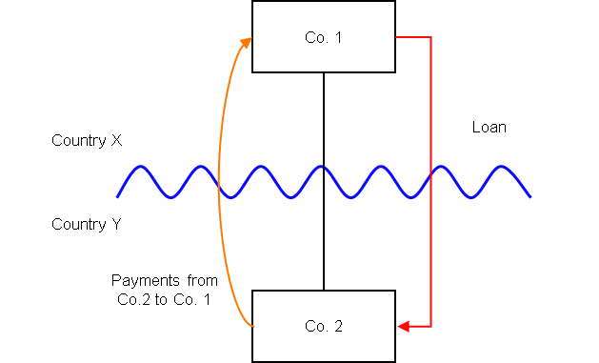

Background
- Co. 2 is a company resident in Country Y
- Co. 1 is a company resident in Country X and owns all the shares in Co. 2
- Co. 1 lends money to Co. 2 on arm’s length terms (the ‘Loan’).
- The terms of the Loan are such that it is subordinated to the ordinary creditors of Co. 2 and can be suspended in the event Co. 2 fails to meet certain solvency requirements.
- Under the laws of Country Y the Loan is treated as a debt instrument, and the payments of interest under the Loan are deductible in calculating Co. 2’s profits for a taxable period.
- Under the laws of Country X the Loan is treated as an equity instrument (i.e. shares), and the payments of interest under the Loan are treated as dividends.
- Country X exempts dividends received from a foreign company where the recipient controls the payer. If the instrument had been treated as a debt instrument in Country X then ordinarily Co. 1 would be taxable on those receipts.
- The payee is not a relevant investment fund as defined in s259NA.
- The Loan is not a regulatory capital security for the purposes of the Taxation of Regulatory Capital Securities Regulations 2013 (SI 2013/3209).

Applying the tests in s259CA TIOPA 2010
Do the interest payments satisfy the relevant conditions to fall within the scope of the hybrid or other mismatches arising from financial instruments rules?

Condition A: Are the payments of interest made under, or in connection with, a financial instrument?
There are payments of interest made in satisfaction of the obligations arising under the Loan. The Loan is defined as a financial instrument for the purposes of UK GAAP, and is therefore within the definition of a financial instrument in s259N.
Condition A is satisfied.

Condition B: Is either Co. 1 or Co. 2 within the charge to corporation tax for a relevant payment period?
The charge to corporation tax is the charge to the corporation tax in the UK.
If the UK is Country X, Country Y or both (i.e. a wholly domestic transaction), Condition B is satisfied, as either Co.1, Co.2 or both are within the charge to corporation tax.
If the UK is neither Country X nor Country Y, then Condition B is not satisfied, as neither Co.1 nor Co.2 are within the charge to corporation tax. You will need to consider the remaining conditions only if the imported mismatch rules in Chapter 11 apply.

Condition C: Is it reasonable to suppose that there would be a ‘hybrid or otherwise impermissible deduction/ non-inclusion mismatch’ in relation to these payments?
The background suggests it is reasonable to suppose that Country Y will allow Co. 2 a deduction (the relevant deduction) for the payment of interest against its ordinary income. It is also reasonable to suppose that, by reason of the terms of the Loan, Country X will not require Co. 1 to bring the corresponding receipt into tax as ordinary income.
This creates a case 1 mismatch, as defined in s259CB(2), as
- the relevant deduction exceeds the sum of the amounts of ordinary income that, by reason of the payment, arises to the payee in the permitted taxable period, and
- all or part of that excess arises by reason of the terms of the financial instrument.
Condition C is satisfied.
Note: If Country X is the UK or, like the UK, has adopted distribution exemption rules, you will need to consider how those rules treat the distribution received by Co.1.
If the UK is in the position of Country X, the rules at s931B(c) and s931D(c) CTA 2009 apply. Those provisions deny or restrict the distributions exemption for Co.1 where the dividends have been allowed as a deduction of a company outside the UK - see INTM650000 for more details.
This changes the amount of ordinary income arising to Co.1, and the calculation of whether any mismatch arises. Where the provisions at s931B(c) and s931D(c) CTA09 (or a non-UK equivalent provision) apply and result in the dividend receipt being treated as taxable income of Co.1, the receipt will also be ordinary income of Co. 1.
The result is that if the UK is Country X, then the application of the distributions exemption rules will result in ordinary income matching the deduction allowed in Country Y. Condition C will not be satisfied.

Condition D: Are the two companies related or is the Loan, or any arrangement connected with it, a structured arrangement?
Co. 1 owns all the shares in Co. 2, so the companies are related as defined at s259NC.
Condition D is satisfied.
There is no need to consider whether the arrangement is also a structured arrangement.

Conclusion
As all the relevant conditions are satisfied to characterise the arrangement as a ‘hybrid or otherwise impermissible deduction/ non-inclusion mismatch’, the relevant counteractions should be considered.

Counteraction
The counteraction applied will depend upon whether the UK is in the position of Country X or Country Y (or both).

Counteraction where the UK is in the position of Country Y (the payer jurisdiction)

Primary Response
Where the UK is in the position of Country Y (the payer jurisdiction) s259CD will apply. Co. 2’s allowable deductions in relation to the payments of interest must be reduced to the extent that the deduction is a ‘hybrid or otherwise impermissible deduction/ non-inclusion mismatch’.
In this example Country X exempts the receipt from tax, therefore the excess is the entire amount and none of the deduction will be allowed.
If Country X had subjected the receipt to a rate of taxation lower than the full marginal rate for interest income , then the deduction will be disallowed by an amount as quantified under s259CB(9) TIOPA 2010.

Counteraction where the UK is in the position of Country X (the payee jurisdiction)
Note: The following will only apply where, exceptionally, the dividend receipt by Co.1 is not treated as ordinary income (as detailed under Condition C above).

Secondary Response
Where the UK is Country X (the payee jurisdiction) and the mismatch has been fully counteracted in the payer jurisdiction by s259CD or an equivalent provision, no further action will be taken by the UK.
If the ‘hybrid or otherwise impermissible deduction/ non-inclusion mismatch’ has not been fully counteracted, s259CE TIOPA 2010 applies. The UK will counteract the remaining ‘hybrid or otherwise impermissible deduction/ non-inclusion mismatch’ by treating that amount as taxable income of the payee arising in the counteraction period.
Note: If, exceptionally, the UK is in the position of both Country X and Country Y (i.e. the transaction is not cross-border but wholly domestic, and UK law results in a mismatch), counteraction is applied to the payer. S259CD takes priority over s259CE by virtue of s259CE(1)(b)(i).
Return to contents

