INTM550086 D: Hybrids: Introduction: Examples: Interaction with transfer pricing - Double deduction scenario
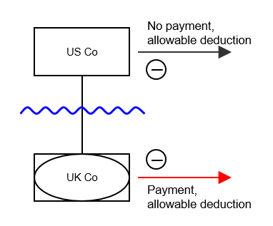
Background 1
- US Investor sees the UK payer as a transparent entity.
- UK Payer is opaque in the UK.
- UK payment is an allowable deduction
- US Investor also has an allowable deduction
- Under arm’s length terms, the value of the payment made by UK Payer would be 60.
.
Analysis
Applying transfer pricing with Part 6A factored in.
Step 1: Test outcome of actual provision, disregarding transfer pricing rules
Payer makes payment of 100. This is the double deduction amount for Part 6A purposes. Counteraction under Chapter 9 would therefore be to restrict use of deduction of 100 to being set against dual inclusion income.
Step 2: Test outcome of arm’s length provision
Payer makes payment of 60. For the purposes of Part 6A, the deduction in the US would also be computed on the basis that a payment of 60 was made, and is assumed in the example to be 60. This is the double deduction amount for Part 6A purposes. Counteraction under Chapter 9 would therefore be to restrict use of deduction of 60 to being set against dual inclusion income.
Step 3: Test if payer is a potentially advantaged person for transfer pricing purposes
Payer’s tax relief under the actual provision would be 100. Under the arm’s length provision it would be 60. In each case that relief could only be set against dual inclusion income. Payer is therefore potentially advantaged.
Step 4: Recompute payer’s tax position as if the arm’s length provision was imposed
Payer is taxed as if it has made a payment of 60, which may only be set against dual inclusion income.
To the extent relevant, corresponding adjustments would be available under s.174 as if the arm’s length payment of 60 had been made.
Applying Part 6A (Chapter 9) to consider whether a further counteraction is required.
Step 1: Identify double deduction amount
Payer makes payment of 100. However, this exceeds the arm’s length amount so transfer pricing would require recomputation of payer’s tax position as if it was paying 60. In identifying the double deduction amount, a payment of 60 would be assumed to be made for US purposes as well as for the UK and, as above, that is assumed in this example to give rise to a deduction in the US of 60. The double deduction amount is therefore 60.
Step 2: Apply counteraction
The double deduction amount of 60 is restricted to use against dual inclusion income. This is the same outcome as delivered by Part 4 and so the separate application of Part 6A has no consequence.
Return to contents

