INTM550086 B: Hybrids: Introduction: Examples: Interaction with transfer pricing - Hybrid payer
These two examples demonstrate how Part 6A and the Transfer Pricing rules apply in the case of a hybrid payer. The diagram is the same for both fact patterns.
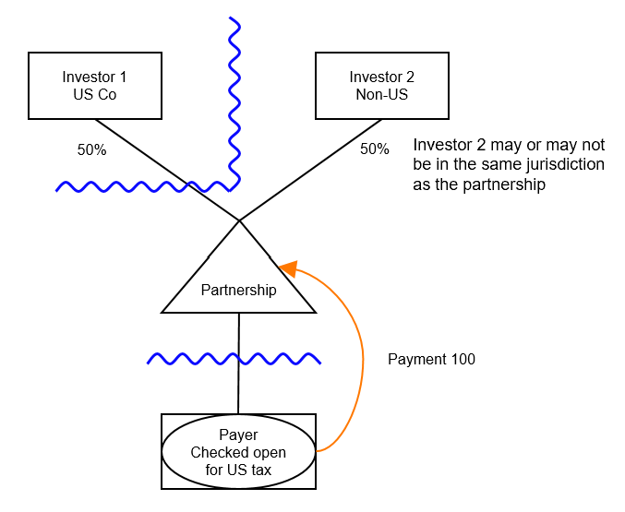
Background 1
- A payment of 100 is made by the Payer who is checked open for US tax purposes.
- The payee is a non-US partnership.
- Investor 1 (US Co) sees the payer as a transparent entity.
- Investor 2 (non-US co) sees the payer as an opaque entity.
- Both investors see the partnership as transparent.
Under arm’s length terms, the value of the payment between Payer and Partnership would be 60, not 100.

Analysis
Applying transfer pricing with Part 6A factored in.
Step 1: Test outcome of actual provision, disregarding transfer pricing rules
Payer makes payment of 100. This is the relevant deduction for Part 6A purposes. Total payee ordinary income is 50. Counteraction under Chapter 5 would therefore be restriction of 50 of relevant deduction to apply against dual inclusion income only. Total relief available to payer for normal use would therefore be 50.
Step 2: Test outcome of arm’s length provision
Payer makes payment of 60. This is the relevant deduction for Part 6A purposes. Total payee ordinary income would be 30. Counteraction under Chapter 5 would therefore be restriction of 30 of relevant deduction to apply against dual inclusion income only. Total relief available to payer for normal use would therefore be 30.
Step 3: Test if payer is a potentially advantaged person for transfer pricing purposes
Payer’s tax relief under the actual provision would be 50 available for general use and 50 available to set against dual inclusion income only. Under the arm’s length provision it would 30 in each category. Payer is therefore potentially advantaged.
Step 4: Recompute payer’s tax position as if the arm’s length provision was imposed
Payer is taxed as if it has made a payment of 60. 30 of the resulting relief is restricted to use against dual inclusion income by Chapter 5. The remaining 30 is available for general use.
To the extent relevant, corresponding adjustments would be available under s.174 s if the arm’s length payment of 60 had been made.
Applying Part 6A (Chapter 5) to consider whether a further counteraction is required.
Step 1: Identify relevant deduction (ie relief available disregarding hybrids rules)
Payer makes payment of 100. However, this exceeds the arm’s length amount so transfer pricing would require recomputation of payer’s tax position as if it was paying 60. Relevant deduction is therefore 60.
Step 2: Identify payees’ total ordinary income
Only Investor 2 is recognising ordinary income. It receives 50. So the total ordinary income of all payees is 50.
Step 3: Test if there is a hybrid payer deduction/non-inclusion mismatch
The relevant deduction is 60 and the total ordinary income of payees is 50. There is therefore a hybrid payee deduction/non-inclusion mismatch of 10.
Step 4: Apply counteraction
An amount of the relevant deduction equal to the mismatch of 10 is restricted for use against dual inclusion income only. The maximum the payer may deduct generally is therefore 50. However, since the application of the transfer pricing rules has led to a greater restriction, with 30 of relief limited to use against dual inclusion income and only 30 of relief available for general use, the counteraction has no effect in practice.
Note that if a corresponding adjustment claim was made by Investor 2, Part 6A would have imposed a counteraction of 30 (as total payee ordinary income would have been reduced to 30), setting a maximum deduction for general use of 30, leading to the same outcome as Part 4. Part 6A would therefore have had no effect in its own right.

Background 2
- Investor 1 sees the payer as a transparent entity.
- Investor 2 sees the payer as an opaque entity.
- Both investors see the partnership as transparent.
- Under arm’s length terms, the value of the payment between Payer and Partnership would be 40, not 100.
Analysis
Applying transfer pricing with Part 6A factored in.
Step 1: Test outcome of actual provision, disregarding transfer pricing rules
Payer makes payment of 100. This is the relevant deduction for Part 6A purposes. Total payee ordinary income is 50. Counteraction under Chapter 5 would therefore be restriction of 50 of relevant deduction to apply against dual inclusion income only. Total relief available to payer for normal use would therefore be 50.
Step 2: Test outcome of arm’s length provision
Payer makes payment of 40. This is the relevant deduction for Part 6A purposes. Total payee ordinary income would be 20. Counteraction under Chapter 5 would therefore be restriction of 20 of relevant deduction to apply against dual inclusion income only. Total relief available to payer for normal use would therefore be 20.
Step 3: Test if payer is a potentially advantaged person for transfer pricing purposes
Payer’s tax relief under the actual provision would be 50 available for general use and 50 available to set against dual inclusion income only. Under the arm’s length provision it would 20 in each category. Payer is therefore potentially advantaged.
Step 4: Recompute payer’s tax position as if the arm’s length provision was imposed
Payer is taxed as if it has made a payment of 40. 20 of the resulting deduction is restricted to use against dual inclusion income by Chapter 5. The remaining 20 is available for general use.
To the extent relevant, corresponding adjustments would be available under s.174 as if the arm’s length payment of 40 had been made.
Applying Part 6A (Chapter 5) to consider whether a further counteraction is required.
Step 1: Identify relevant deduction (ie relief available disregarding hybrids rules)
Payer makes payment of 100. However, this exceeds the arm’s length amount so transfer pricing would require recomputation of payer’s tax position as if it was paying 40. Relevant deduction is therefore 40.
Step 2: Identify payees’ total ordinary income
Only Investor 2 is recognising ordinary income. It receives 50. So the total ordinary income of all payees is 50.
Step 3: Test if there is a hybrid payer deduction/non-inclusion mismatch
The relevant deduction is 40 and the total ordinary income of payees is 50. There is therefore no hybrid payee deduction/non-inclusion mismatch.
Since there is no hybrid payee deduction/non-inclusion mismatch, there is no counteraction.
Payer has an unrestricted deduction of 20, with a further 20 restricted to use against dual inclusion income, in accordance with the outcome of applying the transfer pricing rules.
Note that if a corresponding adjustment claim was made by Investor 2, Part 6A would have imposed a counteraction of 20 (as total payee ordinary income would have been reduced to 20), setting a maximum deduction for general use of 20, leading to the same outcome as Part 4. Part 6A would therefore have had no effect in its own right.
Return to contents

