User Role Requests

Changes to managers request for COTAX user roles
Managers will continue to use the SRS Add/Remove Services function to request the allocation of COTAX User Roles. The system has been enhanced to include an additional screen where the manager must complete a business case to support the request. The screen will look like the following
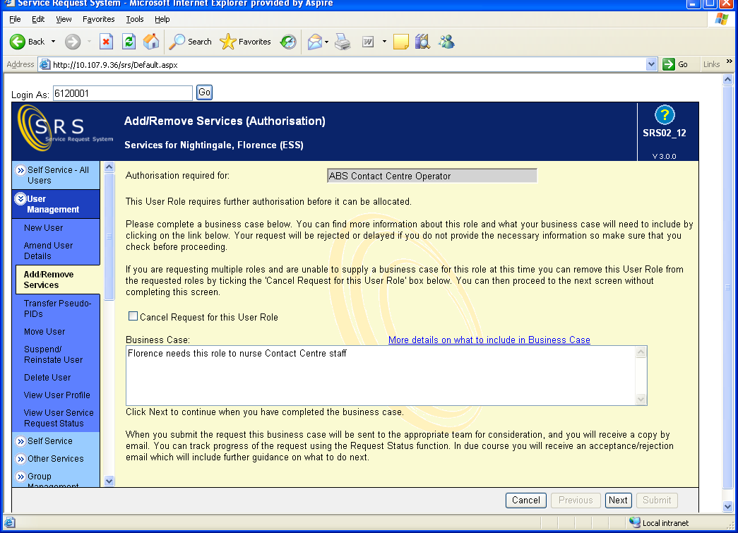
Managers will be given guidance on how to complete the business case which must always include the MUID in which the role is required. Once the manager has supplied the business case they will complete the remaining screens as before and submit the request.

SRS Process
On receipt of the request the SRS system will automatically create a Unique Reference number. This number will be displayed to the manager when they have completed their request and they will be able to use it to track the progress of the request. The SRS system will also automatically issue an e-mail to the responsible COTAX Role Authoriser, telling them a request has been made and referring them to SRS to review the request.

COTAX Role Authoriser
All Authorisers will use a new function in SRS called Authorise Requests to review requests.
The summary screen will look like this
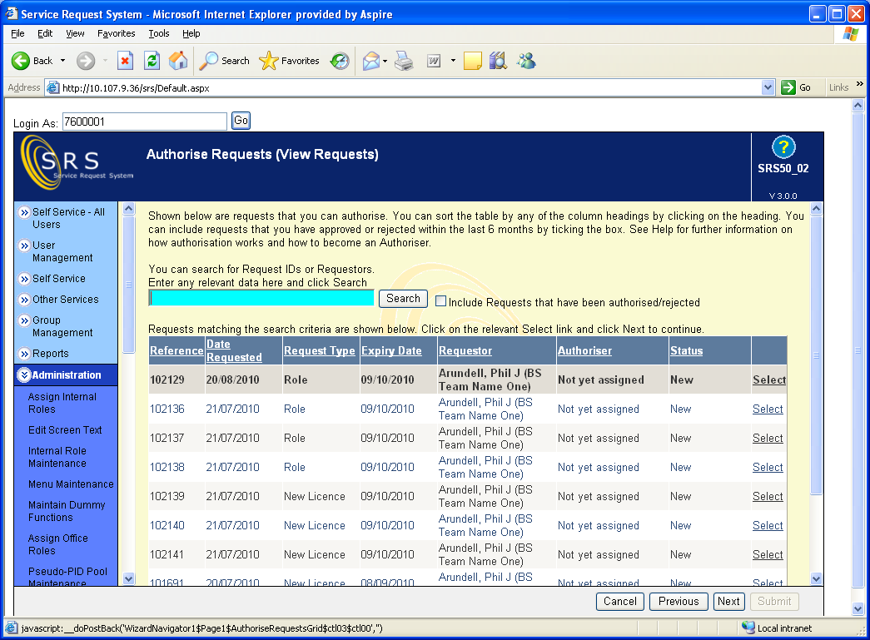
All requests initially created will have a status of ‘New’. You will be able to see all outstanding requests for COTAX roles that are in the system awaiting authorisation. To select the request that you have responsibility for you should enter the Unique Reference number given in the e-mail in the search field and click on the ‘Search’ button. The SRS system will display the result and you will then be able to select it. SRS will show the full details of the request, which will look like this
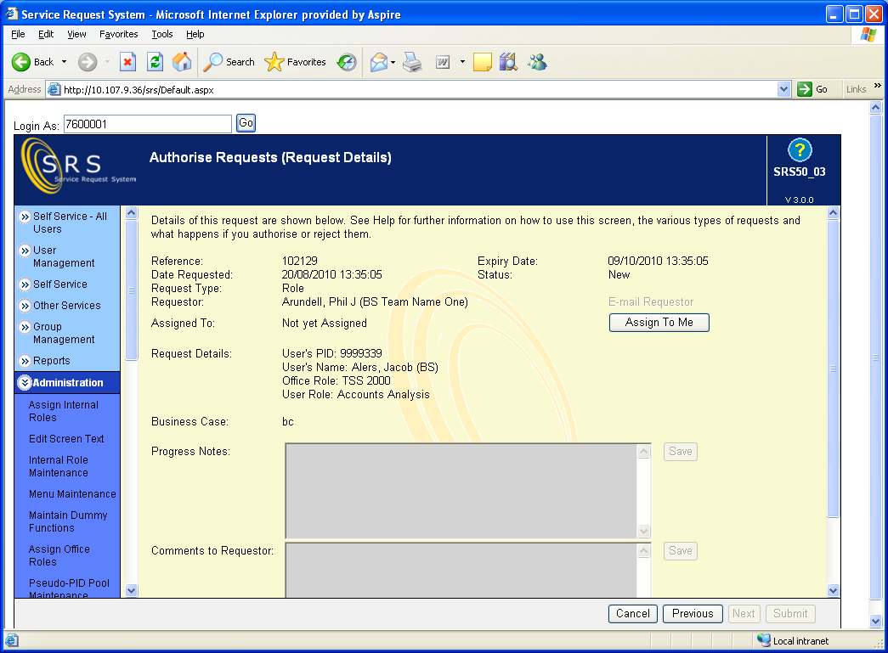
You must accept the case by clicking on the ‘Assign To Me’ button before you can review the request. Once you have assigned the case to yourself you will see that the ‘E-mail Requestor’, ‘Authorise’ and the ‘Reject’ become available for you to use.
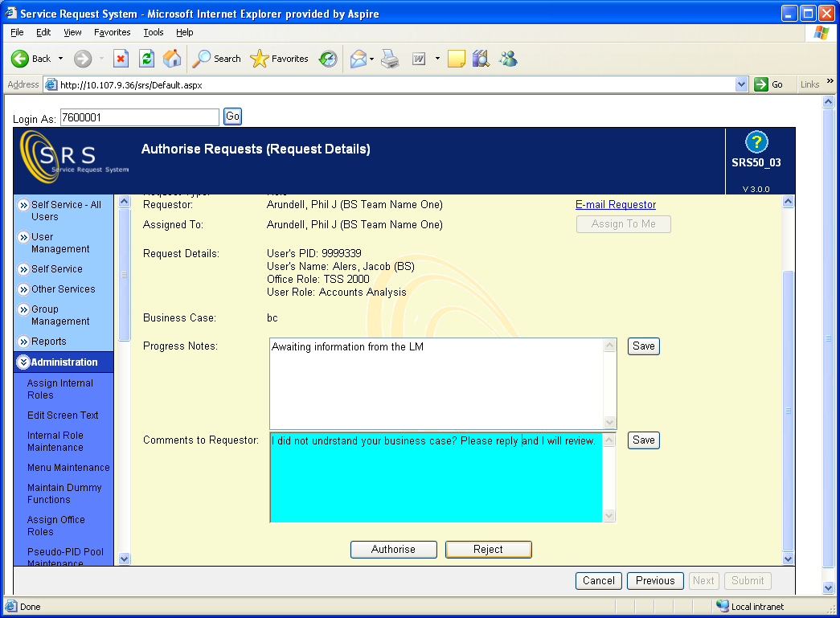
Details of the request and the supporting business case will be visible on this screen together with a Notes field which you can use to record the progress of a case should you need to make further enquiries before authorising the request. From this screen you can do the following
- Authorise the request
- Reject the request
- E-mail the manager making the request direct from this screen if you need further information or anything is not clear.

Authorising the request
If you authorise the request, SRS will send an e-mail to the manager informing them that the request has been accepted and that the role will be allocated to their member of staff.

Rejecting the request
If you reject the request you should complete the ‘Comments to Requestor’ field advising the manager why you have rejected the request. SRS will send an e-mail to the manager informing them that the request has been rejected and include your comments.

Further information required
If you need further information you should update the ‘Progress Notes’ field of the actions you have taken. You should then complete the ‘Comments to Requestor’ before clicking on ‘E-mail Requestor’ which will automatically send an e-mail to the manager. Once you receive a reply you can pick the case up again from the Authorise Requests screen and complete either the authorisation or rejection of the request.

